Economic Growth (Revision Presentation)

http://www.slideshare.net/tutor2u/as-macro-revision-economic-growth-31476050?ref=http://beta.tutor2u.net/economics/reference/economic-growth-revision-presentation

http://www.slideshare.net/tutor2u/gdp-as-a-measure-of-economic-growth-and-standard-of-living?qid=6c0dd4d0-cf84-474c-8100-8c515339f8dd&v=qf1&b=&from_search=20

http://www.slideshare.net/tutor2u/standard-of-living?related=1

http://www.slideshare.net/tutor2u/as-macro-revision-national-income-and-standard-of-living?related=2

http://www.slideshare.net/tutor2u/as-macro-revision-multiplier-accelerator-and-keynesian-economics?related=1

Economic Growth - An Introduction
Economic growth is a long-term expansion of the productive potential of the economy
Trend growth refers to the smooth path of long run national output
Measuring the trend rate of growth requires a long-run series of data perhaps of 20-30 years or more in order to calculate average growth rates from peak to peak across different economic cycles
The table below tracks the growth rates achieved in the world economy for three recent years and also for developing countries excluding China and India.
Real GDP growth (annual % change) |  | 2010 | 2011 | 2012
 | World Economy | 4.1 | 2.7 | 2.5
 | Developing countries excluding China and India | 5.6 | 4.4 | 3.6
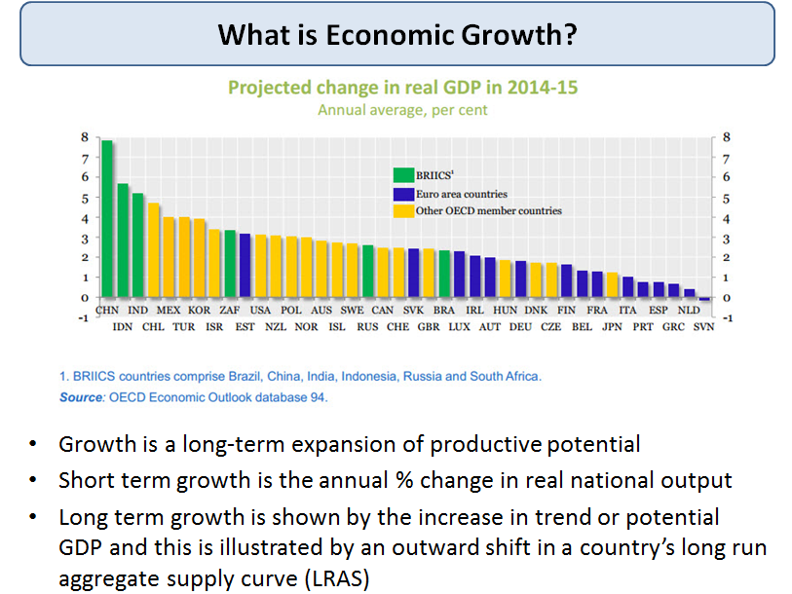
What is economic growth?
What determines the rate of economic growth?
- Every country is different, each factor will vary in importance for a country at a given point in time
- Remember too that in our inter-connected globalising world, growth does not happen in isolation. Events in one country and region can have a significant effect on growth prospects in another
Growth Drivers
Here are some of the main determinants of economic growth – they apply for both developing and developed countries although the relative weighting that we might attach to each will depend on the individual circumstances facing each country or region.
- Growth in physical capital stock - leading to a rise in capital per employee (capital deepening)
- Growth in the size of the active labour force available for production
- Growth in the quality of labour (human capital)
- Technological progress and innovation driving productivity improvements i.e. higher GDP per hour worked
- Institutions - including maintaining the rule of law, stable democracy, macro-economic stability
- Rising demand for goods and services - either led by domestic demand or from external trade
Key exam point:
- Economic growth is not the same as economic development!
- Growth can support development but the two are distinct – an important point to make in any A2 macro essay or data response question
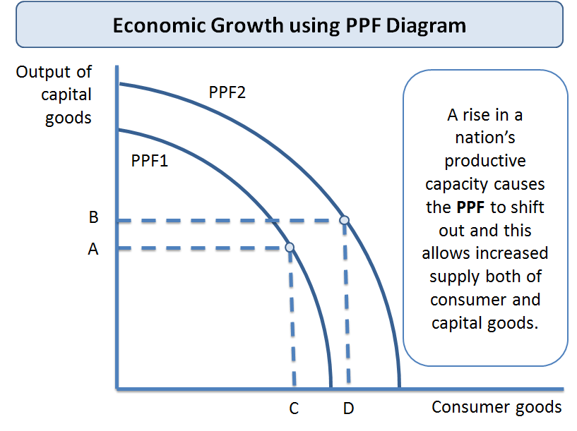PPF and economic growth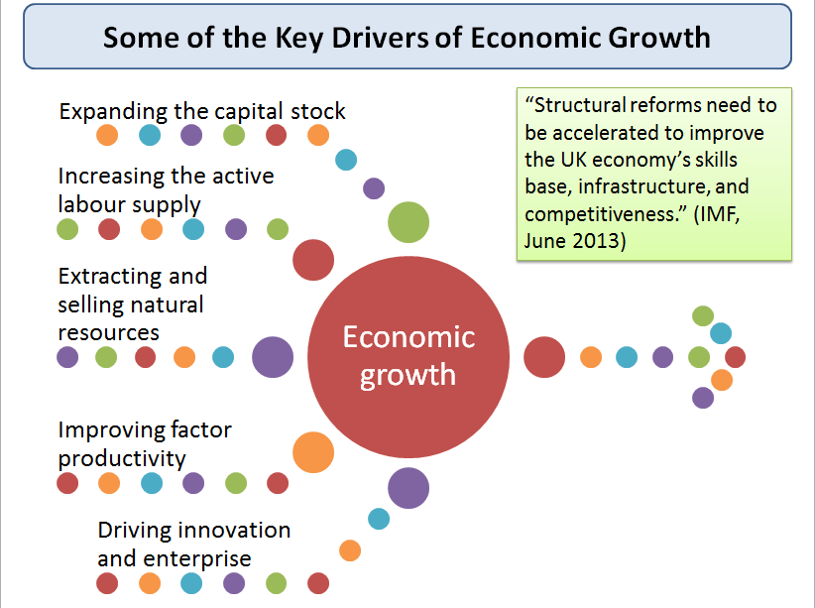Key drivers of economic growth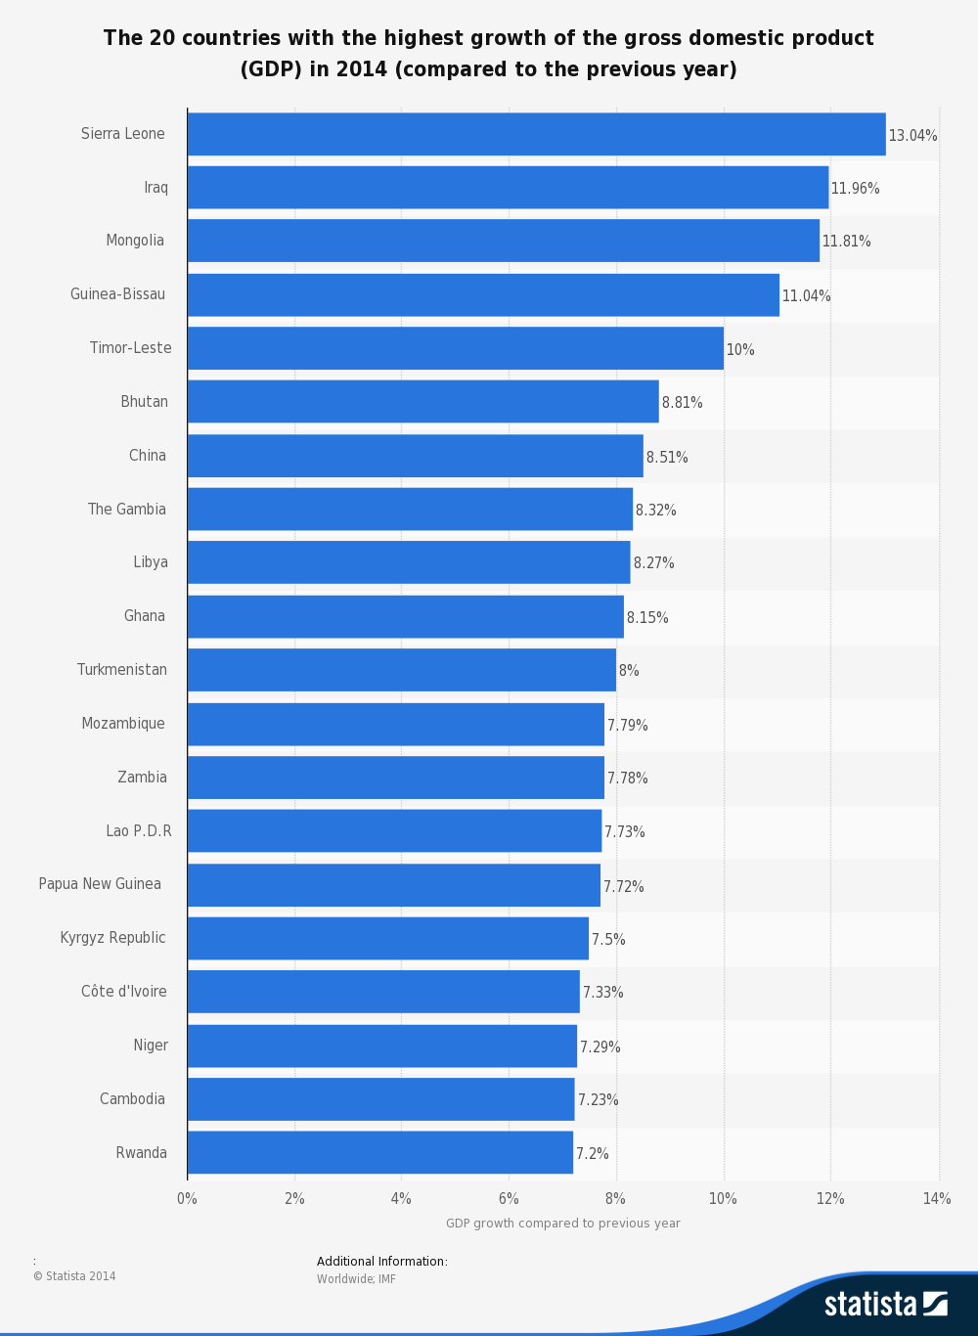Fastest growing countries in 2014
Threats / Challenges to Economic Growth
- Changes in the real exchange rate affecting competitiveness
- Cyclical fluctuations in national output and external trade
- Financial instability e.g. unsustainable credit boom and fall in savings
- Volatility in world prices for essential imports and key exports
- Political instability / military conflicts
- Natural disasters and other external supply shocks
- Unexpected breakthroughs in the state of technology

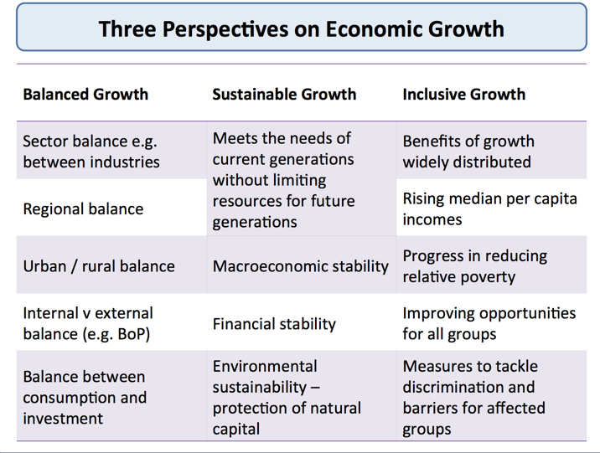3 Perspectives on Growth

Economic Growth in the UK - Government Policies
31st January 2015
The UK government stated in its 2011 Plan for Growth that it would aim to 'rebalance' the economy by encouraging growth in UK exports and FDI.
This was one of four priorities for achieving growth. The others were:
- Reforms to the tax system
- Measures intended to make the UK a more attractive place to start a business
- Measures intended to create a more educated and a more flexible workforce.
The Plan for Growth was centered around supply-side reforms and policy interventions designed to improve business competitiveness and labour market flexibility
Business taxation:
- Corporation tax cut to a new level of 20% from 2015
- Patent box (lower taxes on patented products) to stimulate innovation
- New tax reliefs for animation, high-end television and games industries
- Reductions in national insurance contributions for businesses employing long-term unemployed / youth unemployed
Other policies
- Creation of Green Investment Bank for renewable energy investment
- Funding for Lending Scheme in association with the Bank of England
- 24 new Enterprise Zones established in areas of high unemployment
- Qualifying period for unfair dismissal increased from one year to two
Education reforms:
- Expansion of free schools and academies
- Large rise in the number of apprenticeships available under Youth Contract
- 14 science and innovation capital projects

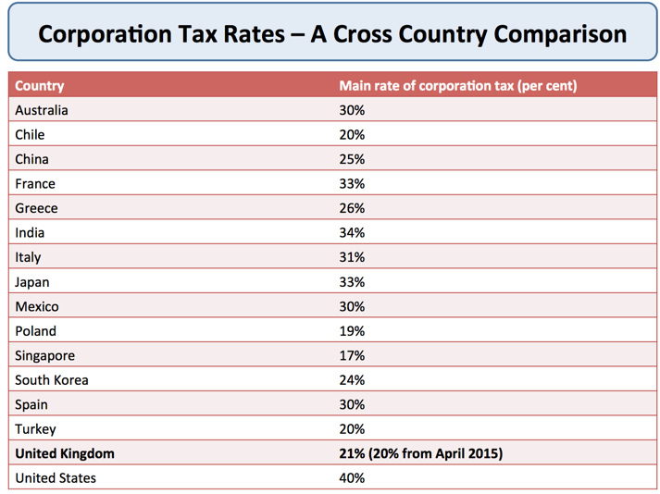
Selection of corporation tax rates by country

Measuring National Income (GDP)

National income measures the monetary value of the flow of output of goods and services produced in an economy over a period of time
Measuring the level and rate of growth of national income (Y) is important for keeping track of:
- The rate of economic growth
- Changes to living standards
- Changes to the distribution of income between groups within the population
Gross Domestic Product
- Gross domestic product (GDP) is the total value of output produced in a given time period
- GDP includes the output of foreign owned businesses that are located in a nation following foreign direct investment. For example, the output produced at the Nissan car plant on Tyne and Wear contributes to the UK’s GDP
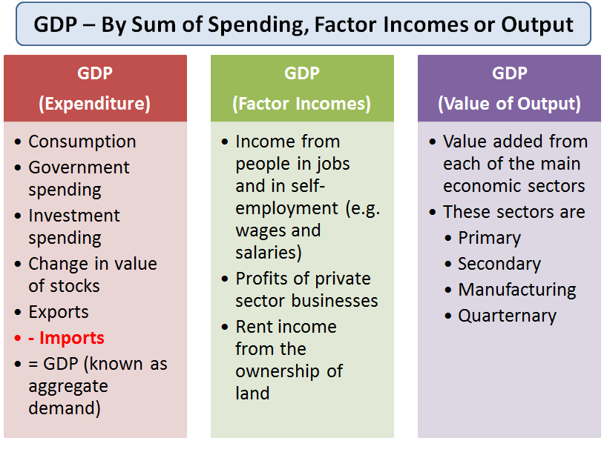Three ways to measure GDP
There are three ways of calculating GDP - all of which in theory should sum to the same amount:
National Output = National Expenditure (Aggregate Demand) = National Income
(i) The Expenditure Method - Aggregate Demand (AD)
The full equation for GDP using this approach is
GDP = C + I + G + (X-M) where
- C: Household spending on goods and services
- I: Capital Investment spending
- G: Government spending
- X: Exports of Goods and Services
- M: Imports of Goods and Services
The Income Method – adding together factor incomes
GDP is the sum of the incomes earned through the production of goods and services. This is:
- Income from people in jobs and in self-employment (e.g. wages and salaries)
- +
- Profits of private sector businesses
- +
- Rent income from the ownership of land
- =
- Gross Domestic product (by sum of factor incomes)
Only those incomes that are come from the production of goods and services are included in the calculation of GDP by the income approach. We exclude:
Transfer payments e.g. the state pension; income support for families on low incomes; the Jobseekers’ Allowance for the unemployed and other welfare assistance such housing benefit and incapacity benefits
Private transfers of money from one individual to another
Income not registered with the tax authorities Every year, billions of pounds worth of activity is not declared to the tax authorities. This is known as the shadow economy.
Published figures for GDP by factor incomes will be inaccurate because much activity is not officially recorded – including subsistence farming and barter transactions
Gross Value Added and Contributions to a nation’s GDP
- There are three main wealth-generating sectors in an economy – manufacturing and construction, primary (including oil& gas, farming, forestry & fishing) and a wide range of service-sector industries.
- This measure of GDP adds together the value of output produced by each of the productive sectors in the economy using the concept of value added. .
Value added is the increase in the value of goods or services as a result of the production process
Value added = value of production - value of intermediate goods
Say you buy a pizza from Dominos for £9.99. This is the retail price and will count as consumption. The pizza has many ingredients at stages of the supply chain – tomato growers, dough, mushroom farmers and also the value created by Dominos as they put the pizza together and deliver to the consumer.
Some products have a low value-added, for example cheap tee-shirts selling for little more than £5. These are low cost, high volume, low priced products.
Other goods and services are such that lots of value can be added as we move from sourcing the raw materials through to the final product. Examples include designer jewellery, perfumes, meals in expensive restaurants and sports cars. And also the increasingly lucrative computer games industry.
Manufacturing in the World Economy
- The creative force behind 10bn unique products
- It accounts for 15-20 per cent of world economy
- It employs about 300m people (roughly 5 pc of world population)
GDP by Output (Value Added)
- The majority of UK GDP comes from service industries such as banking and finance, tourism, retailing, education and health.
- In 2012, the service sector accounted for 79% of economic output, the manufacturing sector for 10% and the construction sector for 6%.
Manufacturing
Manufacturing is one of the production industries, which also include mining; electricity; water and waste management; and oil and gas extraction. The production industries accounted for 16% of UK output in 2011. Many jobs have been lost in manufacturing and construction in recent years. In 2012 there were 2.6 million jobs in manufacturing, 8% of all jobs in the UK
Service sector industries
Tourism in the UK Economy
In 2012 there were 31.1 million inbound visits to the UK. London was the most popular destination in the UK, attracting 50% of all visits.
Tourism directly employed 3.2 million people and tourism directly contributed £44.6 billion to the UK economy.
The main service sector industries in the UK are:
- Hotels and restaurants, and a range of services provided by local government
- Transport, logistics, storage and communication
- Business services and finance, motor trade, wholesale trades and retail trade
- Land transport and air transport, post and telecommunications
- Real estate activities, computer and related activities, Education, Health and social work
- Sewage and refuse disposal
- Recreational, cultural and sporting activities
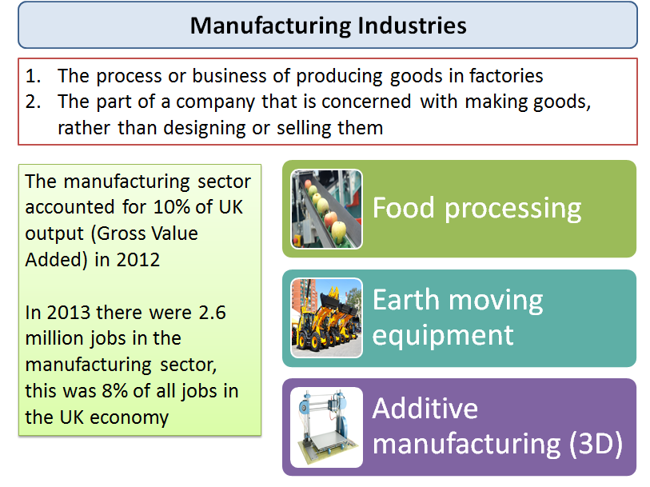Manufacturing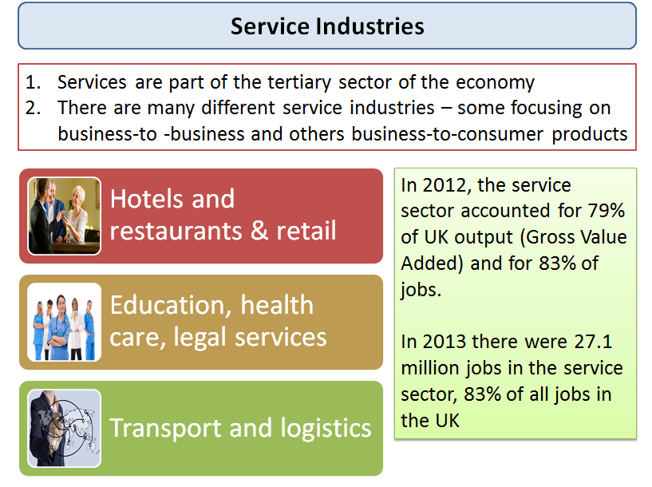Services

Per Capita Gross National Income
How much does each person earn on average? We use per capita measures to give us a guide to this. Income per capita is a way of measuring the standard of living for the inhabitants of a country.
Gross National Income per capita = Gross National Income / Total Population

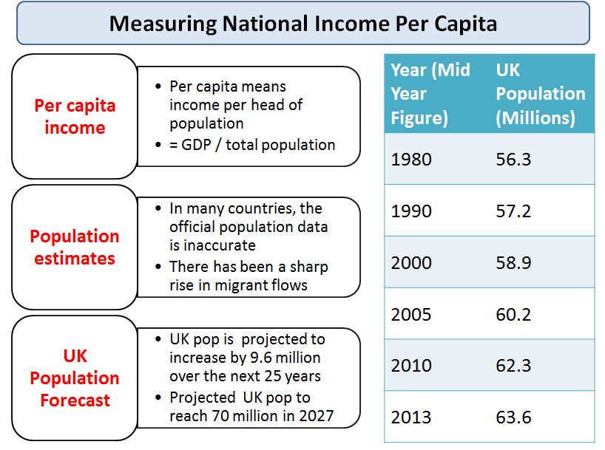Per capita national income

Measuring National Income

National income measures the monetary value of the flow of output of goods and services produced in an economy over a period of time
Measuring the level and rate of growth of national income (Y) is important for seeing:
- The rate of economic growth
- Changes to average living standards
- Changes to the distribution of income
Gross Domestic Product
Gross domestic product (GDP) is the total value of output in an economy and is used to measure change in economic activity. GDP includes the output of foreign owned businesses that are located in a country following foreign direct investment. For example, the output produced at the Nissan car plant on Tyne and Wear and by foreign owned restaurants and banks all contribute to the UK’s GDP.
There are three ways of calculating GDP - all of which should sum to the same amount:
National Output = National Expenditure (Aggregate Demand) = National Income
(i) The Expenditure Method - aggregate demand (AD)
The full equation for GDP using this approach is GDP = C + I + G + (X-M) where
- C: Household spending
- I: Capital Investment spending
- G: Government spending
- X: Exports of Goods and Services
- M: Imports of Goods and Services
The Income Method – adding factor incomes
Here GDP is the sum of the incomes earned through the production of goods and services. This is:
- Income from people in jobs and in self-employment +
- Profits of private sector businesses +
- Rent income from the ownership of land =
- Gross Domestic product (by factor incomes)
Only those incomes that are come from the production of goods and services are included in the calculation of GDP by the income approach. We exclude:
Transfer payments e.g. the state pension; income support for families on low incomes; the Jobseekers’ Allowance for the unemployed and welfare assistance such housing benefit
Private transfers of money from one individual to another
Income not registered with the Inland Revenue or Customs and Excise. Every year, billions of pounds worth of activity is not declared to the tax authorities. This is known as the shadow economy or black economy. According to a World Bank report published in 2010, the average size of the shadow economy (as a percentage of official gross domestic product) in Sub-Saharan Africa was 38%; in Europe and Central Asia (mostly transition countries), it was 36%, and in high-income OECD countries – 13%
Published figures for GDP by factor incomes will be inaccurate because much activity is not officially recorded – including subsistence farming, barter transactions and the shadow economy. Many African countries in particular have trouble measuring the size of their relatively large subsistence economies and unrecorded economic activity.
In 2013 the United States made changes to the way that the value of their GDP is calculated – they now include the amount spent on intellectual property outlays such as pop song production and drug patents for the first time.
Value Added and Contributions to a Nation’s GDP
- There are four main wealth-generating sectors of the economy – manufacturing, oil& gas, farming, forestry & fishing and a wide range of service-sector industries.
- This measure of GDP adds together the value of output produced by each of the productive sectors in the economy using the concept of value added. .
Value added is the increase in the value of goods or services as a result of the production process
Value added = value of production - value of intermediate goods
Let us say that you buy a ham and mushroom pizza from Dominos at a price of £14.99. This is the final retail price and will count as consumption. The pizza has many ingredients at different stages of the supply chain – for example tomato growers, dough, mushroom farmers and also the value created by Dominos themselves as they put the pizza together and get it to the consumer.
Some products have a low value-added, for example those really cheap tee-shirts that you might find in a supermarket for little more than £5. These are low cost, high volume, low priced products.
Other goods and services are such that lots of value can be added as we move from sourcing the raw

Measuring the Standard of Living

The standard of living measures our material welfare
“Equity, dignity, happiness, sustainability – these are all fundamental to our lives but absent in the GDP. Progress needs to be defined and measured in a way which accounts for the broader picture of human development and its context"
Source: Helen Clarke, UNDP
The baseline measure is real national output per head of population or real GDP per capita
Real income per capita is an inaccurate and insufficient indicator of living standards
For many economists, there is a growing disconnect between GDP and wellbeing
National income data can be used to make cross-country comparisons. This requires
- Converting GDP data into a common currency
- Making an adjustment to reflect differences in the cost of products in each country to produce data expressed at purchasing power parity standard
- The PPP dollar takes into account the fact that it is cheaper to live in some countries than others
Problems in using national income statistics to measure living standards
- Official data on GDP understates the growth of real national income per capita over time due to the shadow economy and the value of unpaid work by volunteers and people caring for their family
- The "shadow economy" includes illegal activities such as drug production and distribution, prostitution, theft, fraud and concealed legal activities such as tax evasion on otherwise-legitimate business activities such as un-reported self-employment income
- Often official GDP data is inaccurate, e.g. many countries in sub-Saharan Africa do not update their reporting often enough, and so their GDP numbers may miss large and fast-growing sectors, like cell phones. In 2014 Nigeria became the largest economy in Africa (over-taking South Africa) after a fundamental reassessment of their GDP calculation.
Reasons why GDP data may give a distorted picture of living standards in a country:
Bill Gates on Alternative Measures of the Standard of Living
- The Human Development Index uses health and education statistics in addition to GDP.
- The UN's Multidimensional Poverty Index uses 10 indicators; including nutrition, sanitation, and access to cooking fuel and water.
- By using purchasing power parity, which measures the cost of the same basket of goods and services in different countries, economists can adjust GDP to gain better insight into living standards.
- Regional variations in income and spending: National data can hide regional variations in output, employment and income per head of the population
- Inequalities in income and wealth: Average (mean) incomes might rise but inequality could grow
- Leisure and working hours and working conditions: An increase in real GDP might have been achieved at the expense of leisure time if workers are working longer hours or if working conditions have deteriorated
- Imbalances between consumption and investment: High levels of investment as a share of GDP might be superb for creating extra capacity to produce but at the expense of consumer goods and services for the current generation
- Changes in life expectancy: Improvements in life expectancy don't always show through in GDP accounts. Putting a monetary value on the benefits of increased longevity is difficult
- The value of non-marketed output: Much useful and valuable work is not sold in markets at market prices. The value of the output of people working for charities, self-help groups and of housework might reasonably be added to national income statistics
- Innovation and the development of new products: New goods and services become available because of invention and innovation that simply would not have been available to the richest person on earth less than fifty years ago. About half of what we spend our money on now was not invented in 1870. Examples include air travel, cars, computers, antibiotics, hip replacements, insulin and many other life-enhancing and life-saving drugs
- Environmental considerations: Rising output might have been accompanied by an increase in air and noise pollution and other externality effects that have a negative effect on our social welfare
- Defensive expenditures: Much spending is to protect against an economic or social bad e.g. crime, or spending to clean up the effects of pollution and waste
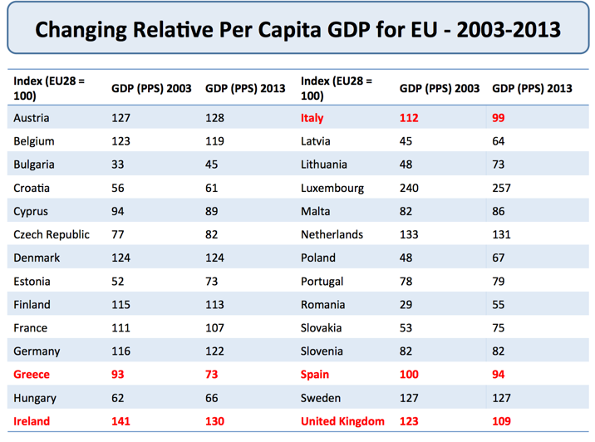
Changes in per capita GDP for member nations of the European Union
Moving away from GDP per capita – the case for median household incomes
There is widespread agreement that changes a nation's GDP per capita are an inadequate measure of human wellbeing.
Instead of tracking changes in mean per capita incomes, some economists are now pushing for an extra indicator – namely changes in median per capita household incomes. Household income measures the flow of income that finds its way to households each year.
The median is better than the mean since it is reflective of progress in the middle of the income distribution. For example, increases in GDP that go solely to the rich would not increase this measure. Looking at median income would create more focus on inclusive growth that generates wider benefits.
In the United Kingdom, median income growth has lagged behind GDP per capita since the early 1980s, in part because of the growth of income inequality reflected in an increase in the Gini coefficient.

Measuring Macroeconomic Performance

Macroeconomic performance is how well a country is doing in reaching objectives or targets of government policy.
- The main aim is an improvement in the average real standard of living
- The term ‘real’ means that we have taken into account the effects of rising prices so that we get an accurate picture of how much we can afford to buy and consume.
- The main aims are macroeconomic policies are to improve outcomes in these indicators:
- Jobs – how high is unemployment? Is the economy creating enough new jobs for people entering the labour market each year? Are there sufficient opportunities for people looking for work?
- Prices –are price rises under control? Can the economy avoid a period of price deflation? Price stability refers to low, stable, positive inflation of between 1-3% per year.
- Trade – is the economy performing well in trading goods and services with other countries? How competitive are British businesses in the global economy?
- Growth – how successful has the country been in achieving growth and in laying foundations for future expansion and development
- Development - the expansion of people’s freedom to live long, healthy and creative lives
- Efficiency - is the economy improving productivity so that more goods and services can be supplied at lower cost? Are we cutting the amount of energy we use per unit of output?
- Public services – have the benefits of growth flowed through into better provision of state services such as education, law and order, the National Health Service and transport?
- The environment – whether economic growth is sustainable in terms of environmental impact.
- Inequality of income and wealth - leaving aside changes in average living standards, has the economy made progress in achieving an acceptable distribution of income and wealth? Or has the gap between lower and higher-income families become wider leading to higher relative poverty?
The macroeconomic performance of any one nation is affected by events, policies and shocks in other countries. No economy is immune to what is happening in the global financial and economic system.

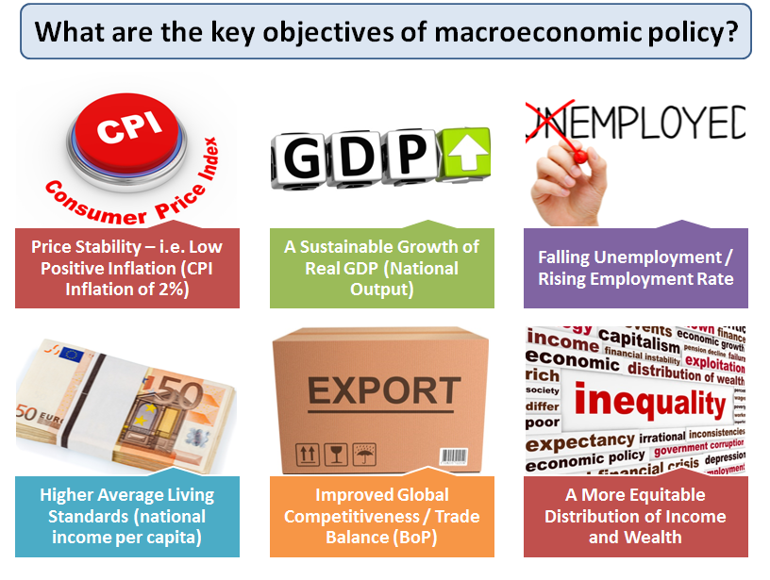Objectives of Macro Policy

Double-Dip Recession
A double-dip recession happens when an economy goes into recession twice without having undergone a full recovery in between. There are several different possible causes of a double-dip recession:
f
United Kingdom Real GDP Change from Previous Year from Timetric
A double dip can occur for a variety of reasons including:
A fresh external economic shock: Industries involved in exporting goods and services are affected by a downturn in one or more of their major overseas export markets
Consumer confidence: There is a decline in consumer confidence which turns a fragile economic recovery into another contraction. Confidence might decline for a variety of reasons – for example a persistent fall in property prices, declining real disposable incomes or the effects of rising unemployment
Business confidence: There is a fall in business confidence leading to a fresh burst of production cut-backs and a fall in planned capital investment spending. One of the features of the recent recession in Europe has been the sharp decline in business and investor confidence – something that Keynesian economists know as a worsening of “animal spirits”.
Higher exchange rate: Recovery might be halted by an appreciation of the exchange rate which lowers a country’s international competitiveness –for example an appreciation of the Euro against the US dollar.
Policy mistakes - e.g. tightening of policy too soon: The withdrawal of a monetary and/or fiscal stimulus (e.g. higher interest rates, higher taxes and cuts in government spending) has the effect of causing a contraction of demand and production in the circular flow.
You might use an AD-AS analysis diagram to show a double-dip recession – illustrating for example an inward shift of the AD curve or a leftward shift in the short run aggregate supply curve.

UK Economy - Competitiveness Policies

31st January 2015
This page provides a summary of some of the policies introduced in recent years to improve the competitiveness of the UK economy
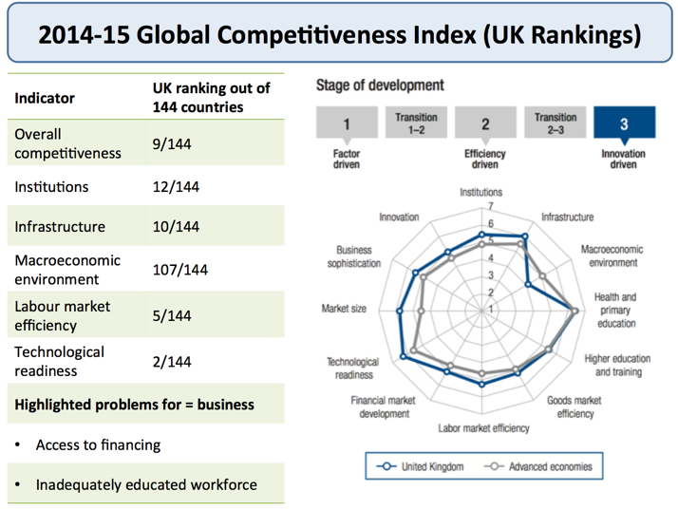

UK World Economic Forum Competitiveness Ranking for 2014-15
Policy | Detail | Click on the links to explore further on each policy area
Investment in infrastructure | •Public sector investment in infrastructure worth over £100bn by 2020  •Government guarantees for lenders financing infrastructure projects | Background on the Government's National Infrastructure Plan (2014 version)
Increasing access to finance for business | •Funding for Lending Scheme  •Creation of a £1bn Business Bank to help smaller businesses access finance and support | Funding for Lending  Business Bank
Encouraging businesses to invest | •Increase in the tax allowance on investment from £25 000 to £250 000  •Reduction in corporation tax from 23% to 20% by 2015 | Corporation tax rate cut in the UK (2013)
Simplifying business  regulation | •For every new regulation, the government has committed to remove two regulations | Red Tape Challenge(Government website)
Creating an educated  workforce | •Changes to the curriculum to improve literacy and numeracy  •Improving training and apprenticeships | Background on the Government's Youth Contract

http://beta.tutor2u.net/economics/reference/uk-economy-competitiveness-policies

Labour Market - Real Wages
Real income measures the purchasing power of a given amount of nominal (money) income – i.e. nominal income adjusted for inflation
In recent years, the annual growth of earnings for people in work has been less than inflation – causing real incomes to fall
Why have real wages in the UK labour market been falling?
Real wages have been falling because the annual rate of change of wages / earnings from jobs has been slower than the increase in consumer prices
Some reasons for slow wage growth:
- Tough pay restraint in the public sector e.g. NHS workers have seen as 10% decline in real wages since the start of the recession
- Many private sector businesses have introduced pay freezes (and in some cases, pay cuts) as an alternative to bigger job cuts during the recession
- Trade union bargaining power has been hit by economic problems at home and forces of globalisation
- For much of the last five years, consumer price inflation has been above the 2% target measure, not least because of big increases in fuel and energy prices.
- Labour productivity has been disappointing – businesses find it harder to fund wage rises if output per person employed is flat
According to the Office for National Statistics: Nominal wage growth below the rate of price inflation has resulted in real wages in the United Kingdom falling for the longest sustained period since at least 1964.
A series of tax rises has also added to the decline in real disposable incomes for millions of households.
What are the consequences of a fall in GDP per head?
- Average living standards decline (falling per capita incomes)
- More workers need a second job to supplement their incomes – now more than 1 million people with second jobs
- Less consumer demand for goods & services
- Reduced incomes per capita may cause GDP growth to remain slow – making the recovery more fragile
- Lower incomes and low net savings makes many more people reliant on (expensive) consumer debt e.g. pay day loans
- Becomes much harder for people to reduce the debts accumulated during the growth years including mortgages
- The government receives lower-than-expected tax revenues – making it a lot harder to reduce the fiscal deficit

Questioning the UK Economic Recovery - Exam Style
A lot has been made of the recent set of growth figures recently published of the UK economy. Despite the seemingly positive 0.5% quarterly growth and 2.6% annual growth, the overall impression is of disappointment and despondence.
I am part of this crowd, a believer that the UK economy is only partially on the road to recovery. Several obstacles remain on this path ahead and some are already slowing us down including:
- Poor real wage inflation
- Poor productivity
- A ever bulging current account deficit
- National debts at record levels despite 'austerity'. Austerity set to continue
- Huge economic and political uncertainty in the Eurozone
- Consumer and Business confidence no more than pre-crisis levels and increasing survey data showing how households' perception of their financial situation is far below pre-crisis levels
- Long term and youth unemployment above pre-crisis levels
- Private indebtedness at record levels manageable through record low interest rates
- Banks remain unwilling to lend despite huge rounds of QE - Deflation risks putting banks off even more
- National election uncertainty
- Credit fuelled consumption the key avenue promoting growth. Manufacturing, construction and the trade sector are not contributing substantially to growth and in some senses are shrinking
- A rise in market interest rates which could cause our debt time bomb to explode
These points make for excellent evaluation for an exam style question on the UK recovery, particularly for OCR's Global Economy paper.
But can students actually effectively get these points down answering the question in the detail and clarity required to score fully? The difference between grasping a concept, applying it and reading about it in this case and writing formally can be stark.
Here is my attempt to get students to see the light when it comes to transferring these real evaluation points on paper referring specifically to extract 1 of the OCR stimulus material to an evaluation question of whether UK recovery can be sustained.
Point (1)
There are concerns that even though unemployment in the UK is falling, the long term unemployed are accounting for an ever increasing share of the unemployment figure. Professor John van Reenen in the extract is concerned that 36% of the unemployed have been unemployed for more than one year. A major negative impact of this is hysteresis where unemployment can lead to permanent unemployment in the future due to the loss of skills and human capital as that person becomes detached from the working environment. As a consequence, labour supply may be permanently lower in the medium term as growth picks up in the economy harming future potential growth curbing aggregate supply (a waste of resources) and aggregate demand through reduced incomes and spending. The recovery therefore may not be sustained.
Point (2)
Although growth has increased, real wages in the economy have yet to increase at any pace, that is wage growth beyond the rate of inflation. This is because productivity levels in the economy remain low and firms are not yet fully confident in increasing their costs when the economic climate is uncertain. Consequently, incomes and therefore spending in the economy maybe more subdued in the future if growth begins to slow halting the recovery.
Point (3)
To deal with mounting national debt, the UK government has implemented a strict deficit reduction plan which may conflict with UK economic recovery. This plan has involved heavy reductions in government spending accompanied by increases in taxation such a rise in VAT from 17.5% to 20% in 2011. Further austerity measures may reduce aggregate demand in the economy and reduce the chances of sustained economic growth and therefore recovery.
Point (4)
There are also concerns that UK growth is unbalanced with credit fuelled consumption still dominating. Personal levels of indebtedness are very high, corporate and public sector debt is also at record highs with this debt needing servicing. The longer the UK continues to grow based on borrowing, the more difficult it will be to sustain as money becomes more difficult to service and pay back. No where is this more evident than by looking at the UK's current account position. Net trade is negative and has been negative for a large period of time and this deficit is growing. To finance this, the UK is borrowing large sums abroad adding to indebtedness. It is argued that for the recovery to be sustained, growth should be pursued from more investment and trade, which requires an improvement in international competitiveness.
Evaluation
Whether the UK recovery can be sustained depends on the nature of growth. If the UK economy is reliant on debt fuelled consumption to buy UK goods and services or imports (increasing the current account deficit), there is a risk that as interest rates begin to rise debts become so hard to service and repay that spending in the economy may grind to a halt. However if the UK can diversify and stimulate the trade sector, exporting more and importing less coupled with sustainable approaches to increase growth like increasing investment and productivity in the economy, these concerns may be limited.
Judgement
Based on the evidence, the UK economic recovery may well be sustained in the future. Inward growth from consumption as a result of higher incomes and falling unemployment will keep growth increasing as consumption is the major driving factor of UK GDP accounting for approximately 66% of growth. However there are significant risks to this recovery such as unsustainable levels of indebtedness, unbalanced growth and of real wages not increasing quickly enough which could scupper recovery if the UK suffers an unexpected economic shock, perhaps emanating from economic troubles in the Eurozone.

Sterling's strength undermines UK rebalancing
The extent to which an export recovery can help the UK economy rebalance in the short term is in doubt following latest trade figures released by the ONS this week. Rebalancing has occupied centre stage in recent months as the UK looks to shake off its over-reliance on private and public debt. The two pillars of rebalancing – private investment and exports – have both weakened in recent months, and the latest trade figures have reinforced the view that export-led growth may not be a reliable pillar.
The ONS estimated that, seasonally adjusted, the deficit on trade in goods and services, excluding erratic items (such as big-ticket items like aircraft purchases, and unstable commodities), was £2.4 billion in May 2014, compared with £2.1 billion in April. The deficit of £9.2 billion on goods was partly offset by an estimated surplus of £6.8 billion on services. Although the quarterly figures show a reducing overall deficit, the recent figures are worrying and it is likely that the recent strength of Sterling has put the brakes on the UK’s export led rebalancing. This week Sterling rose to $1.71 – an increase of 14% in the last 12 months (and up 25% since 2008). Given that the UK’s main export markets are in the Eurozone, the weakness of Europe’s recovery – coupled with Sterling’s strength – suggests that the UK’s ‘rebalancing act’ is proving more difficult in practice.

UK unemployment falls and the pattern of jobs changes
Students will know that I am a big fan of the Financial Times channel on You Tube. Today's clip focuses in on the (hugely welcome) fall in unemployment in the UK and also the fast-changing pattern of jobs.
Are we seeing a disproportionate number of new jobs in relatively low-paid sectors? What are the consequences of a recovery largely filled with service sector jobs offering meagre earnings?
https://www.youtube.com/watch?v=Yukqo4TaNmA

The Economics of Enough
Is economic growth always a good thing? Why are people in countries like the US and UK not happier or working fewer hours when GDP has tripled since 1950?
Dan O'Neill's thought-provoking talk exposes the pitfalls of economic growth and hints at alternative ways to measure progress

https://www.youtube.com/watch?v=WIG33QtLRyA

Economic pain continues despite the recovery

Economic wellbeing is not simply the product of the published GDP figures telling us just where we are in the business cycle. There are many more aspects to wellbeing than this and the UK Office for National Statistics has published their annual survey of alternative indicators.
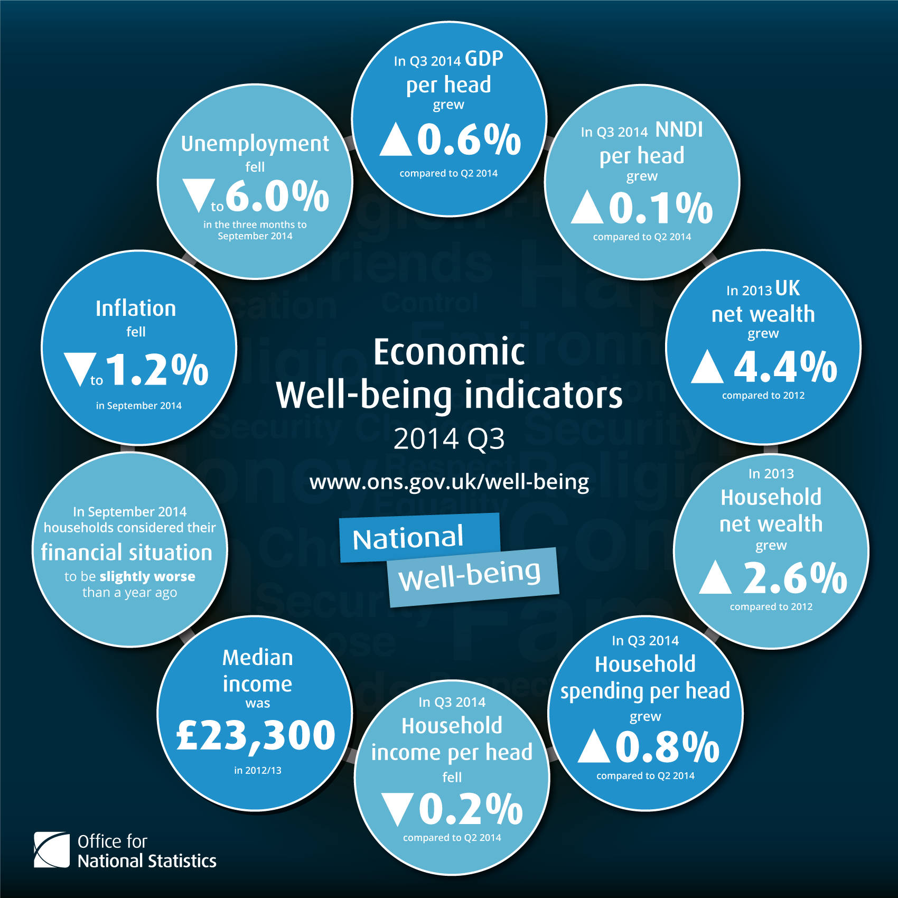
Indicators of Economic Well-Being
Why despite a period of healthy recovery are so many people worse off than at the start of the last recession? This selection of charts helps to provide the answer.
According to the Office for National Statistics:
In the 3rd quarter of 2014, UK GDP per head increased 0.6% compared to Q2 2014 but remains 1.8% below pre-economic downturn levels. This was a slightly slower growth rate than the 0.7% quarterly increase seen in GDP.
Net National Disposable Income (NNDI) per head, which represents the income for UK residents, has remained broadly flat since Q1 2012 and remains 5.6% below pre-economic downturn levels.

Economic Growth - Advanced Nations
Developed countries include all 28 members of the European Union (including newly acceded members that are regarded as "transition economies"), other non-EU western European countries and territories (including Switzerland, Norway, Iceland, etc.) The group also includes the United States, Canada, Japan, Australia, New Zealand and South Korea – now a member of the OECD (which is the group of leading advanced economies
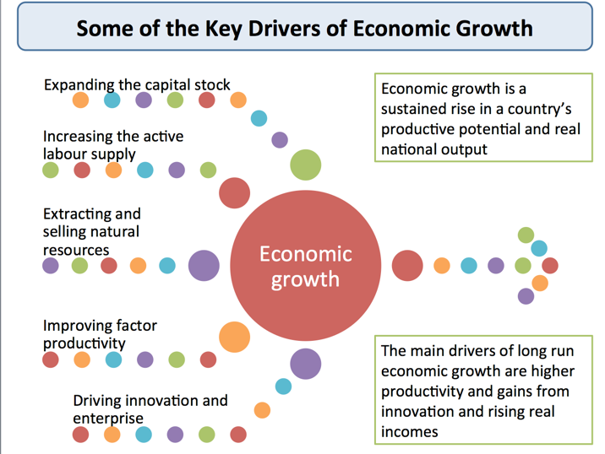
Some drivers of economic growth
Why is economic growth so weak in many advanced countries?
- Secular stagnation theory
  - Some economists argue that developed countries are experiencing a sustained period of slower trend GDP growth caused by
  - Weaker productivity growth
  - A dip in the pace of innovation in markets
  - The effects of an ageing population / rising dependency ratio
- Global shifts in investment and production to emerging nations
- The debilitating effects of the global financial crisis including a shrinking of finance available for business investment
- Persistently high unemployment in many advanced countries
- The negative effects of fiscal austerity policies especially in the EU/UK
- Damaging effects of deflation in countries such as Japan
- Weaker growth has brought about stagnant or declining real incomes
- Growth in developed countries may have been hit the the effects of rising inequalities of income and wealth
Economic recession and weak growth in the Euro Area
What factors have contributed to persistent recession in the Euro Area?
- Continued fall out from the global financial crisis
  - Contractions in bank lending, many banks required bailouts / nationalization
  - Sharp falls in real output and investment in industries such as construction
  - Large declines in business confidence and investment
  - Decline in property prices – asset price deflation
- Labour market failures
  - High rates of structural unemployment and economic inactivity
  - Low employment rates in many EU countries especially in southern Europe
  - Low levels of labour mobility compared to the United States
- High exchange rate
  - The Euro (a floating currency) has remained fairly strong against the US dollar and other currencies despite the economic crisis (perhaps overvalued?)
  - Fiscal crisis and resulting fiscal austerity programmes
- Increase in relative poverty – causing steep declines in consumption
- Policy inertia on behalf of the European Central Bank
  - Reluctance to move beyond low interest rates
  - Programme of quantitative easing only introduced in January 2015

The other debt and the other deficit
This is a timely and excellent article from Duncan Weldon (BBC Newsnight) for student macroeconomists on two deficits that seem to get far less media attention than the government's fiscal deficit.
The first one of the huge level of household debt relative to incomes. This rose during the boom years and has remained stubbornly high despite the early stages of economic recovery. Higher personal debt - much of it linked to the housing market - is a threat to the UK, especially if interest rates start rising again or the economy falls back into another slowdown. Stagnant or falling real wages is making it tough for millions of people to repay their debts.
The second deficit focuses on the UK balance of payments. At the end of 2014, the UK is running a current account deficit of more than 5% of GDP. The country is not paying its way economically and hopes of an export-driven recovery appear to have fallen flat. As Duncan Weldon argues
"There is nothing especially virtuous about a current account surplus and nothing especially vice-like about running a current account deficit. If we want to live in a globalised world then goods, services and investment flows will cross borders and some countries will have a positive balance and some a negative one. But large and persistent deficits can cause a problem. (As in a different way can large and persistent surpluses!)."
Go back over your balance of payments notes and think about why a 5% external deficit really does matter for the UK economy at this stage of the economic recovery / cycle.
Read the article here: https://medium.com/@DuncanWeldon/the-other-debt-and-the-other-deficit-78c44f7234ef

Aspects of the Economic Cycle - Revision Presentation

http://www.slideshare.net/tutor2u/as-macro-revision-aspects-of-the-economic-cycle?ref=http://beta.tutor2u.net/economics/reference/aspects-of-the-economic-cycle-revision-presentation

Economic Growth & Development - Revision Quiz

The links between economic growth and development are explored by these revision MCQs.

http://beta.tutor2u.net/economics/reference/economic-growth-development-revision-quiz-1

Economic Growth - Revision Quiz

These revision MCQs are on the core topic of economic growth

http://beta.tutor2u.net/economics/reference/economic-growth-revision-quiz-1

Measuring Development - Key Indicators

There are many indicators to consider when taking a broad look at the process of economic development:
- Risk of extreme poverty - % of the population living on less than $1.25 per day (measured at PPP)
- Percentage of adult male and female labour in agriculture, % of arable land that is cultivated
- Combined primary/secondary school enrolment figures and other indicators of progress in building human capital. The 1990 HDR started with this phrase: “People are the real wealth of a nation.”
- Access to clean water / improved sanitation facilities
- Energy consumption per capita / depth of hunger, incidence of malnutrition
- Fertility rates, natural rate of growth of population
- Prevalence of HIV, average life expectancy at birth, years of healthy life expectancy, child mortality
- Access to mobile cellular phone services, access to bank accounts, insurance
- Dependence of a country on foreign aid / levels of external debt
- Availability of /scope of social support programmes through welfare programmes
- Unemployment rates and vulnerable employment rates, % of female population in paid work
- High-technology exports (% of manufactured exports), patterns of exports
- Degree of primary export dependence
- Changes in the published value of the Human Development Index (HDI)
- Progress in improving outcomes using the Multi-Dimensional Poverty Index(MDPI)
- Progress in achieving the stated Millennium Development Goals (MDGs)

The output gap: how much economic potential has been lost?
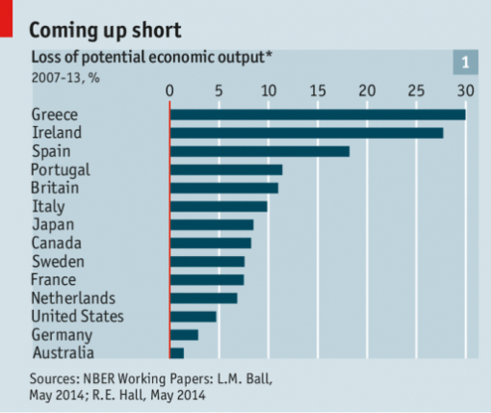
An interesting piece in the Economist about the current state of the output gap – the difference between an economy’s actual output and its potential output.
Paul Ormerod argues that this value is almost impossible to estimate, so it is a pretty useless concept. Others think trying to estimate the size of the gap is valid, and knowing how much spare capacity the economy has could be a crucial guide to economic policy makers.
What are the thoughts of economists who have been looking at recent OECD data?
According to the article, later this year British output should regain the level it reached in early 2008. Yet relative to what was expected of it pre-crisis, it will therefore be producing far less than once seemed possible. This is a worrying thought, but it wouldn’t be too bad if you optimistically assumed that as thispotential output could spring back into life once the economy picks up speed again. A big output gap should mean the economy can go through a massive phase of expansion before ‘running out’ of spare AS, triggering inflation.
But economists very often aren’t so optimistic. Since early in the recession they have fretted that it might leave permanent scars. A long slump can lead to low levels of investment, leaving economies ill-equipped to grow in future. Labour markets can suffer from hysteresis, in which short-term joblessness leads to higher long-run unemployment as workers’ skills, motivation and connections erode. In other words, there might not actually be much spare economic potential if it has withered away.
Each year the OECD releases an economic outlook which includes estimates of members’ potential economic output: the highest level of production each economy could feasibly sustain without igniting inflation. This is calculated based on long-run trends in investment, labour-force growth and the productivity of workers and capital; more of each means an economy boasts a greater economic capacity.
Before the crisis some economies were operating a bit above their true potential, thanks to unsustainable credit growth. Yet in the tumult that followed, the rich world gave back that ground and much more. A few rich countries, like Australia and Switzerland, came through the past seven years largely unharmed (see graph above). Yet Britain took a huge hit – and by 2015 the weighted average loss among rich countries as a whole is projected to reach 8.4%—as if the entire German economy had evaporated. According to the article, the figures suggest that many economies, in Europe especially, have suffered structural damage that can be fixed only with ambitious reform and booming investment.
There’s more you can read about precisely where this potential has been lost; with four main contributors to disappointing growth: unemployment, labour-force participation, capital investment and productivity.

The ‘output gap’: another piece of economic mumbo-jumbo
The concept of the 'output gap’ is central to mainstream macroeconomics. It is not merely of academic interest.
The Office for Budget Responsibility (OBR) has a specific requirement to estimate the output gap, which it defines formally as “the difference between the current level of activity in the economy and the potential level it could sustain while keeping inflation stable”.
The output gap is a key consideration for central banks around the world including the Bank of England. If output is well below its potential, nominal interest rates should be kept low, to try to stimulate the economy. And a large output gap should keep cost and price inflation low. Prices are hard to put up in a depressed economy.
See: http://www.bbc.co.uk/news/business-23145755 for a discussion of the changes made to the policy of forward guidance.
The task of estimating the output gap empirically is fraught with difficulties. The OBR points that there are at least three recognised ways of doing this, none of which will make sense to anyone lacking an advanced training in statistics. So there is plenty of scope for disagreement amongst orthodox economists who believe in the concept.
Yet rather like the medieval debates about how many angels could dance on a pin, these disputes have little meaning in the economy of the 21st century.
The economy is not a physical object and cannot, say, be placed on a pair of scales and weighed.
GDP has to be estimated, using a wide range of information. The basic principles of how to measure output were worked out in the 1930s and 1940s. A major problem is that these principles are much more suited to an economy which, as it was at that time, is dominated by the production of goods rather than services.
We can count how many Ford Model Ts have been built. It is much less clear what the outputs of Google or Facebook are.
The problems are even more acute with the concept of potential output. Many internet-based services incur substantial fixed costs in order to have just a single customer.
But the additional cost of servicing the second customer, and all subsequent ones, is effectively zero. Potential output does not have much meaning in these contexts, it is not obvious what the limit might be.
A powerful blow against the concept of potential output has been published in the latest edition of the American Economic Association’s journal Applied Economics. Igal Hendel and Yossi Speigel document the evolution of productivity over a 12 year period in a steel mini-mill producing an unchanged product, working 24/7.
The steel melt shop is almost the Platonic ideal from a national accounts perspective of output measurement. The product – steel billets - is a simple, homogenous, internationally traded product. There was virtually no turnover in the labour force, very little new investment, and the mill worked every hour of the year.
Yet despite production conditions which were almost unchanged, output doubled over the 12 year period.
As the authors note, rather drily, “the findings suggest that capacity is not well defined, even in batch-oriented manufacturing”. Time to put the concept of potential output into the rubbish bin!
Paul Ormerod is an economist at Volterra Partners LLP, a Visiting Professor at the UCL Centre for Decision Making Uncertainty, and author of Positive Linking: How Networks Can Revolutionise the World
http://www.bbc.co.uk/news/uk-politics-26629587
Read this article relating to the output gap from the Wall Street Journal: http://blogs.wsj.com/moneybeat/2014/03/20/looming-..

July 2014 - UK Economy back to Pre Crisis Level
An important landmark for the UK economy? Britain’s economy is finally larger than it was before the financial crisis six years ago. FT economics editor Chris Giles analyses the data and warns that continuing weak productivity means output growth will be slower than before the crisis - an excellent analysis of the key macro indicators suitable for all A level economics students.
I have added some charts on the UK drawn from the latest IMF world economic outlook.
Chris Giles on the performance of the UK economy
https://www.youtube.com/watch?v=qSiNN7ByG5k
Data on the UK economy from the IMF world economic outlook
Suggestions for further reading
Robert Peston - farewell to the mother of all recessions (BBC): http://www.bbc.co.uk/news/business-28480145
Guardian: Martin Rowson on George Osborne's GDP victory – cartoon - http://www.theguardian.com/commentisfree/cartoon/2...
GDP isn’t everything. This is six years of stagnation, not recovery (Guardian) - http://www.theguardian.com/commentisfree/2014/jul/...
The British economic recovery in 13 charts (Financial Times) - http://ftalphaville.ft.com/2014/07/25/1908192/the-...

Macroeconomics - Why has the UK recovered so fast?
Just in time for the unit 2 exam, and in good time for unit 4 students, this week's Deloitte Monday Briefing looks at the reasons behind the rapid recovery of growth in the UK. The Monday Briefing always makes very good reading, and often features analysis which is written with great clarity by Ian Stewart, their Chief Economist in the UK - to subscribe and receive an email every week, visitwww.deloitte.co.uk/mondaybriefing
Below, I have copied much of this week's briefing with a little additional comment to emphasise the role of monetary and fiscal policies, and to look forward in order to consider how these may be evaluated in order to assess the contribution they may make in the near future.
Deloitte Monday Briefing: What Caused the UK Recovery
Background
* On average, economists expect the UK economy to grow by around 3.0% in 2014, almost twice what was expected a year ago. Why has the UK economy bounced back so rapidly?
1. Monetary Policy
* Probably the biggest factor is that low interest rates, Quantitative Easing and cheap money policies have finally fed through to the economy. There has been a longer-than-usual time lag, due to massive lack of confidence, and to ‘dislocation in the financial system and elevated perceptions of risk’ but it is now working.
* Here is the evidence: Over the last year, credit availability has improved for all sizes of businesses, mortgage lending has risen by 25% and consumer credit has started to recover. Easier credit conditions have helped fuel recoveries in car sales and in the housing market. The fact that the Bank of England policymakers are worrying aloud about the housing market shows that, in some respects, monetary policy may be too loose.
Looking ahead:- might this sudden release of pent-up consumer demand lead to demand-pull inflation?
* For most of the last four years earnings have lagged behind (cost-push) inflation, squeezing consumer spending power. The severity of that squeeze has eased in the last two years as inflation has fallen. Consumers have started to spend and, lower inflation, together with rising consumer borrowing and windfall gains from payment protection compensation, have provided the fuel.
2. Fiscal policy
* Just over a year ago the International Monetary Fund warned that the government's programme of cuts in public spending was "playing with fire" and risked a third recession. The austerity has continued, yet growth has returned.
* This falls short of complete victory for austerity. As Keynesian critics of the Chancellor's policies point out, the economy has been helped by an easing of the fiscal squeeze in the last year. Still, recovery has come even as the government has stuck to a recognisable programme of austerity.
Looking ahead:- cuts in government spending will only really start to kick in this year, and are planned to accelerate over the next few years. Will the effects of this dent growing confidence for both consumers and businesses, and hold back growth, or will the reduction in injections from government spending simply help to cushion fast-growing consumption and investment?
3. External factors
* The end of the acute phase of the euro crisis has also played a part in the recovery. A declining risk of a break-up of the euro area has reduced a major source of uncertainty and bolstered financial markets and business confidence in the UK.
Summary:
* Cheap money, lower inflation, improving prospects in Europe have helped drive Britain's recovery. Austerity has not proved as great a drag on growth as some feared. Recovery is taking root, so much so that policymakers are mulling when and how to intervene to calm things down. Investment and consumer incomes seem close to a turning point, offering the prospect of broader-based growth to come. Markets are worrying less about UK growth. Speculation about the timing and means of monetary tightening are likely to move centre stage.

2014 and the economy recovers - what happens then?
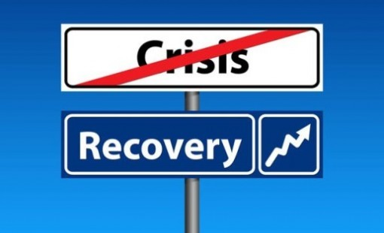
I hope I'm right about this, but there should be plenty of blogs in 2014 on the impact of any economic recovery on inflation, unemployment, trade and so on. At this stage, even the idea of an economic recovery might seem a bit optimistic (Paul Ormerod looks back over 2008-2013 here). After all, we're only talking about theeconomy getting back to where it was in 2008, in GDP terms.
In fact, the economy might be bouncing back far more strongly than was expected. How the economy behaves - and how policy makers will respond - depends crucially on the size of the economy's output gap. This is such a crucial indicator it appears as the 2nd slide in these key charts on the UK economic cycle.
The key issue to grasp is how much 'slack', or spare capacity does the UK economy have? If there's plenty, then the economy can roar back into life, without worrying too much about shortages in supply creating inflationary pressures. If - on the other hand - the economy has been badly disabled by the recession (an effect known ashysteresis) even modest growth will soon run up against bottlenecks, buffers and obstacles. You can follow the arguments here.
One problem is the huge array of unknowns. The Bank of England has indicated that it will consider tightening monetary policy when unemployment falls back below 7%. That's one measure it's using to judge how much slack the economy has. It's an imprecise measure of an unknown quantity. And the speed with which unemployment has fallen seems to have surprised the Bank.
Here's hoping for more nice surprises like that in 2014.

Labour Market - Real Wages

30th January 2015
Real income measures the purchasing power of a given amount of nominal (money) income – i.e. nominal income adjusted for inflation
In recent years, the annual growth of earnings for people in work has been less than inflation – causing real incomes to fall
Why have real wages in the UK labour market been falling?
Real wages have been falling because the annual rate of change of wages / earnings from jobs has been slower than the increase in consumer prices
Some reasons for slow wage growth:
- Tough pay restraint in the public sector e.g. NHS workers have seen as 10% decline in real wages since the start of the recession
- Many private sector businesses have introduced pay freezes (and in some cases, pay cuts) as an alternative to bigger job cuts during the recession
- Trade union bargaining power has been hit by economic problems at home and forces of globalisation
- For much of the last five years, consumer price inflation has been above the 2% target measure, not least because of big increases in fuel and energy prices.
- Labour productivity has been disappointing – businesses find it harder to fund wage rises if output per person employed is flat
According to the Office for National Statistics: Nominal wage growth below the rate of price inflation has resulted in real wages in the United Kingdom falling for the longest sustained period since at least 1964.
A series of tax rises has also added to the decline in real disposable incomes for millions of households.
What are the consequences of a fall in GDP per head?
- Average living standards decline (falling per capita incomes)
- More workers need a second job to supplement their incomes – now more than 1 million people with second jobs
- Less consumer demand for goods & services
- Reduced incomes per capita may cause GDP growth to remain slow – making the recovery more fragile
- Lower incomes and low net savings makes many more people reliant on (expensive) consumer debt e.g. pay day loans
- Becomes much harder for people to reduce the debts accumulated during the growth years including mortgages
- The government receives lower-than-expected tax revenues – making it a lot harder to reduce the fiscal deficit

Market Failure - Income and Wealth Inequality
In a market economy an individual's ability to consume goods & services depends upon his/her income or other resources such as savings
An unequal distribution of income and wealth may result in an unsatisfactory allocation of resources and can also lead to alienation and encourage crime with negative consequences for the rest of society
The free-market system will not always respond to the needs and wants of people with insufficient economic votes to have any impact on market demand. What matters in a market based system is your effective demand for goods and services.
When we are discussing inequality and poverty, we make value judgements i.e. normative views about what is an acceptable scale of inequality and what is not
Absolute poverty
- Absolute poverty measures the number of people living below a certain income threshold or the number of households unable to afford certain basic goods and services
- What we choose to include in a basic acceptable standard of living is naturally open to discussion.
Relative poverty
- Relative poverty measures the extent to which a household's financial resources falls below an average income level.
- Although living standards and real incomes have grown because of higher employment and sustained growth, Britain has become a more unequal society over the last 30 years
Poorer families have a lower life expectancy
People from poorer backgrounds are unhealthier and die earlier than the rich, according a study measuring the link between health and wealth. Poorer people in their fifties were 10 times more likely to die earlier than those who are richer, according to a report from the Institute of Fiscal Studies (IFS). The poor often have to stop work early due to ill health, the group added and this increases the risk of these groups suffering income poverty during their retirement years.
Source: BBC news and Institute for Fiscal Studies
The most commonly used threshold of low income in Britain is 60% of median household income after deducting housing costs.
Another way of showing this income data is in the table below – this shows the distribution of disposable income by household income quintile. The data is for 2009.
 | Bottom Fifth | Next Fifth | Middle Fifth | Next Fifth | Top Fifth
% share of disposable income | 7 | 12 | 16 | 22 | 42

5 Reasons for Slow Economic Growth
Nobel Laureate Michael Spence identifies five factors that are dampening growth across many countries.
He argues that governments have under-utilised the growth-enhancing effects of public sector infrastructure investment. And he points to widening inequality as a major drag on growth. You probably won't read anything new in this article, but it is worth a look at for the clarity of expression from a noted economist.
Read more: Five Reasons for Slow Growth (Project Syndicate)

A remarkable pattern has emerged since the 2008 global financial crisis: Governments, central banks, and international financial institutions have consistently had to revise their growth forecasts downward. With very few exceptions, this has been true of projections for the global economy and individual countries alike.
It is a pattern that has caused real damage, because overoptimistic forecasts delay measures that are needed to boost growth, and thus impede full economic recovery. Forecasters need to come to terms with what has gone wrong; fortunately, as the post-crisis experience lengthens, some of the missing pieces are coming into clear focus. I have identified five.
First, the capacity for fiscal intervention – at least among developed economies – has been underutilized. As former United States Deputy Secretary of the Treasury Frank Newman argued in a recent book, Freedom from National Debt, a country’s capacity for fiscal intervention is better assessed by examining its aggregate balance sheet than by the traditional method of comparing its debt (a liability) to its GDP (a flow).
Reliance on the traditional method has resulted in missed opportunities, particularly given that productive public-sector investment can more than pay for itself. Investments in infrastructure, education, and technology help drive long-term growth. They increase competitiveness, facilitate innovation, and boost private-sector returns, generating growth and employment. It does not take a lot of growth to offset even substantial investment – especially given current low borrowing costs.
Research by the International Monetary Fund has indicated that these fiscal multipliers – the second factor overlooked by forecasters – vary with underlying economic conditions. In economies with excess capacity (including human capital) and a high degree of structural flexibility, the multipliers are greater than once thought.
In the US, for instance, structural flexibility contributed to economic recovery and helped the country adapt to long-term technological changes and global market forces. In Europe, by contrast, structural change faces resistance. Fiscal stimulus in Europe may still be justified, but structural rigidity will lower its impact on long-term growth. Europe’s fiscal interventions would be easier to justify if they were accompanied by microeconomic reforms targeted at increasing flexibility.
A third piece of the forecast puzzle is the disparity between the behavior of financial markets and that of the real economy. Judged only by asset prices, one would have to conclude that growth is booming. Obviously, it is not.
A major contributor to this divergence has been ultra-loose monetary policy, which, by flooding financial markets with liquidity, was supposed to boost growth. But it remains unclear whether elevated asset prices are supporting aggregate demand or mainly shifting the distribution of wealth. It is equally unclear what will happen to asset prices when monetary assistance is withdrawn.
A fourth factor is the quality of government. In recent years, there has been no shortage of examples of governments abusing their powers to favor the ruling elite, their supporters, and a variety of special interests, with detrimental effects on regulation, public investment, the delivery of services, and growth. It is critically important that public services, public investment, and public policy are well managed. Countries that attract and motivate skilled public managers outperform their peers.
Finally, and most important, the magnitude and duration of the drop in aggregate demand has been greater than expected, partly because employment and median incomes have been lagging behind growth. This phenomenon preceded the crisis, and high levels of household debt have exacerbated its impact in the aftermath. The stagnation of incomes in the bottom 75% of the distribution presents an especially large challenge, because it depresses consumption, undermines social cohesion (and thus political stability and effectiveness), and decreases intergenerational mobility – especially where public education is poor.
Sometimes change occurs at a pace that outstrips the capacity of individuals and systems to respond. This appears to be one of those times. Labor markets have been knocked out of equilibrium as new technology and shifting global supply chains have caused demand in the labor market to change faster than supply can adjust.
This is not a permanent condition, but the transition will be long and complex. The same forces that are dramatically increasing the world economy’s productive potential are largely responsible for the adverse trends in income distribution. Digital technology and capital have eliminated middle-income jobs or moved them offshore, generating an excess supply of labor that has contributed to income stagnation precisely in that range.
A more muscular response will require an awareness of the nature of the challenge and a willingness to meet it by investing heavily in key areas – particularly education, health care, and infrastructure. It must be recognized that this is a difficult moment and countries must mobilize their resources to help their people with the transition.
That will mean redistributing income and ensuring access to essential basic services. If countering inequality and promoting intergenerational opportunity introduces some marginal inefficiencies and blunts some incentives, it is more than worth the price. Public provision of critical basic services like education or health care may never be as efficient as private-sector alternatives; but where efficiency entails exclusion and inequality of opportunity, public provision is not a mistake.
One hopes that a growing awareness of the significance of these and other factors will have a positive effect on policy agendas in the coming year.

Accelerator Effect
The accelerator effect is when an increase in national income results in a proportionately larger rise in investment
Consider an industry where demand is rising at a strong pace.
Firms will respond to growing demand by expanding production and making fuller use of their existing productive capacity. They may also choose to meet higher demand by running down their stocks of finished products.
At some point – and if they feel that the higher level of demand will be sustained – they may choose to increase spending on capital goods such as plant and machinery, factories and new technology in order to increase their capacity. If this investment goes beyond what is needed simply to replace worn out, fully depreciated machinery, then the capital stock of the business will become larger.
In this sense, the demand for capital goods is being driven by the demand for the products that the firm is supplying to the market. This gives rise to the accelerator effect - the principle states that a given change in demand for consumer goods will cause a greater percentage change in demand for capital goods.
A good example might be the surge in capital investment in wind turbines due to the super-high level of oil and gas prices and a rising market demand for renewable energy. In this case, strong demand created a positive accelerator effect. But this can also go into reverse e.g. during an economic slowdown or recession. World oil prices have collapsed and many wind farm projects have been scaled back or postponed.
The Capital Output Ratio
- The accelerator model works on the basis of a fixed capital to output ratio
- For example if demand in a given year rises by £4 million and each extra £1 of output requires an average of £3 of capital inputs to produce this output, then the net level of investment required will be £12 million.
One criticism of this simple accelerator model is that the capital stock of a business can rarely be adjusted immediately to its desired level because of ‘adjustment costs’ and ‘time lags’. The adjustment costs include the cost of lost business due to installation of new equipment or the financial cost of re-training workers. Firms will usually make progress towards achieving an optimum capital stock rather than moving smoothly from one optimal size of plant and machinery to another.
A further criticism of the basic accelerator model is that it ignores the spare capacity that a business might have at their disposal and also their ability to outsource production to other businesses to meet a short term rise in demand.
The accelerator principle is used to help explain business cycles. The accelerator theory suggests that the level of net investment will be determined by the rate of change of national income. If national income is growing at an increasing rate then net investment will also grow, but when the rate of growth slows net investment will fall. There will then be an interaction between the multiplier and the accelerator that may cause larger fluctuations in the trade cycle.
The accelerator effect will tend to be high when
- The rate change of consumer income and spending is strongly positive
- The amount of spare productive capacity for businesses is low
- The available supply of investment funds is high

Economic Cycle
All countries experience regular ups and downs in the growth of output, jobs, income and spending.
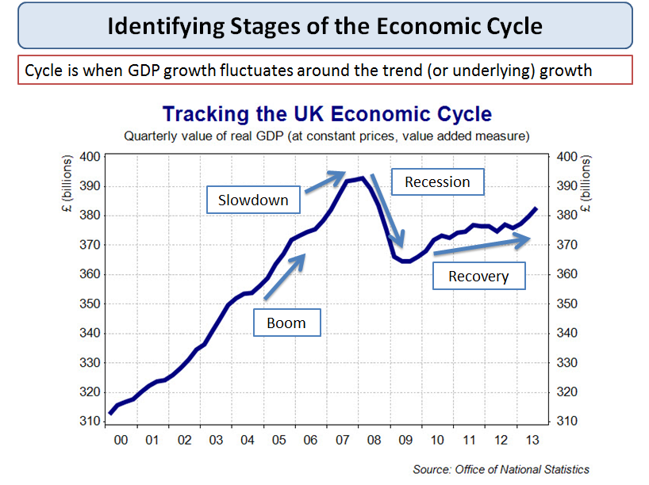
UK economic cycle
Boom
- A boom occurs when real national output is rising at a rate faster than the trend rate of growth. Some of the characteristics of a boom include:
- A fast growth of consumption helped by rising real incomes, strong confidence and a surge in house prices and share prices
- A pick up in demand for capital goods as businesses invest in extra capacity to meet strong demand and to make higher profits
- More jobs created and falling unemployment and higher real wages
- High demand for imports which may cause the economy to run a larger trade deficit because it cannot supply all of the goods and services that consumers are buying
- Government tax revenues will be rising as people earn and spend more and companies are making larger profits – this gives the government money to increase spending in areas such as education, the environment, health and transport
- An increase in inflationary pressures if the economy overheats and has a positive output gap
Slowdown
- A slowdown occurs when the rate of growth decelerates – but national output is still rising
- If the economy grows without falling into recession, this is called a soft-landing
Recession
A recession means a fall in the level of real national output i.e. a period when growth is negative, leading to a contraction in employment, incomes and profits.
A simple definition:
- A fall in real GDP for two consecutive quarters i.e. six months
A more detailed definition:
- A recession is a significant decline in economic activity spread across the economy, lasting more than a few months, normally visible in real GDP, real income, employment, industrial production, and retail sales.
There are many symptoms of a recession – here is a selection of key indicators:
- A fall in purchases of components and raw materials (i.e. intermediate products)
- Rising unemployment and fewer job vacancies available for people looking for work
- A rise in the number of business failures and businesses announcing lower profits and investment
- A decline in consumer and business confidence
- A contraction in consumer spending & a rise in the percentage of income saved
- A drop in the value of exports and imports of goods and services
- Large price discounts offered by businesses in a bid to sell their excess stocks
- Heavy de-stocking as businesses look to cut back when demand is weak – causes lower output
- Government tax revenues are falling and welfare benefit spending is rising
- The budget (fiscal) deficit is rising quickly
The difference between a recession and a depression
- A slump or a depression is a prolonged and deep recession leading to a significant fall in output and average living standards
- A depression is where real GDP falls by more than 10% from the peak of the cycle to the trough
- An example of a country that has suffered a depression in recent years isGreece. National output has fallen in six successive years and real GDP is more than 25% lower than at the peak of the cycle
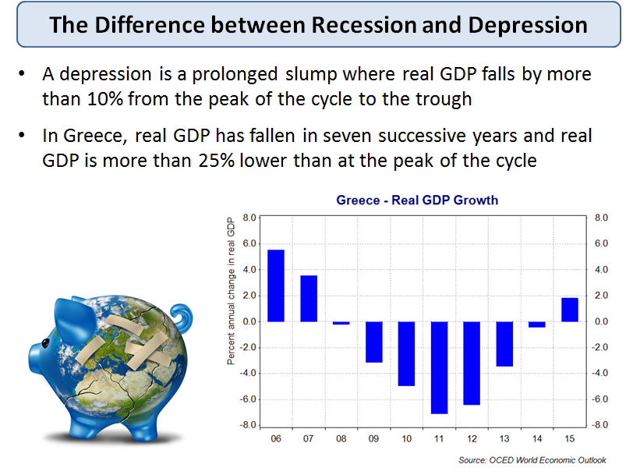
Recession and depression
Recovery
- This occurs when real GDP picks up from the trough reached at the low point of the recession.
- The state of business confidence plays a key role here. Any recovery might be subdued if businesses anticipate that it will be temporary or weak in scale.
- A recovery might follow a deliberate attempt to stimulate demand. In the UK we have seen
1.Cuts in interest rates – the policy interest rate fell to 0.5% in the Autumn of 2008 and they have stayed at this low level since then
2.A rise in government borrowing
3.A policy of quantitative easing (QE) by the Bank of England to pump more money into the banking system in a bid to increase the supply of loans – now worth more than £375 billion.
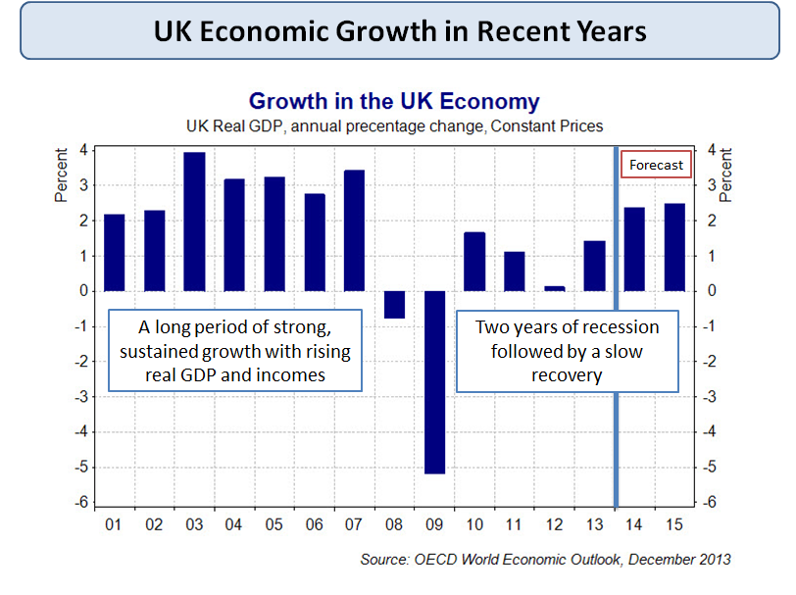
UK economic growth in recent years
Why is GDP growth difficult to forecast?
When economists make forecasts about the future path for an economy they have to accept the inevitability of forecast errors. No macroeconomic model can hope to cope with the fluctuations and volatility of indicators such as inflation, exchange rates and global commodity prices.
- Uncertain business confidence levels
- Fluctuations in exchange rate
- External events e.g. volatile oil and gas prices
- Uncertain reactions to macro policy changes
- Rate of business job creation hard to forecast

Capital Investment
Investment is spending on capital goods such as new factories & other buildings machinery & vehicles
- Much investment include and takes advantages of advances in technology
- Investment is a component of AD, and is a factor affecting competitiveness in a globalising world
- In market-based economies, most investment is done by private sector businesses but a substantial amount comes from the government (in the state sector)
- A broader definition of investment includes spending on improving the human capital of the workforce through training and education to improve the skills and competences of workers
Infrastructure is spending on new sewers, roads, wind farms, telecommunications networks and ports – this is done by both the private and the public sector. Examples of infrastructure investment projects in the UK include:
- 2nd Forth Road Bridge
- Argyll wind farm array
- Cross Rail
- High Speed Rail project (flagship transport project – not yet started)
- Exeter flood defence scheme
- London Gateway Port
- Network Rail’s £28bn infrastructure plan for the UK rail network
- London’s new super sewer
- Nuclear power plants e.g. the proposed one at Hinkley Point
- £589m Mersey Gateway Bridge
- Heathrow Terminal 2 upgrade
- Gwynt y Môr offshore windfarm
Gross and Net Investment
Gross Investment pending is the total amount that the economy spends on new capital. But this figure includes an estimate for the value of capital depreciationsince some investment is needed each year just to replace technologically obsolete or worn-out plant and machinery.
If gross investment is higher than depreciation, then net investment will be positive and this means that businesses will have a higher productive capacity and can meet rising demand in the future
Gross investment – capital depreciation = net investment
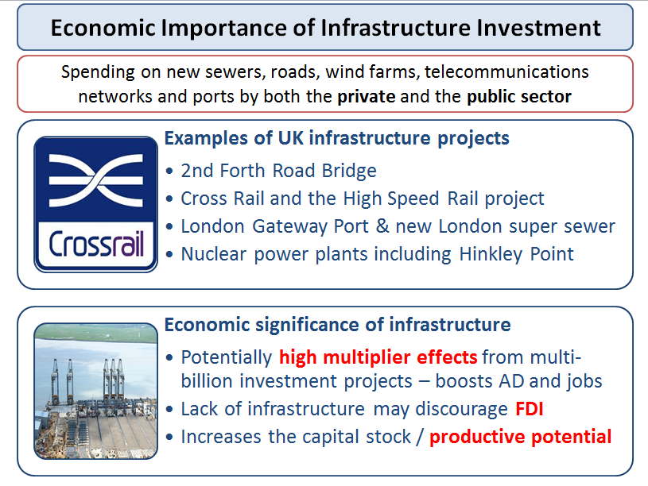
Infrastructure Investment
Investment and Aggregate Demand
- Investment is a component of AD i.e. (C+I+G+X-M). Businesses involved in developing, manufacturing, testing, distributing and marketing the capital goods themselves stand to benefit from increased orders for new plant and machinery.
A rise in capital spending will have a positive multiplier effect Increased spending on capital goods boosts demand for industries that manufacture the technology / hardware / construction sector
Investment and jobs
- Some investment projects cost people their jobs when a business replaces labour with capital inputs.
- Investment creates jobs in producing, designing and installing plant and equipment
Quality of investment
- A high level of investment on its own may not be sufficient to create an increase in LRAS since workers need training to work the new machinery and there will betime lags between new capital spending and the effects on output and productivity.
- If there is insufficient demand, a growing capital stock may lead to excess capacity putting downward pressure on prices and profits
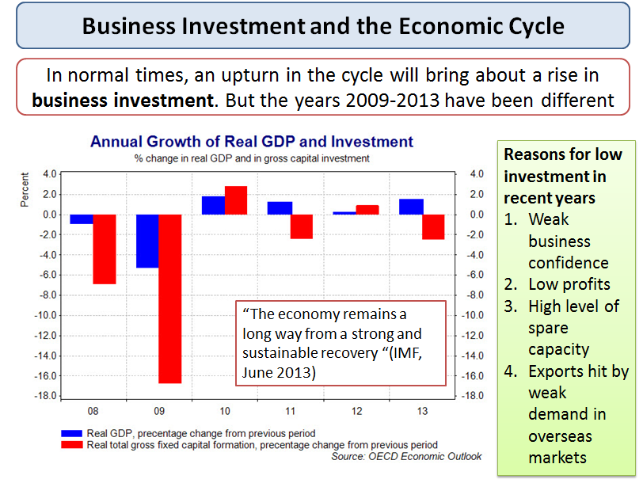
Investment spending and the economic cycle
Key factors affecting capital investment spending
What are the main factors that affect how much businesses can commit to investment projects?
1.Interest rates – which affect the cost of capital
- If the rate of interest increases, the cost of funding investment increases, lowering the expected rate of return on a capital project
- Higher interest rates also raise the opportunity cost of using profits to finance investment – i.e. a business might decide that they can earn a better return by simply investing the cash
2.Risk: Committing money to a project involves taking a risk for no business can be certain that a given project will succeed and bring about a profit. When risk and uncertainty is high for example during times of volatility then business investment spending may fall
3.The rate of growth of market demand: Investment tends to be stronger when consumer spending is rising. Higher expected sales also increase potential profits – in other words, the price mechanism should allocate extra funds and factor inputs towards capital goods into those markets where consumer demand is rising.
4.Corporate taxes
- Corporation tax is paid depending on the level of business profits. If the government reduces the rate of corporation tax there is a greater incentive to invest.
- The main rate of corporation tax in the UK has been reduced from 28% in 2010 to 21% in 2015
- The Small Profits Corporation Tax Rate can be claimed by qualifying companies with profits at a rate not exceeding £300,000 per year. This tax rate has come down from 21% to 20%
- The government may also change the level of tax allowances e.g. the incentives for businesses to offset their investment spending against future tax bills
- Regulations can also affect planned investment. For example laws on carbon emissions might affect investment and innovation in the transport industry. The price of carbon emissions in the EU trading system might influence investment by businesses looking to cut their emissions and make significant progress towards low carbon production
5. Technological change and degree of market competition: In markets where technological change is rapid, companies may have to invest simply to remain competitive. A good example is the intense competition in the markets for smart-phones.
6. Business confidence: During a downturn many businesses may postpone investment because they feel that demand will not be high enough to give them the rate of profit they need. The Keynesian term for business confidence is animal spirits.
7. Social costs and benefits: In the public (government) sector, a different set of criteria may be used. Typically local and central government will use cost-benefit analysis when assessing the likely economic and social effects of investment; this is often used for infrastructure projects.
Research and Development Spending (R&D)
- In 2011 UK gross expenditure on R&D was £27.4 billion
- £17.4 billion (63.6%) of this was business investment
- £9.4 billion (34.6%) was government investment
- £0.5 billion (1.9%) was from private non-profit organisations
- UK R&D spending as a proportion of GDP was 1.79%, slightly below the EU average of 2.03%.

Household Saving
Saving is a decision by people to postpone their consumption
- Saving is disposable income that is not spent
- There are many ways in which money can be saved ranging from accounts in bank and building society accounts to savings in pensions and the stock market
- The savings ratio is the % of disposable income saved rather than spent e.g. if a person has an annual income of £25,000 and saves £2500 of this, then the savings ratio is 10%
- A high savings ratio (other factors remaining equal) lowers consumption and aggregate demand
What factors affect how much of their income people save?
- Real interest rate on savings deposits – i.e. the return on savings adjusted for inflation
- Expectations of future income and job security / all linked to consumer confidence
- Availability of credit – borrowing to finance extra spending counts as dis-saving
- Taxation of saving e.g. tax efficient savings schemes and tax relief on occupational pensions such may encourage people to put away more of their disposable income
- The need to save to repay debt – e.g. property owners stuck in negative equity where their house is worth less than their mortgage debt or families that need to cut their debts on credit cards
- A need to save to build up a deposit for a mortgage, pay school and university fees, and save for retirement in an occupational pension scheme
- The availability of savings institutions such as banks and our trust in those institutions. The UK government guarantees deposits in UK banks but in other countries including Cyprus in 2013, large-scale depositors were hit by an unexpected tax as part of the Cyprus emergency bail-out.
Evaluating the importance of saving for an economy
Decisions by people and by businesses about how much to save have a powerful effect on economic performance – here are some reasons:
- Corporate savings provide a cushion during a recession when demand and profits fall. Business savings can be used as finance for takeovers and for capital investment projects
- Savings by families flow into financial institutions
  - Banks need deposits as capital from which they can lend. Many small businesses have complained about the difficulty in getting loans in the aftermath of the global financial crisis
  - Savings flow into pension funds – these can be reinvested in stock markets providing funds for businesses that need to raise capital to finance expansion plans.
- Savings provide a source of household wealth and a buffer against uncertain times allowing people to smooth out their consumption when times are tough. They allow people to reduce debts and save to allow a reasonable standard of living during retirement.
The Paradox of Thrift
- The paradox of thrift is an important idea from Keynesian economics. Saving is regarded as positive because it provides the funds to finance the capital investment needed to promote long-term growth
- But if many people start saving more at the same time, this causes a drop in consumer demand and an even deeper recession
- What might be rational and virtuous for an individual might be damaging for the economy as a whole
Household savings ratio for European Union countries
Savings rate of households in selected countries worldwide 2009-2013
% of disposable income
 | 2008 | 2009 | 2010 | 2011 | 2012 | 2013
France | 15.6 | 16.4 | 15.9 | 16.2 | 15.7 | 15.4
Sweden | 11.2 | 11 | 8.3 | 10 | 12.1 | 12.2
Switzerland | 11.7 | 11.4 | 11.3 | 12.7 | 13.6 | 13.4
Germany | 11.7 | 10.9 | 10.9 | 10.4 | 10.3 | 9.9
Spain | 13.5 | 17.8 | 13.1 | 11 | 4.4 | 7
Belgium | 11.7 | 13.3 | 10.1 | 8.8 | 9.6 | 9.8
Portugal | 7.1 | 10.9 | 10.2 | 10 | 12.2 | 12.5
Norway | 3.7 | 6.6 | 6.1 | 7.8 | 8.5 | 8.7
Ireland | 5.5 | 9.8 | 7 | 5.4 | 5.2 | 5
Austria | 11.5 | 11.2 | 9.1 | 7.4 | 7.4 | 8.2
Hungary | 2.7 | 4.8 | 5.4 | 5.1 | 1.9 | 2.4
Japan | 2.2 | 2.4 | 2.1 | 2.9 | 0.8 | 0.8
United Kingdom | 3.2 | 6.6 | 6.6 | 6 | 6.8 | 5.8
Czech Republic | 4.8 | 6.8 | 6.8 | 4.9 | 5.9 | 4.4
Poland | 0.8 | 6.8 | 5.9 | 3.5 | 2.6 | 1
United States | 5.4 | 4.7 | 5.1 | 4.2 | 5.6 | 4.5
Canada | 3.9 | 4.9 | 4.8 | 3.5 | 5 | 5
Italy | 8 | 7.1 | 5.3 | 4.3 | 3.6 | 4.3
Netherlands | 5.9 | 5.6 | 3.4 | 5 | 4.1 | 4.4
Slovakia | 2.2 | 1.6 | 5.7 | 4.8 | 3 | 2.5
Finland | 0 | 4.2 | 3.3 | 1.1 | 1.1 | 1.9
Denmark | -3.3 | 0.2 | -1 | -0.6 | -0.7 | -1.1

Consumer Spending
Consumption is spending by households on goods & services
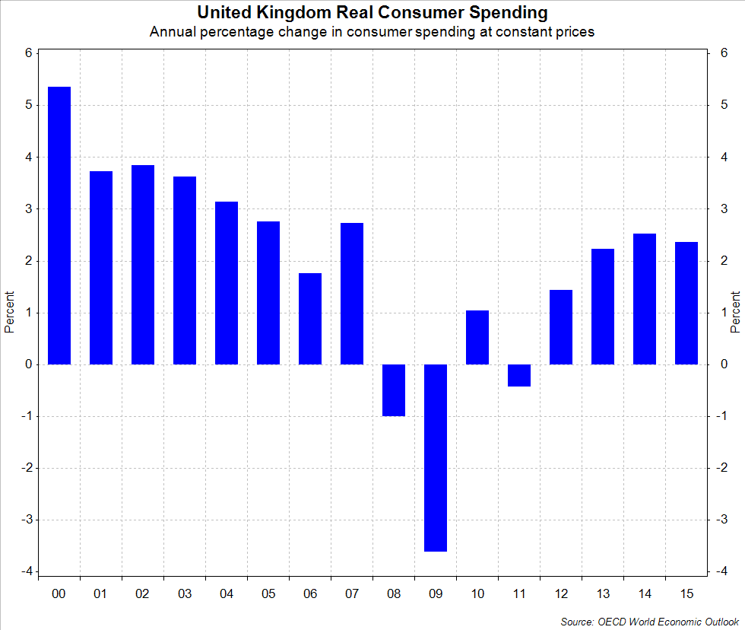Consumer spending
In 2012 consumer spending in the UK was £927 billion out of a total GDP level of £1504 billion
Consumption is the biggest single component of aggregate demand, in 2012 it was 61% of GDP
Many factors affect the ability of people to spend and this has a large effect on the economic cycle
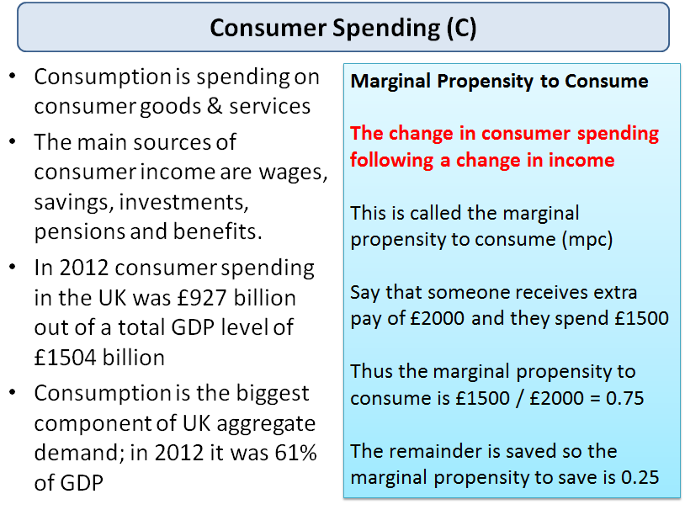Consumer spending
Disposable income and spending – the propensity to spend
John Maynard Keynes was undoubtedly one of the major figures in the history of economics developed a theory of consumption that depended mainly on disposable income. Disposable income is income after direct taxes and welfare benefits.
The Propensity to Consume
What matters is the rate at which consumers increase their spending as income rises. This is called the marginal propensity to consume. Say that someone receives extra pay of £2000 in a year and they spend £1500, thus the marginal propensity to consume is £1500 / £2000 = 0.75. The remainder is saved so themarginal propensity to save is 0.25.
A simple rule to remember is that the marginal propensity to consumer added to the marginal propensity to save must always equal 1.
Generally, people on lower incomes tend to have a higher propensity to spend. This matters when the government announces changes in taxation and the level of welfare benefits. A fall in the marginal propensity to spend will cause a lower level of consumption for a given level of income.
Some Factors that Determine Consumer Spending
Many factors have an influence on the total level of consumer spending in an economy.
- Real incomes – if people’s money wages rise faster than prices, then real incomes will increase and this leads to a higher level of real purchasing power
- Direct and indirect taxation – if there is a cut in direct taxation then, other factors remaining the same, consumers will experience an increase in their disposable income and spending power. In contrast, a hike in indirect taxes such as import duties or VAT will cause prices to rise and real incomes to decline.
- Interest Rates – lower interest rates cuts the cost of paying the debt on a mortgage and increases the effective disposable income of homeowners. In recent years many central banks around the world have made deep cut in interest rates in a bid to stimulate consumer demand. Official interest rates in the UK have been at 0.5% since March 2009.
- Household Wealth – for example a sustained fall in house prices might cause a decline in personal wealth and spending as homeowners have less housing equity available to borrow. This is sometimes referred to as the negative wealth effect. Housing equity is the difference between the market value of property and the outstanding mortgage loan.
- Consumer Confidence – for example, fears of rising unemployment and expectations of higher taxes will hit consumer sentiment and spending. If you don’t have enough confidence, you are unlikely to go ahead with major purchases such as a new car or kitchen.
- The Supply of Credit: One of the features of the credit crunch has been a slump in the flow of credit available for many households and businesses – banks have become less willing to lend and if they do, the rate of interest on the loan has increased. The supply of mortgage finance has dried up and would-be homebuyers now need to find a bigger deposit before getting a home loan.
- The Distribution of Income: Lower income families tend to have a higher propensity to consume than better-off households (who tend to have a higher savings ratio). Thus a redistribution of income towards poorer families may have the effect of boosting total consumer demand.
- Demographics: The size and growth rate of a country’s population and the age structure has a direct effect on total consumer spending. Some countries have a strongly positive natural rate of population growth perhaps aided by net migration of labour. An expanding population will add to demand for many different goods and services including housing, health care and education.
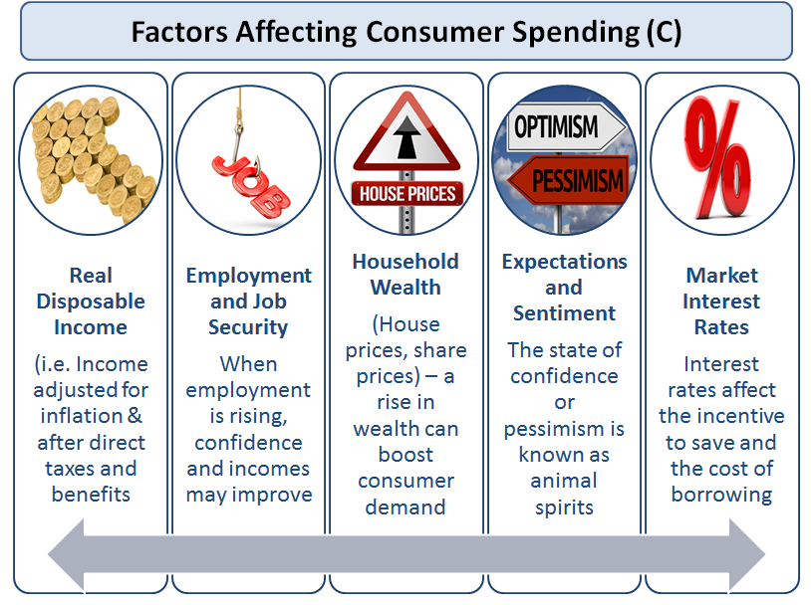Factors affecting total consumer demand for goods and services
Consumer confidence
Consumer confidence is measured using surveys that ask people about their own financial situation and expectations for themselves and the economy. When consumer confidence is low people save more because of fears about job security and future income.
The Wealth Effect
- Wealth represents the value of a stock of assets
- For most people the majority of their wealth is held in property, shares in quoted companies on the stock market, savings in banks, building societies and money building up in occupational pension schemes
- Many economists think that there is a positive relationship between wealth and spending although the size of the effect is open to question.
- For millions of people, assets in the form of savings and occupational pension schemes are important. So the real value of their savings and the income that flows from deposit accounts from interest payments will have a direct effect on their spending power.
- In recent years the average rate of interest on UK savings deposits have less than the rate of inflation – causing a cut in the real purchasing power of savers
Consumer borrowing
Most of us at some time in our lives need to borrow money to finance spending. The credit market for individuals is complex. Broadly speaking we can distinguish between:
- Unsecured borrowing – that is a loan or an overdraft which is not tied to the value of another asset. Examples of this are student overdrafts, bank loans and money borrowed on store and credit cards
- Secured borrowing – is lending where the borrower must use another asset as collateral for the loan. The best example of this is a mortgage with a bank or building society. Home buyers are at risk if they fail to keep up with monthly mortgage repayments and ultimately, the lender may foreclose and seek repossession of the property.
One of the most important features of the British economy in recent years has been the high levels of borrowing. To use a technical term, what we have seen is a‘leveraging up’ of the consumer sector – people seem to have been happy to increase the ratio of their debt to income with the result that the UK still has one of the highest debt-to-income ratios of any of the leading economies.

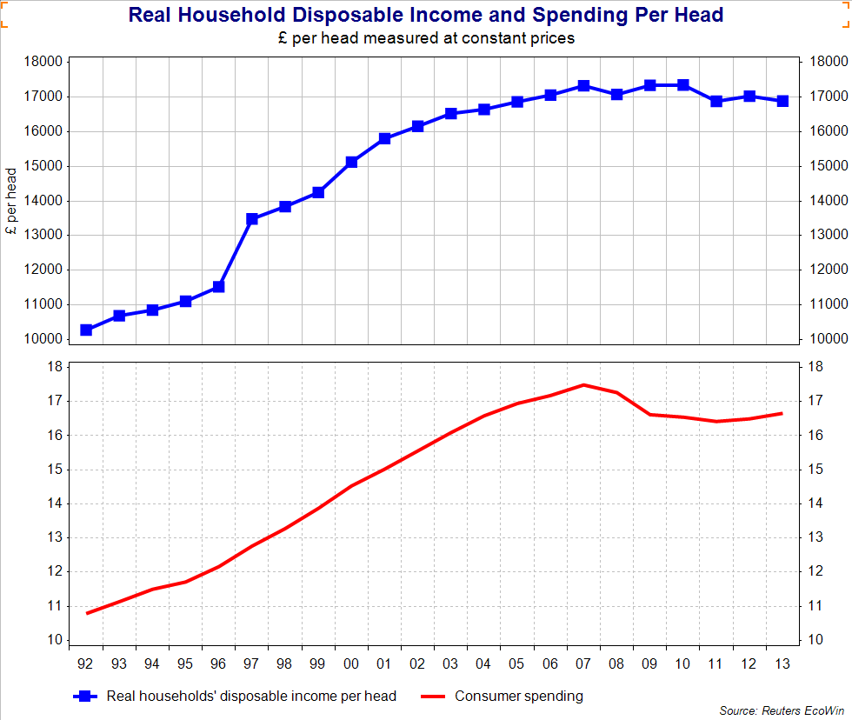Real disposable income and household spending

The Importance of Consumption
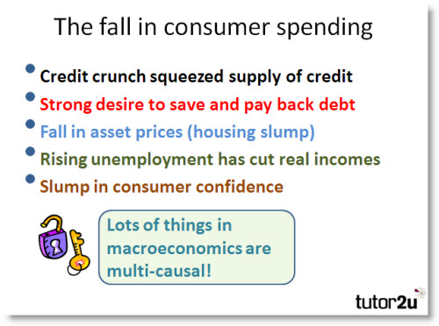
Consumer spending on goods and services is the main driver of aggregate demand in the British economy. Over sixty five per cent of demand comes from the household sector and the strength or weakness of household spending has a major bearing on movements in the economic cycle.
In 2009 the real level of consumption dropped by 3% - one of the steepest declines in consumption for many years. It helps to explain the severity of the recession. Consumer spending is forecast to recover in 2010 but growth will be relatively weak and this has contributed to fears of a double-dip recession
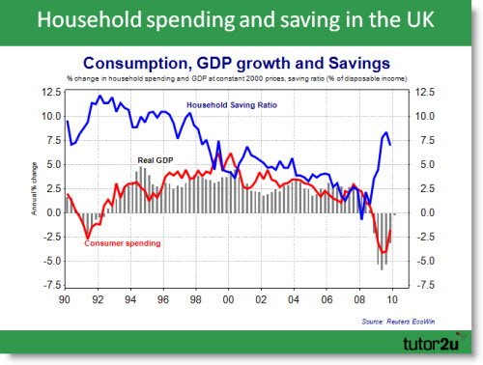
Changes in consumer spending have a big impact on other aspects of the economy:
1/ They affect the level of spare capacity in markets and the level of planned investment by businesses
2/ Changes in consumption affect the flow of direct and indirect tax revenues flowing into the government
3/ By impacting on aggregate demand, changes in consumption affect the level of demand-pull inflationary pressure
4/ UK consumers have a high marginal propensity to import - changes in consumption have a direct bearing on the balance of trade in goods and services
5/ Swings in consumer spending and saving have a huge effect on the labour market. The fall in consumption in 2009 was a big reason why unemployment rose so steeply last year.
Revision on the key factors that drive consumer spending
Factors that affect consumer demand
* A change in interest rates – lower interest rates act to lower the cost of servicing the debt on a mortgage and thereby increase the effective disposable income of homeowners. One of the features of the current recession has been the sharp reduction in official ‘policy interest rates’ by central banks. Nominal interest rates in the UK have been cut to 0.5% and are likely to stay there for some time. But despite this consumption fell in 2009 - telling us that other factors were having a strong effect on planned spending
* A change in real disposable incomes - real disposable income is the money value of household income adjusted for the effects of price changes and after direct taxes and welfare benefits have been included. When disposable incomes are growing, people have more money in their pockets and bank accounts to increase spending on goods and services
*A change in household wealth – for example a sustained fall in house prices might cause a decline in personal wealth and spending as homeowners have less housing equity available to borrow. This is sometimes referred to as the negative wealth effect.
*A change in consumer confidence – for example, fears of rising unemployment and expectations of higher taxes (as the government seeks to cut the budget deficit) will hit consumer sentiment and spending
*A change in the supply of credit - One of the features of the credit crunch has been a slump in the flow of credit available for both households and businesses – banks became less willing to lend and the rate of interest charged on unsecureedd loans and overdrafts has increased. The supply of mortgage finance has contracted and would-be homebuyers now need to find a bigger deposit before getting a home loan. The loan to valuation ratios have fallen that has affected people’s ability to borrow to fund property purchases.
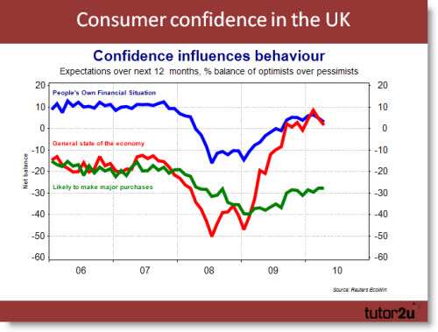
Revision blog on consumer borrowing

Macroeconomic Objectives and Macro Stability
What are objectives of macroeconomic policy?
- Objectives are the goals of government policy
- Instruments are the means by which these aims might be achieved
For example, the government might want to achieve an objective of a low rate of price inflation. The main instrument to achieve this are changes in monetary policy interest rates, since 1997 they have been set by the Bank of England. Fiscal policy could be another instrument to achieve this aim. This is in the hands of the government. Supply-side policies can also be used to control inflation and promote growth over the longer-term.
The government might have another objective to make the distribution of income more equal. It would then choose the policy instruments it thinks are best suited to reaching to this aim, perhaps a change in the income tax system or a rise in the national minimum wage.
The main policy instruments available to meet macroeconomic objectives are
- Monetary policy –changes to interest rates, the supply of money and credit and also changes to the value of the exchange rate
- Fiscal policy – changes to government taxation, government spending and borrowing
- Supply-side policies designed to make markets work more efficiently
Objectives of UK Macroeconomic Policy
The key objectives for the UK are:
- Stable low inflation - the Government’s inflation target is 2.0% for theconsumer price index.
- Sustainable growth – growth of real gross domestic product – sustainable in keeping inflation low and reducing the environmental impact of growth.
- Improvements in productivity – this is designed to improve competitiveness and global trade performance
- High employment - the government wants to achieve an increase employmentand eventually a situation where all those able and available can find meaningful work
- Rising living standards and a fall in relative poverty – cutting child poverty and reducing pensioner poverty.
- Sound government finances - including control over state borrowing and the total national debt

Objectives of UK macroeconomic policy
What is meant by macroeconomic stability?
- Economic stability occurs when there is low volatility in key indicators such as prices, jobs, growth, interest rates, investment and trade.
- All countries experience an economic cycle which tracks the fluctuations in the rate of growth of a country’s Gross Domestic Product, some countries have a more volatile cycle than others

Macroeconomic Objectives and Conflicts (Revision Presentation)

The key macroeconomic objectives and potential conflicts between those objectives are explored in this revision presentation

http://www.slideshare.net/tutor2u/as-macro-revision-macro-objectives-and-conflicts?ref=http://beta.tutor2u.net/economics/reference/macroeconomic-objectives-and-conflicts-revision-presentation

The Phillips Curve - 60 Second Adventures in Economics

https://www.youtube.com/watch?v=H_LHFs_Htak

Sustainable Development

The term 'sustainable' means 'enduring' and 'lasting' and 'to keep in being'
According to the World Bank, sustainable development is about people - better lives now and a healthy planet for future generations
According to the late David Pearce, sustainable development means that each generation should pass on at least as much "capital" as it inherits, the Pearce approach defines capital in broad terms, to include physical capital (machinery and infrastructure); intellectual capital (knowledge and technology) and environmental capital (which includes quality and the stock of natural resources).
The Brundtland Commission on Environment and Development defined sustainable development as: "development that meets the needs of the present without compromising the ability of future generations to meet their own needs”.
The UK Government supports the concept of sustainable development and focuses on four main objectives set out below:
- Social progress which recognizes the needs of everyone: Everyone should share in the benefits of increased prosperity and a clean and safe environment. Needs must not be met by treating others, including future generations and people elsewhere unfairly.
- Effective protection of the environment: We must limit global environmental threats, such as climate change to protect human health and safety from hazards such as poor air quality and toxic chemicals and to protect things that people need or value, such as wildlife and landscape
- Prudent use of natural resources: We need to ensure that non-renewable resources are used efficiently and that alternatives are developed to replace them. Renewable resources, such as water, should be used in ways that do not endanger the resource or cause serious damage or pollution.
- Maintenance of high and stable levels of economic growth and employment, so that everyone can share in high living standards and greater job opportunities.
Growing interest in the impact of economic activity on our natural and man-made resource base has led to the development of concepts such as ecological footprints and carbon footprints. Many environmentalists are inherently cautious about the long-term impact of growth on our living environment. They are deeply skeptical about the effects that growth might have in preserving and or improving it.
Others argue that the pessimists are over-stretching their case. Bjorn Lomborg in “The Skeptical Environmentalist” challenges beliefs that the environmental situation is getting worse and worse.
Decoupling growth and the environment impact
Can countries successfully manage to decouple the impact of economic growth on the environment?
- Can they find innovative ways of reducing the ecological impact of production and consumption?
- Can the right incentives lead producers and consumers to alter their behaviour in ways that benefit the wider environment?
- Can countries agree and then enforce policies to mitigate and adapt to existing climate change?
- What scale of economic growth sacrifice might be needed to achieve a sustainable rate of GDP growth in the future?
Natural Capital
- Natural capital is an economic metaphor for environmental assets, such as air, forests, soils or marine habitats that supply resources to the economy or offer a receptacle for disposal of wastes.
- Economic development changes the profile of a nation’s capital stock - for example industrialization leads to deforestation and a rapid run down of natural capital, replaced often by life-changing physical capital, intellectual capital and human capital.
- Living standards have been raised through this substitution process but the fundamental question central to the whole environmental debate is the extent to which the natural stock of capital can continue to be run down at present rates. The weight of scientific knowledge says that the answer is no - we cannot replace a stable climate by more human and physical capital under a business as usual pathway.
- There are many externalities created by the destruction of natural capital – for example, tourism can be deterred by industrial pollution and wilderness degradation
To mark the 2012 Rio Summit, the United Nations has started to publish anInclusive Wealth Index which builds into an evaluation of a country’s wealth the impact of growth and development on the stock of a country’s natural capital. Scientists and environment groups have been pressuring governments to include the value of their countries’ natural resources (or natural capital) - and use or loss of them - into future measurements of economic activity to show their true future growth prospects.
According to the Economist
“Comprised of human, natural and produced capital, the index covers 20 countries between 1990 and 2008. Between them they account for 58% of the world’s population and 73% of its GDP. As GDP does not consider natural-resource depletion or environmental degradation, the UN’s index records lower annual average growth in wealth compared with GDP, of 1.7 percentage points.”
- When measured solely by GDP, the economies of China, the United States, Brazil and South Africa grew by 422 percent, 37 percent, 31 percent and 24 percent respectively between 1990 and 2008.
- When their performance was assessed by the IWI, China’s economy grew by 45 percent, the United States by 13 percent, Brazil by 18 percent and South Africa decreased by 1 percent due to the depletion of natural resources
- Six nations - Russia, Venezuela, Saudi Arabia, Colombia, South Africa and Nigeria - experienced negative growth under the IWI, whereas it was positive under GDP measurements
Collapses in Fish Stocks – The Tragedy of the Commons
A controversial study by Worm et al published in Science in 2006 projected that if current behaviour persists, all of the world's fisheries would collapse by 2048.
According to the United Nations Development Programme, “The world’s oceans and coastal areas are the source of a variety of life-sustaining goods and services—including food, transport, oil and gas, tourism, and minerals. Marine and coastal resources directly provide at least US$3 trillion annually in global economic output.” Over-fishing represents a fundamental threat to economic activity in many countries, accelerating degradation of the marine environment stems primarily from market and policy failures. Market and policy failures have led both the private and public sectors to under-invest in environmental protection measures, such aswastewater treatment and coastal habitat protection, and over-invest in activities detrimental to the marine environment, including over-fishing and chemically intensive agriculture.
Deforestation
The Human Development Report 2011 reported that deforestation is a severe problem. In the last two decades, Latin American and Sub-Saharan Africa have experienced severe forest losses, especially when compared to the rest of the world. Deforestation causes flooding and disrupts agriculture and other economic activity.
For economists the economic and social costs of rapid deforestation represent a telling example of the tragedy of the commons where the pursuit of individual self-interest can risk a permanent destruction of natural resources that undermines the sustainability of communities and societies for current and future generations. The United Nations calculates that deforestation and degradation is responsible for nearly 20 per cent of global greenhouse gas emissions. One of the policy approaches is the REDD programme.
The REDD Programme
REDD stands for Reducing Emissions from Deforestation and Forest Degradation in Developing Countries and is designed to provide financial incentives funded by advanced nations for developing countries to preserve their forests and instead invest in low-carbon paths to sustainable development.
The United Nations estimates financial flows of up to $30bn could come from REDD and related initiatives - the scheme effectively allows rich countries to offset their carbon emissions from domestic industries and consumers by funding clean low-carbon development projects in developing countries. But it is highly controversial and opposed by many organisations such as Friends of the Earth and the World Rainforest Movement.
Poor Countries and Vulnerability to Natural Disasters
According to 2014 Human Development Report, “Environmental threats highlight potential tradeoffs between the well-being of current and future generations. If current consumption surpasses the limits imposed by our planetary boundaries, the choices of future and current generations will be seriously compromised.“
From tsunamis to tornadoes, from droughts to floods, 2011 was a particularly nasty year for natural disasters in many parts of the world. These natural disasters inevitably have demand and supply side effects affecting not just those countries affected but ripple impact across regions and in the broader global economy. These include:
- Effects on the stock of physical capital / infrastructure
- Impact on a country’s human capital
- Effects on commodity prices, export revenues
- Effects on agricultural output, profits, investment, productivity
- Ripple effects on manufacturing industries and energy supply/cost
- Impact on state tax revenues and the costs of re-building and providing emergency financial support
- Effect on the movement of population following extreme climatic events
- Natural disasters and changes in the distribution of income / risk of poverty
According to the World Bank, since the year 2000, almost 1 million people have lost their lives to disasters caused by natural hazards. 2 billion people have been affected. 1 trillion dollars in damage was caused. Globally, floods account for one-third of losses caused by natural disasters.
Sustainable growth
https://www.youtube.com/watch?v=XrrrwB36UmI

Tourism and Economic Development
For many developing countries tourism is already a major part of their economy and a significant source of income and employment
For example, tourism accounts for about 10% of Thailand's GDP. But there is a fierce debate about the consequences of tourism - what role can tourism play in growth and development? Can travel to less developed countries do more harm than good?
Economic and Social Benefits from Tourism
- Employment creation, tourism is labour intensive industry. Employs a higher % of women. The growth of ethical tourism has been a key recent feature + volunteerism
- Export earnings - tourism is a service industry - generates important foreign exchange earnings. An important source of diversification for many smaller countries
- Boost to aggregate demand - creating local and regional income-multiplier effects. Spillover benefits for suppliers of local foods/drinks; better informed tourists
- Accelerator effects from investment in tourism infrastructure and services such as airlines and telecommunications
Tourism as a threat to sustainable growth and development
- Exploitation of local labour by overseas transational tourist businesses, rapid growth of sex industry in many countries. Many workers in tourism are migrant workers suffering frm poor employment conditions
- Outflow of profits from foreign-owned tourist resorts, manyresorts have few locally-owned and run hotels. All-inclusive deals ignore the local economy. Passengers from cruise ships have little direct effect on the local economy.
- Externalities - from construction projects, congestion, waste, pressure on the natural environment. Rising property prices makes housing less affordable for local people.
- Deepening pressures on local cultures from westernisation, the doubtful benefits of slum-tourism
Background data on the global tourism industry:
- Globally, tourism is a $3 billion a day industry
- The income elasticity of demand for overseas travel and tourism is high
- According to a recent United Nations Report, in over 150 countries, tourism is one of five top export earners, and in 60 it is the number one export
- Developing countries account for 40% of world tourism arrivals and 30% of tourism receipts
- South-South tourism is growing rapidly – i.e. from developing to other developing countries
- Women make up 70 per cent of the labour force in the tourism sector, and half of all tourism workers are 25 or under
- There is growing pressure for inclusive tourism and sustainable tourism investment
Tourism in Sub Saharan Africa
According to the 2014 edition of Africa Pulse, "International tourist arrivals in Sub-Saharan Africa grew by 5.2 percent in 2013, reaching a record 36 million, up from 34 million in 2012, contributing to government revenue, private incomes, and jobs."

Private Sector and Economic Development
To what extent can private sector businesses and corporations be a key driver of growth and development in many of the world’s poorer developing countries?
Free-market approaches favour giving a larger role to private sector enterprises with liberalization of markets, structural economic reforms to boost incentives for people and businesses and increased transparency and accountability for government given a key focus
The Washington Consensus
The Washington Consensus was a term first coined in 1989 in the wake of the Latin American financial crisis and over the years it has become a highly contentious canvas on which supporters and protestors of western-style globalisation have battled.
According to John Williamson, the economist who came up with the idea of the Washington Consensus it comprised a group of market-friendly policy prescriptions favouring the private sector including:
- Fiscal discipline - keeping control of government budget deficits and national debt
- Reallocating state spending from subsidies towards health care, education & infrastructure.
- Tax reform - widening the base of taxation and encouraging lower tax rates to boost enterprise and work incentives as a means of creating wealth
- Liberalising interest rates - allowing financial markets more freedom in setting interest rates on savings and loans and letting market interest rates allocate capital among competing uses
- Exchange rates – supports a choice of fixed or free floating exchange rates but a preference against "dirty floating" i.e. intervention to manipulate the value of a currency
- Trade liberalisation - a gradual reduction in import tariffs and other forms of protectionism – trade seen as an important engine of growth and development
- Liberalization of inward foreign direct investment - capital investment between countries
- Privatization - transferring state-owned enterprises into the private sector
- Deregulation - lowering entry and exit barriers in markets but not at the expense of necessary regulation of aspects such as working conditions and employment rights
- Property rights - protecting intellectual and other rights to encourage innovation and risk-taking
According to the World Bank, the private sector already provides 90% of jobs in developing nations, so the health of the private sector will be crucial to maintaining growth and development in the years ahead.
What are the Key Criticisms of Private Sector Dominated Growth?
The Washington Consensus has come under sustained criticism even though private-sector friendly policies in many countries have contributed to an increase in trade and investment much of which has flowed into lower-income developing countries. However, development driven by the private sector has been criticised on several different grounds – some of suspicions about the private sector include the following:
- Concern over rising inequality of income and wealth - especially if there is a race to the bottom to cut wages
- Fears that profit-seeking businesses invest in the hunt for scarce resources rather than long term partnerships - land grabs in Africa are an example of this
- Disputes over ethical standards from transational businesses e.g. labour market standards and tax payments. FoxConn has come under criticism in recent times
- Profit-motives are not always aligned with improving social welfare - WTO agreements apply to government policies and actions rather than individual companies
- Monopsony power of multinational businesses - hitting prices, revenues and profits flowing to smaller producers
- Doubts over sustainable production processes - e.g. the impact of fast private sector growth on the environment and the loss of natural capital in many resource-rich poorer countries
- Tax avoidance - Developing countries lose an estimated $160 billion each year through tax avoidance by multinational companies
- Limited job creation - the 200 largest multinationals account for 20% of global trade but only 1% of global employment
Supporters of the private sector have a firm belief that the wealth generated from private sector activity and investment can have a huge positive effect on prospects for countries at every stage of development. This quote taken from the UK government website captures this view:
“The private sector is the engine of economic growth - creating jobs, increasing trade, providing goods and services to the poor and generating tax revenue to fund basic public services such as health and education.
As well as stimulating growth, new thinking within the private sector, shaped by the market, can also offer insights in to how to ensure better access to vital services or goods such as medicines or information.”

Productivity and Economic Growth
Productivity is a measure of the efficiency with which a country combines capital and labour to produce more with the same level of factor inputs
- We commonly focus on labour productivity measured by output per person employed or output per person hour.
- A better measure of productivity growth is total factor productivity which takes into account changes in the amount of capital to use and also changes in the size of the labour force.
- If the size of the capital stock grows by 3% and the employed workforce expands by 2% and output (GDP) increases by 8%, then total factor productivity has increased by 3%.
Productivity is an important determinant of living standards – it quantifies how an economy uses the resources it has available, by relating the quantity of inputs to output. As the adage goes, productivity isn't everything, but in the long run it's almost everything.
Higher productivity can lead to:
- Lower unit costs: These cost savings might be passed onto consumers in lower prices, encouraging higher demand, more output and an increase in employment.
- Improved competitiveness and trade performance: Productivity growth and lower unit costs are key determinants of the competitiveness of firms in global markets.
- Higher profits: Efficiency gains are a source of larger profits for companies which might be re-invested to support the long term growth of the business.
- Higher wages: Businesses can afford higher wages when their workers are more efficient.
- Economic growth: If an economy can raise the rate of growth of productivity then the trend growth of national output can pick up.
- Productivity improvements mean that labour can be released from one industry and be made available for another – for example, rising efficiency in farming will increase production yields and provide more food either to export or to supply a growing urban population.
- If the size of the economy is bigger, higher wages will boost consumption, generate more tax revenue to pay for public goods and perhaps give freedom for tax cuts on people and businesses.
The Productivity Gap
Productivity varies hugely across nations. The Millennium Development Goals Report for 2012 stated that the dollar value of output per worker in the developed regions of the world was $64,319, compared with an average of $13,077 in developing regions.
A table of selected data on output per worker employed is shown below.
Output per worker ($000, at constant 2005 prices, PPP adjusted) | 1991 | 2011
Sub-Saharan Africa | 5 | 6
Southern Asia | 4 | 9
South-Eastern Asia | 6 | 10
Latin America and the Caribbean | 20 | 23
Developing regions | 6 | 13
Developed regions | 48 | 64
What are the main determinants of productivity in a country?
- Access to Hard Technology
- Skills of Labour Force
- Quality of Management
- Training and Education Standards
- Competition within markets
- Cultural Factors such as attitudes and aspirations
South Korea
South Korea is an example of a country that has achieved sustained improvements in labour productivity – a key factor behind escaping the middle-income trap. Higher productivity growth is a key reason why South Korea has now become a high-income member of the OECD.
Productivity improvements in China
China has achieved impressive gains in productivity in recent years and is catching up towards levels for the East Asian and Pacific region and middle income countries such as Malaysia.
What has driven these improvements in Chinese total factor productivity?
- Resource shifts: There has been a huge shift of resources out of relatively low productivity agriculture into more productive work in manufacturing industry and construction. Over half of the Chinese population now lives in urban areas.
- New technology and innovation: The willingness of Chinese businesses to adopt new production technologies and process innovations. Mobile telephony has expanded at a rapid rate
- FDI effects: High levels of inward FDI have boosted productivity – new manufacturing capacity and technology has lifted efficiency and led to productivity spill over effects among supply-chain businesses. For example, in 2012, Samsung Electronics, the world's biggest memory chip maker, unveiled plans to invest $7bn to build its first chip factory in China.
- Openness and global competition: The Chinese economy has become more open – trade is accounting for a rising share of national income – global competition is a stimulus for efficiency improvements
- Better infrastructure: Heavy state spending on critical infrastructure has improved the overall efficiency of the economy for example in reducing transport delays and increasing communication speeds
- Management: Restructuring of state-owned businesses has been a factor behind better productivity. The Economist magazine reported recently that “sophisticated methods of control, more productive use of assets and rapid globalisation have boosted productivity"
- Improved wages: There is strong pressure for mean wages to rise in China especially as the latest Five Year Plan emphasises the need to boost domestic demand. Will a number of years of rapid wage acceleration provide a boost to worker productivity?
Although China's productivity improvements are impressive, the process of catch-up with advanced nations still has a long way to go. China's labour productivity is about 12 per cent of that of the USA
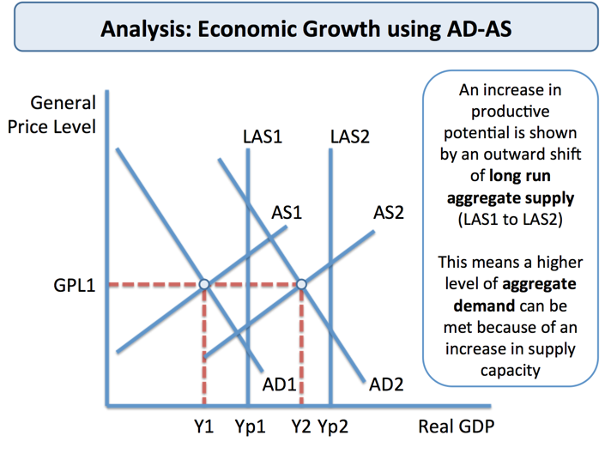Analysis Diagram
Improving Productivity in Agriculture – Focus on the Indian Farm Sector
For India, despite attempts at land reform to boost incentives for farmers, agricultural value added per worker expressed in real US dollars has grown slowly. The divergence between India and South Korea is striking.
The virtuous circle of rising agricultural productivity
- Higher farm output per worker
- Increased incomes
- Higher savings
- Creates funds for capital investment
- Frees up labour for urban areas
- Surplus output exported
In 2011, nearly 70% of Indians still live in the countryside and over half work on the farm but many are tenant farmers operating with short-term leases on their land and with little incentive to invest in machinery to improve farm yields and incomes. For example, annual rice yields in the Indian state of West Bengal remain at about half China's level and below yields in Indonesia, Taiwan and Vietnam. Productivity is further hampered by inadequate infrastructure including poor roads and vulnerability to external climatic shocks such as droughts and floods.
Critics of India agriculture argue that whereas China has liberalized farming markets and encouraged farmers to build up surpluses to sell in local and regional markets, the India government spends too much money subsidizing fertilizer, power and water and price supports for certain farmers that have done little to stimulate diversification among rural producers.

Economic Growth - Advantages of Growth

Growth has a number of economic and social benefits
These include
- Improvements in living standards: Growth is an important avenue through which per capita incomes can rise and absolute poverty can be reduced in developing nations. Professor Paul Collier has argued that “growth is not a cure-all; but the absence of growth is a kill-all.”
- More jobs: Growth creates new jobs – although the pattern of employment will also change
- The accelerator effect of growth on capital investment: Rising demand and output encourages investment in capital – this helps to sustain GDP growth by increasing LRAS
- Greater business confidence: Growth has a positive impact on profits & business confidence
- The “fiscal dividend”: A growing economy boosts tax revenues and generates the money to finance spending on public and merit goods and services without having to raise tax rates
- Potential environmental benefits – as countries grow richer, they have more resources available to invest in cleaner technologies. And, as nations develop, energy intensity levels fall
Benefits from Growth driven by Technological Change
Productivity growth
- Increase in GDP per worker
- Lower unit costs
- Higher wages
- Higher profits
New Goods and Services
- Lower real prices
- Consumer welfare gains
- Improved living standards
Improved health
- Healthy life expectancy rises
- Labour force expands
- Increased productivity

Economic Growth – Disadvantages
There are economic and social costs of a fast-expanding economy
Inflation risk: If demand races ahead of aggregate supply the scene is set for rising prices – many of the faster-growing countries have seen a trend rise in inflation – this is known as structural inflation
Environmental concerns:
- Fast growth can create negative externalities e.g. noise pollution and lower air quality arising from air pollution and road congestion
- Increased consumption of de-merit goods which damage social welfare
- The huge increase in household and industrial waste. These externalities reduce social welfare and can lead to market failure.
Growth that leads to environmental damage may lower the sustainable rate of growth. Examples include the destruction of rain forests through deforestation, theover-exploitation of fish stocks and loss of natural habitat and bio-diversity from the construction of new roads, hotels, malls and industrial estates.
Growth and the Environment: The Sustainability of Economic Growth
Growth may lead to a rapid destruction of rain forests, the over-exploitation of fish stocks and loss of natural habitat created through the construction of new roads, hotels, retail malls and industrial estates. Some of the main environmental threats include:
- The depletion of the global resource base and the impact of global warming. There are plenty of examples of the “tragedy of the commons”; the permanent loss of what should be renewable resources from over-extraction of some of our environmental resources.
- A huge expansion of waste and pollution arising from both production and consumption
- Over-population (particularly in urban areas) putting increased pressure on scarce land and other resources. More than half of the world's population lives in cities in 2009, most of them in developing countries according to the United Nations Population Fund.
- Species extinction leading to a loss of bio-diversity - Scientists predict that at least a third and as much as two-thirds of the world's species could be on their way to extinction by the end of this century, mostly because people are destroying tropical forests and other habitats, over-fishing the oceans and changing the global climate.
Economic Growth and Income and Wealth Inequality
Not all of the benefits of growth are evenly distributed. A rise in real GDP can often be accompanied by widening income and wealth inequality in society that is reflected in an increase in relative poverty.
The Gini coefficient is one way to measure the inequalities in the distribution of income and wealth in different countries. The higher the value for the Gini co-efficient (the maximum value is 1), then greater the inequality. Countries such as Japan, Denmark and Sweden typically have low values for the Gini coefficients whereas African and South American countries have an enormous gulf between the incomes of the richest and the poorest elements of the population.
A frequently quoted example of the impact on inequality of rapid growth is China. Between 1990 and 2012, China experienced an annual GDP growth rate of 10.2%. During the same period, inequality increased more than 1.6% per year as measured by the Gini coefficient, making it among the highest in developing Asia.
One of the key reasons for high levels of structural inequality in China is the urban-rural divide. In common with many developing countries, China has a dual economic structure made up of an urban economy based on modern manufacturing and services, and rural areas dominated by more traditional but less productive agriculture. According to a report published in 2013 by the Asian Development Bank, the urban-rural divide now contributes nearly half (about 45%) of China’s overall income inequality
Inequality has also risen in India – again against a background of sustained growth - India enjoyed strong GDP growth between 1990 and 2012—averaging 6.6% annually. But there was also increase in inequality, with the Gini coefficient rising from 32.5 in 1993 to 37 in 2010

Economic Growth - Innovation
Innovation is about putting a new idea or approach into action. Innovation is commonly described as 'the commercially successful exploitation of ideas
We can make a distinction between:
- Process innovation: This relates to improvements in production processes, the more efficient use of scarce resources - leading to better productive efficiency and a rise in productivity
- Product innovation: This is the emergence of new products which satisfy our needs and wants - leading to improvements in the dynamic efficiency of markets
Innovation is a stimulus to long-run growth because:
- It is a catalyst for investment which helps to shift out the production possibility frontier (PPF)
- It is a spur to productivity growth because of its impact on technological progress
- Innovation also creates a demand for new products from consumers for example in industries where existing products are nearing the end of their product life-cycle
- Effective innovation can establish a unique selling proposition (“USP") for a product – something which the customer is prepared to pay more for. This helps businesses move up the value chain
Social Benefits from Innovation
- There are positive externalities from technology spill-over effects arising from innovation for example in the pharmaceutical industry where new drugs improve the quality of life and increase life expectancy and also improvements in car manufacture that reduce the risk of injury from accidents.
- Innovation in low or zero carbon fuels have positive environmental spill overs
Competition and Innovation in Markets
- William Baumol in “The Free-Market Innovation Machine" stressed that businesses use innovation as a 'prime competitive weapon'.
- Baumol believed that a competitive oligopoly was the best form of market structure to stimulate high levels of research and innovation
- However, firms do not wish to risk too much innovation, because it is costly, and can be made obsolete by rival innovation.
- Firms have responded by buying and selling technology licenses and participation in technology-sharing joint ventures with other firms that can pay huge dividends to the economy as a whole.
What are some of the key drivers of innovation in different countries?
- Recession (necessity can be seen as the mother of invention)
- Tax credits for R&D and lower corporation tax – many countries have chosen this approach
- Creative clusters / special economic zones designed to exploit external scale economies
- Open Global Trade and Investment – a key driver of innovation for many economists
- Migration of skilled and talented workers into businesses / countries
- Investment in science & technology sectors (human capital is strongly linked to innovation)
- Protection of Intellectual Property so that returns from innovation can be commercialised
- Horizontal co-operation between businesses including joint ventures in innovative projects
The public (government) sector and innovation – the Entrepreneurial State
Many people assume encouraging private sector businesses and markets is the most important pathway to increasing rates of innovation.
But this argument can be questioned when one considers the key role that government can play in supporting research that eventually generates significant innovations.
A book “The Entrepreneurial State: Debunking Public vs Private Sector Myths" by economist Mariana Mazzucato argues that the state can often be a more important driver of innovation than the market mechanism.
For example, the US National Science Foundation funded the algorithm that drove Google's search engine and all the technologies which make the iPhone 'smart' are also state-funded including the internet, wireless networks, the global positioning system and touch screen displays.

Economic Growth - Human Capital
The basis of human capital lies in the theories of the Theodore Schultz, an economist from the University of Chicago who was awarded the Nobel Prize for Economics in 1979
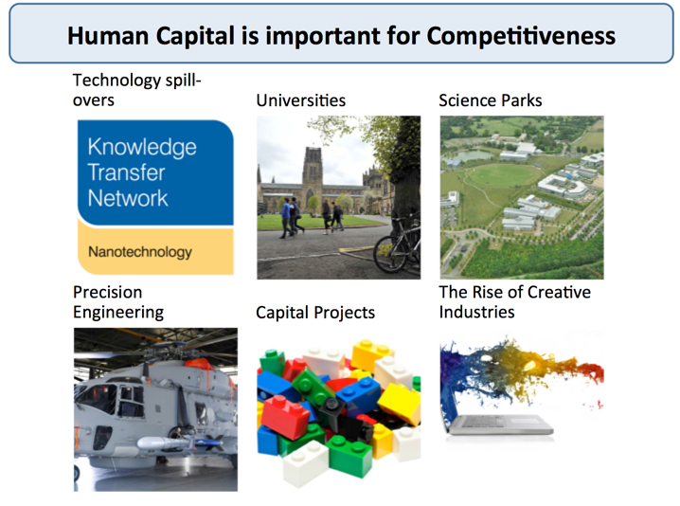Graphic on the importance of human capital
Schultz demonstrated that the social rate of return on investment in human capital in the US economy was larger than that based on physical capital such as new plant and machinery.
Professor Gary Becker(pictured on the right) - the 1992 Nobel Prize winner for economics who died in 2014 - built on the ideas put forward by Schultz, explaining that expenditure on education, training and medical care could all be considered as investment in human capital.
Professor Becker wrote, “people cannot be separated from their knowledge, skills, health or values in the way they can be separated from their financial and physical assets."
According to Michael Milken, “The macro view sees the 21st century defined by global competition for the world's most valuable asset, human capital. Nations build this by strengthening education, healthcare, and access to scientific knowledge, opportunities for women and incentives that attract skilled immigrants."
Human capital is the quality of labour: one of four factors of production. It is not a question of the quantity of labour, but rather the skills that a worker can bring, and is thus another way of saying productivity (although an important part of human capital may the flexibility to adapt to new jobs - so the two are not quite so similar).
Continually improving human capital is vital for economic growth and Milken points out that China's continuing and projected prosperity is derived, in large part, by an evolving middle class driven by a “continuous focus on education".
He goes on to demonstrate the importance of education by comparing Singapore and Jamaica: both former British colonies, with populations of 1.6m and a similar GDP/capita ($2,200, roughly).
Whilst Jamaica chose invest its resources in the agricultural and mining industries (along with tourism)
Singapore chose a different route. It focused on the importance of education and developed advanced technology. The two outcomes, in terms of prosperity and standard of living, show which route was best.
Today Singapore's GDP per capita is over seven times the level of Jamaica's

Economic Development
What does economic development mean?
What is Human Development?
“Human development is the expansion of people’s freedom to live long, healthy and creative lives; to advance other goals they have reason to value; and to engage actively in shaping development equitably and sustainably on a shared planet. People are both the beneficiaries and the drivers of human development, as individuals and in groups”
Source: Human Development Report, November 2010
What does economic development mean?
Michael Todaro specified three objectives of development:
- Life sustaining goods and services: To increase the availability and widen the distribution of basic life-sustaining goods such as food, shelter, health and protection.
- Higher incomes: To raise levels of living, including, in addition to higher incomes, the provision of more jobs, better education, and greater attention tocultural and human values, all of which will serve not only to enhance material well-being but also to generate greater individual and national self-esteem
- Freedom to make economic and social choices: To expand the range of economic and social choices available to individuals and nations by freeing them from servitude and dependence not only in relation to other people and nation-states but also to the forces of ignorance and human misery.
Note the emphasis placed on cultural and human values, self-esteem and freedom from ignorance; it is important to remember that development is about more than advancing economic growth. Many economists believe development should be less about growth, more about inclusive well-being and about building capacities and resilience in a fast-changing and unpredictable world.
The most common measurement of development is the Human Development Index published each year by the United Nations Development Programme
Dudley Sears has defined development as “the reduction and elimination of poverty, inequality and unemployment within a growing economy”
Nobel Economist Amartya Sen writing in “Development as Freedom”, sees development as being concerned with improving the freedoms and capabilities of the disadvantaged, thereby enhancing the overall quality of life - what really matters are the capabilities of people, that is, the extent of their opportunity set and of their freedom to choose among this set, the life they value
Amartya Sen pursues the idea that development provides an opportunity to people to free themselves from deep suffering caused by
- Early mortality
- Persecution
- Starvation / malnutrition
- Illiteracy
For many, economic development should be about increasing political freedom, cultural and social freedom and not just about raising incomes
Amartya Sen on India
In An Uncertain Glory, Sen argues that India’s main problems lie in the lack of attention paid to the essential needs of the people, especially the poor
Despite considerable economic growth and increasing self-confidence as a major global player, modern India is a disaster zone in which millions of lives are wrecked by hunger and by pitiable investment in health and education services. Economic growth without investment in human development is unsustainable – and unethical

Aggregate Demand (AD)
Aggregate means ‘total’ and in this case we use the term to measure how much is being spent by all consumers, businesses, the government and people and firms overseas.
Aggregate demand (AD) = total spending on goods and services
AD = C + I + G + (X-M)
C: Consumers' expenditure on goods and services: Also known as consumption, this includes demand for durables e.g. audio-visual equipment and vehicles & non-durable goods such as food and drinks which are “consumed” and must be re-purchased.
I: Capital Investment – This is spending on capital goods such as plant and equipment and new buildings to produce more consumer goods in the future. Investment includes spending on working capital such as stocks of finished and semi-finished goods.
Capital investment spending in the UK accounts for between 15-20% of GDP in any given year. Of this investment, 75% comes from private sector businesses such as Tesco, British Airways and British Petroleum and the remainder is spent by the government – for example building new schools or in improving rail or road networks. Investment has important effects on the supply-side as well as being an important component of AD.
A small part of investment spending is the change in the value of stocks. Producers may find either than demand is running higher than output (i.e. stocks will fall) or that demand is weaker than expected and below current output (in which case the value of stocks will rise.)
G: Government Spending – This is spending on state-provided goods and services including public goods and merit goods. Decisions on how much the government will spend each year are affected by developments in the economy and the political priorities of the government.
Government spending on goods and services is around 18-20% of GDP but this tends to understate the true size of the government sector in the economy. Firstly some spending is on investment and a sizeable amount goes on welfare state payments.
Transfer payments in the form of benefits (e.g. state pensions and the job-seekers allowance) are not included in current government spending because they are a transfer from one group (i.e. people paying income taxes) to another (i.e. pensioners drawing their state pension having retired, or families on low incomes).
X: Exports of goods and services - Exports sold overseas are an inflow of demand (an injection) into our circular flow of income and spending adding to aggregate demand.
M: Imports of goods and services. Imports are a withdrawal of demand (a leakage) from the circular flow of income and spending.
Net exports measure the value of exports minus the value of imports. When net exports are positive, there is a trade surplus (adding to AD); when net exports are negative, there is a trade deficit (reducing AD). The UK has been running a large trade deficit for several years now.
Components of Aggregate Demand - £bn, 2006 prices
 | Consumer Spending | Government Consumption | Fixed Investment | Exports | Imports
2003 | 859.3 | 297.9 | 221.9 | 362.1 | 409.6
2004 | 887.2 | 309.3 | 235.7 | 379.7 | 438.0
2005 | 912.6 | 316.3 | 244.4 | 414.1 | 468.4
2006 | 928.8 | 323.3 | 258.1 | 463.8 | 515.3
2007 | 954.7 | 325.7 | 277.3 | 454.3 | 507.3
2008 | 946.0 | 332.4 | 258.3 | 459.1 | 498.6
2009 | 912.2 | 334.9 | 215.1 | 419.3 | 445.1
2010 | 921.0 | 336.5 | 221.2 | 447.3 | 480.1
2011 | 916.4 | 336.4 | 215.9 | 467.2 | 481.5
2012 | 927.4 | 345.7 | 217.0 | 471.3 | 494.9
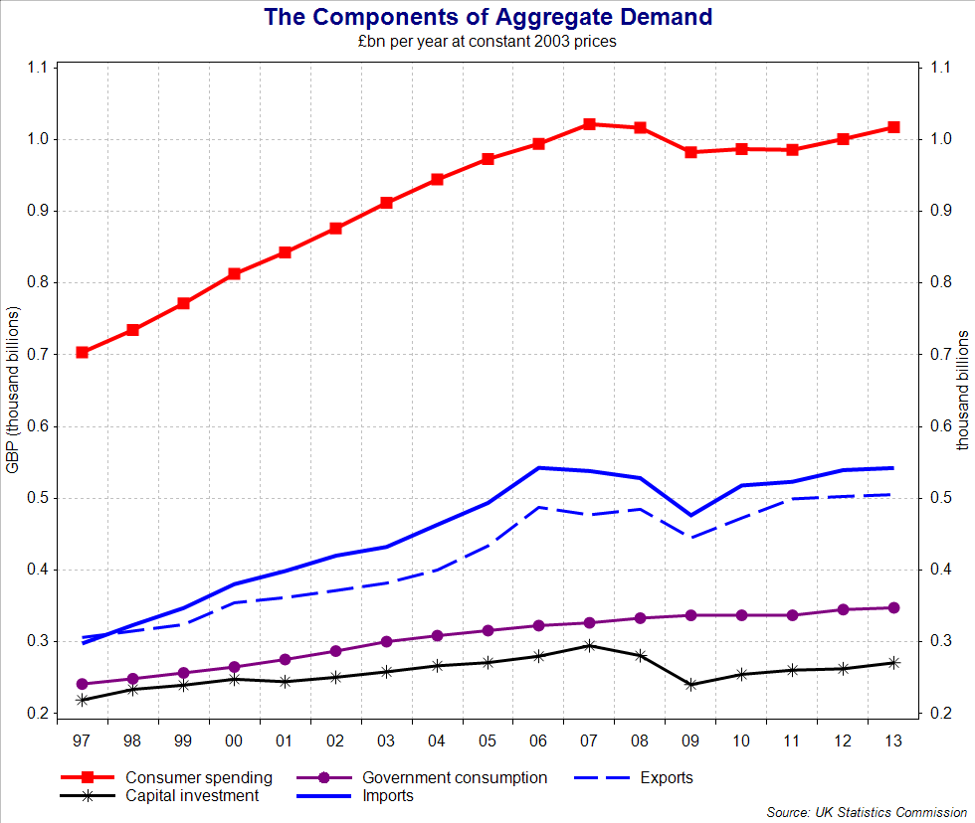Components of Aggregate Demand
Shocks to aggregate demand
- Many unexpected events cause changes in the level of demand, output and employment
- These events are called “shocks”. Some of the causes of AD shocks are as follows:
- A large rise or fall in the exchange rate – affecting export demand and second-round effects on output, employment, incomes and profits of businesses linked to export industries.
- A recession in main trading partners affecting demand for exports of goods and services.
- A slump in the housing market or a big change in share prices
- An event such as the credit crunch (global financial crisis) – involving a fall in the amount of credit available for borrowing by households and businesses.
- An unexpected cut or an unexpected rise in interest rates or change in government taxation and spending – for example deep cuts in government spending as part of fiscal austerity
These shocks will bring about a shift in the aggregate demand curve
The Aggregate Demand Curve
The AD curve shows the relationship between the general price level and real GDP
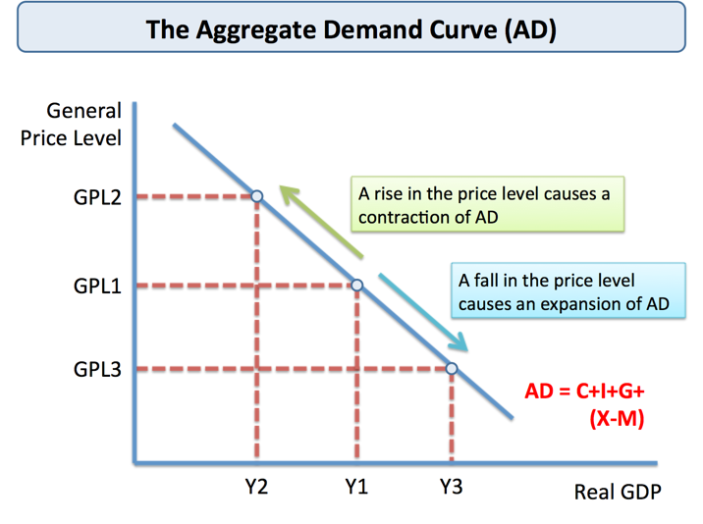The AD curve
Aggregate Demand and the Price Level
There are several explanations for an inverse relationship between AD and the price level in an economy:
1.Falling real incomes: As the price level rises, the real value of people’s incomes fall and consumers are less able to buy the items they want or need. If over the course of a year all prices rose by 10 per cent whilst your money income remained the same, your real income would have fallen by 10%
2.The balance of trade: A persistent rise in the price of level of Country X could make foreign-produced goods and services cheaper in price terms, causing a fall in exports and a rise in imports. This will lead to a reduction in net trade and a contraction in AD
3.Interest rate effect: if the price level rises, this causes inflation and an increase in the demand for money and a possible rise in interest rates with a deflationary effect on the economy. This assumes that the central bank (in our case the Bank of England) is setting interest rates in order to meet a specified inflation target.
Shifts in the AD Curve
- A change in the factors affecting any one or more components of aggregate demand i.e. households (C), firms (I), the government (G) or overseas consumers and business (X) changes planned spending and results in a shift in the AD curve.
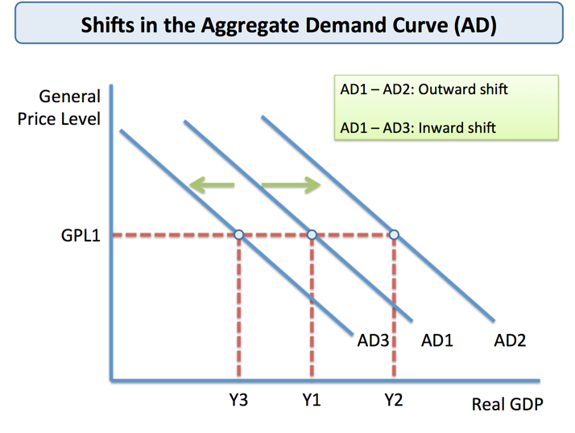Shifts in the AD curve
Factors causing a shift in aggregate demand
Changes in ExpectationsCurrent spending is affected by anticipated income and inflation | - When confidence falls, we see an increase in saving and businesses postpone investment projects because of worries over weak demand and lower expected profits.
Changes in Monetary Policy – i.e. a change in interest rates | - If interest rates fall – this lowers the cost of borrowing and the incentive to save, encouraging consumption & investment  - There are time lags between changes in interest rates and AD
Changes in Fiscal Policy Fiscal Policy refers to changes in government spending, taxation and borrowing | - Income tax affects disposable income e.g. lower income tax raises disposable income and should boost consumption.  - A budget deficit is a net injection of aggregate demand
Economic events in the world economy International factors such as the exchange rate and foreign income | - A depreciation in a currency makes imports dearer and exports cheaper - the net result should be that UK AD rises  - An increase in overseas incomes raises demand for exports. In contrast a recession in a major export market will lead to a fall in exports and an inward shift of aggregate demand.
Changes in household wealth | - Changing share and property prices affect the level of wealth  - Declining asset prices can hit confidence / a fall in expectations
Changes in the supply of credit | - The availability of credit is vital for the smooth functioning of most modern economies  - Many banks and other lenders are now more reluctant to lend  - Interest rates on different loans have become more expensive

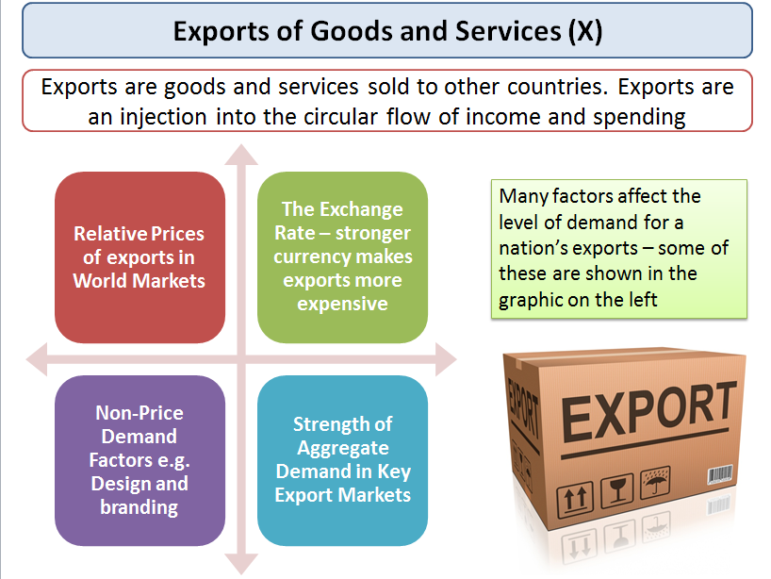Exports - an injection into the circular flow and a component of AD

Multiplier Effect
An initial change in aggregate demand can have a much greater final impact on the level of equilibrium national income. This is known as the multiplier effect
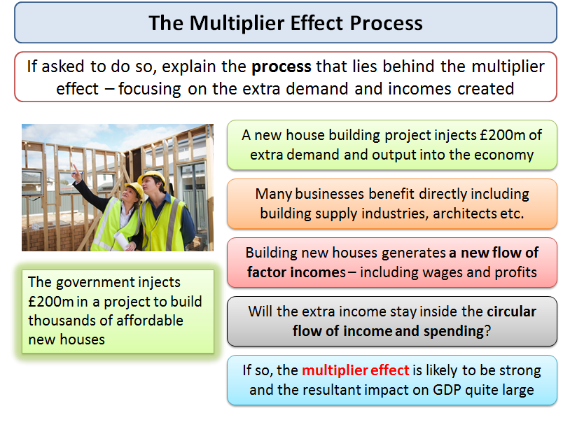Describing the multiplier process
It comes about because injections of new demand for goods and services into the circular flow of income stimulate further rounds of spending – in other words “one person’s spending is another’s income”
This can lead to a bigger eventual effect on output and employment
What is a simple definition of the multiplier?
It is the number of times a rise in national income exceeds the rise in injections of demand that caused it
Examples of the multiplier effect at work
- Consider a £300 million increase in capital investment– for example created when an overseas company decides to build a new production plant in the UK
- This may set off a chain reaction of increases in expenditures. Firms who produce the capital goods and construction businesses who win contracts to build the new factory will see an increase in their incomes and profits
- If they and their employees in turn, collectively spend about 3/5 of that additional income, then £180m will be added to the incomes of others.
At this point, total income has grown by (£300m + (0.6 x £300m).
The sum will continue to increase as the producers of the additional goods and services realize an increase in their incomes, of which they in turn spend 60% on even more goods and services.
The increase in total income will then be (£300m + (0.6 x £300m) + (0.6 x £180m).
Each time, the extra spending and income is a fraction of the previous addition to the circular flow.
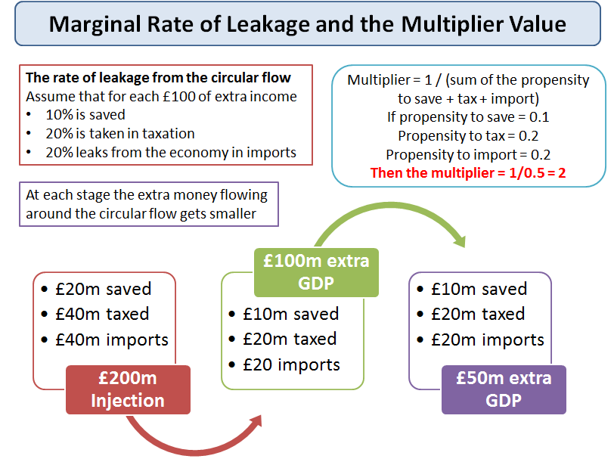The marginal rate of withdrawal affects the size / coefficient of the multiplier
The Multiplier and Keynesian Economics
- The concept of the multiplier process became important in the 1930s when John Maynard Keynes suggested it as a tool to help governments to maintain high levels of employment
- This “demand-management approach”, designed to help overcome a shortage of capital investment, measured the amount of government spending needed to reach a level of national income that would prevent unemployment.
The value of the multiplier depends on:
- Propensity to import
- Propensity to save
- Propensity to tax
- Amount of spare capacity
- Avoiding crowding out
Key points
- 1.The higher is the propensity to consume domestically produced goods and services, the greater is the multiplier effect. The government can influence the size of the multiplier through changes in direct taxes. For example, a cut in the rate of income tax will increase the amount of extra income that can be spent on further goods and services
- 2.Another factor affecting the size of the multiplier effect is the propensity to purchase imports. If, out of extra income, people spend their money on imports, this demand is not passed on in the form of fresh spending on domestically produced output. It leaks away from the circular flow of income and spending, reducing the size of the multiplier.
- 3.The multiplier process also requires that there is sufficient spare capacity for extra output to be produced. If short-run aggregate supply is inelastic, the full multiplier effect is unlikely to occur, because increases in AD will lead to higher prices rather than a full increase in real national output. In contrast, when SRAS is perfectly elastic a rise in aggregate demand causes a large increase in national output.
- 4.Crowding out – this is where (for example) increased government spending or lower taxes can lead to a rise in government borrowing and/or inflation which causes interest rates to rise and has the effect of slowing down economic activity.
In short – the multiplier effect will be larger when
- The propensity to spend extra income on domestic goods and services is high
- The marginal rate of tax on extra income is low
- The propensity to spend extra income rather than save is high
- Consumer confidence is high (this affects willingness to spend gains in income)
- Businesses in the economy have the capacity to expand production to meet increases in demand
Time lags and the multiplier effect
- It is important to remember that the multiplier effect will take time to come into full effect
- A good example is the fiscal stimulus introduced into the US economy by the Obama government. They have set aside many billions of dollars of extra spending on infrastructure spending but these capital projects can take years to be completed. Delays in sourcing raw materials, components and finding sufficient skilled labour can limit the initial impact of the spending projects.
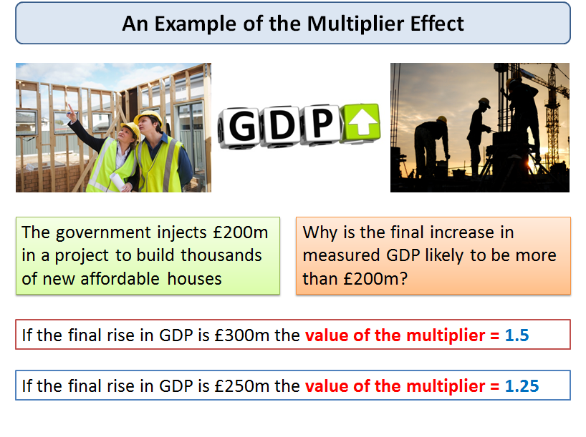Value of the multiplier
The IMF on the Fiscal Multiplier
Government investment—things like infrastructure building—results in higher multipliers. Economists at the IMF have calculated the long-run multiplier at 1.5 for developed countries and 1.6 for developing countries. In other words, developing countries really benefit from government investment over government consumption. Investment can build the productive capacity of the economy, resulting in beneficial long-term effects.
Many governments in developed nations have been introducing fiscal austerity programmes – cutting spending and lifting taxes in a bid to lower their budget deficits. The fiscal multiplier effect is important here too. If the multiplier is 0.5, then an initial government expenditure reduction of 1 per cent of GDP reduces real output by 0.5 per cent.If, however, the multiplier is 1.7, then the same initial public spending cut of 1 per cent of GDP would reduce real output by 1.7 per cent. The big danger of a high fiscal multiplier is that a period of deep cuts in state spending will cause an even larger drop in GDP which in turn will increase the size of the budget deficit. Fiscal austerity can turn out to be self-defeating.
One problem is that the actual value of the multiplier effect is likely to change at different points of the economic cycle.
(Source: Adapted from the Economist and other news reports, July 2013)
Calculating the value of the multiplier
The formal calculation for the value of the multiplier is
Multiplier = 1 / (sum of the propensity to save + tax + import)
Therefore if there is an initial injection of demand of say £400m and
- The marginal propensity to save = 0.2
- The marginal rate of tax on income = 0.2
- The marginal propensity to import goods and services is 0.3
Then the value of national income multiplier = (1/0.7) = 1.43
An initial change of demand of £400m might lead to a final rise in GDP of 1.43 x £400m = £572m
If
- The marginal propensity to save = 0.1
- The marginal rate of tax on income = 0.2
- The marginal propensity to import goods and services is 0.2
The value of the multiplier = 1/0.5 = 2 – the same initial change in aggregate demand will lead to a bigger final change in the equilibrium level of national income.

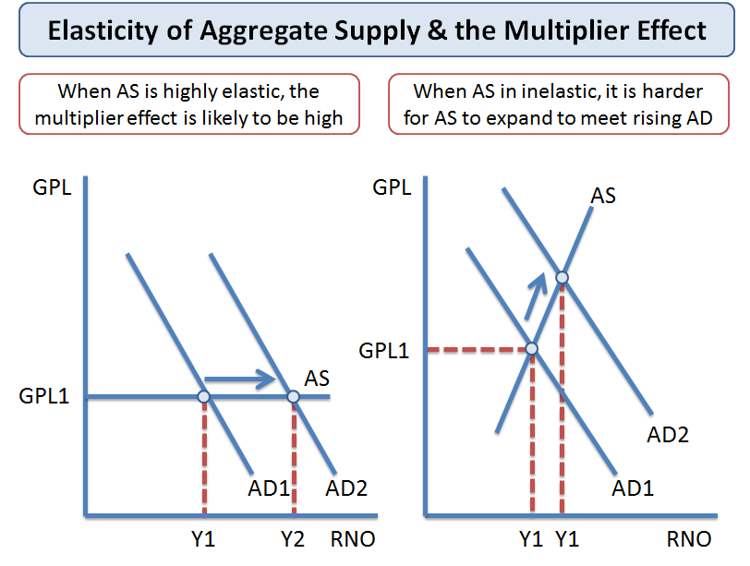Elasticity of aggregate supply and the multiplier effect

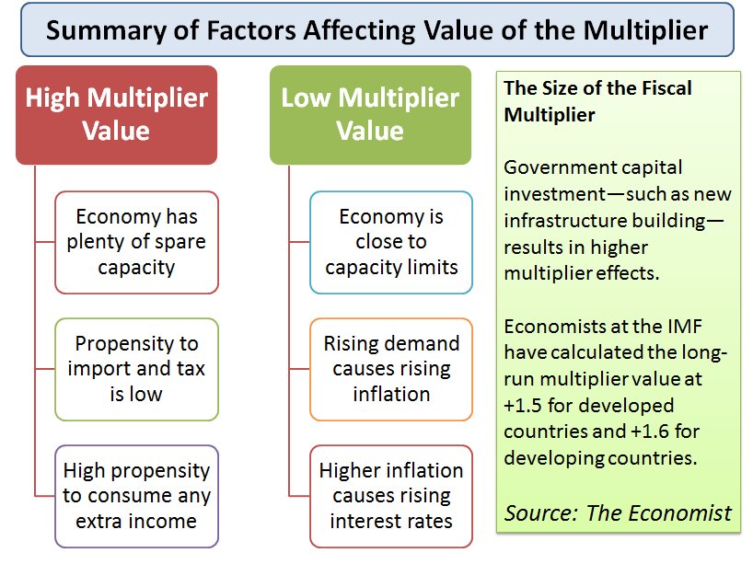Key point summary on the multiplier

Aggregate Supply

Aggregate supply measures the volume of goods and services produced each year. AS represents the ability of an economy to deliver goods and services to meet demand
Short run aggregate supply shows total planned output when prices can change but the prices and productivity of factor inputs e.g. wage rates and the state of technology are held constant.
Long run aggregate supply shows total planned output when both prices and average wage rates can change – it is a measure of a country’s potential output and the concept is linked to the production possibility frontier
- In the long run, the LRAS curve is assumed to be vertical (i.e. it does not change when the general price level changes)
- In the short run, the SRAS curve is assumed to be upward sloping (i.e. it is responsive to a change in aggregate demand reflected in a change in the general price level)
Short Run Aggregate Supply Curve
A change in the price level brought about by a shift in AD results in a movement along the short run AS curve. If AD rises, we see an expansion of SRAS; if AD falls we see a contraction of SRAS.
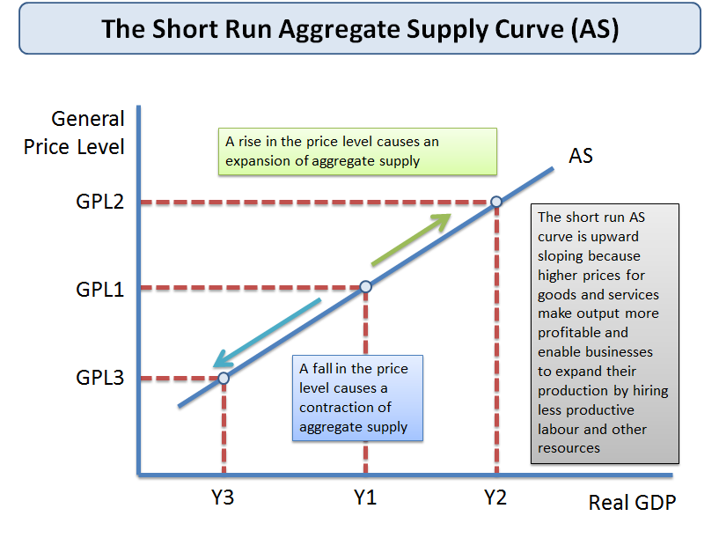Short run aggregate supply curve
Shifts in Short Run Aggregate Supply (SRAS)
Shifts in the position of the short run aggregate supply curve in the price level / output space are caused by changes in the conditions of supply for different sectors of the economy:
- Employment costs e.g. wages, employment taxes. Unit labour costs are also affected by the level of labour productivity
- Costs of other inputs e.g. commodity prices, raw materials. The exchange rate can affect the prices of key imported products
- Impact of government e.g. environmental taxes such as carbon duties & business regulations which affect the costs of production
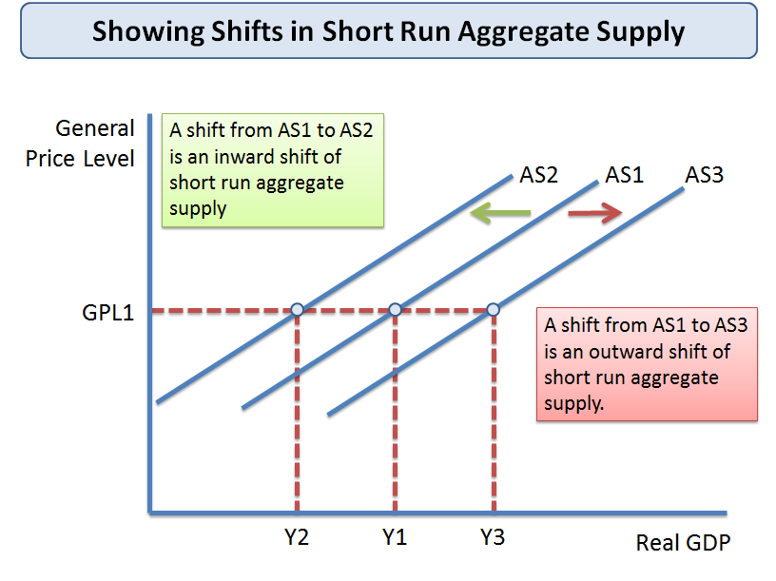Shifts in the aggregate supply curve
The main cause of a shift in the aggregate supply curve is a change in business costs – for example:
1.Changes in unit labour costs - i.e. labour costs per unit of output
2.Changes in other production costs: For example rental costs for retailers, the price of building materials for the construction industry, a change in the price of hops used in beer making or the cost of fertilisers used in farming.
3.Commodity prices Changes to raw material costs and other components e.g. the prices of oil, natural gas, electricity copper, rubber, iron ore, aluminium and other inputs will affect a firm’s costs
4.Exchange rates: Costs might be affected by a change in the exchange rate which causes fluctuations in the prices of imported products. A fall (depreciation) in theexchange rate increases the costs of importing raw materials and component supplies from overseas
5.Government taxation and subsidies:
- An increase in taxes to meet environmental objectives (known as green taxes) will cause higher costs and an inward shift in the SRAS curve – for example a higher price for carbon emissions
- Lower duty on petrol and diesel would lower costs and cause an outward shift in SRAS
6.The price of imports:
  - Cheaper imports from a lower-cost country has the effect of shifting out SRAS
  - A reduction in an import tariff on imports or an increase in the size of an import quota will also boost the supply available at each price level causing an outward shift of SRAS
- Short run shocks to production: Temporary non-economic factors affect SRAS in different countries, for example a hurricane, a tsunami or the effects of drought, flooding or political crisis.
Key revision point: The main driver of SRAS for the economy is the level ofproduction costs some of which are influenced by government policy, others by world prices. Remember that the exchange rate is important for the UK because a large percentage of our components / raw materials / energy are imported.

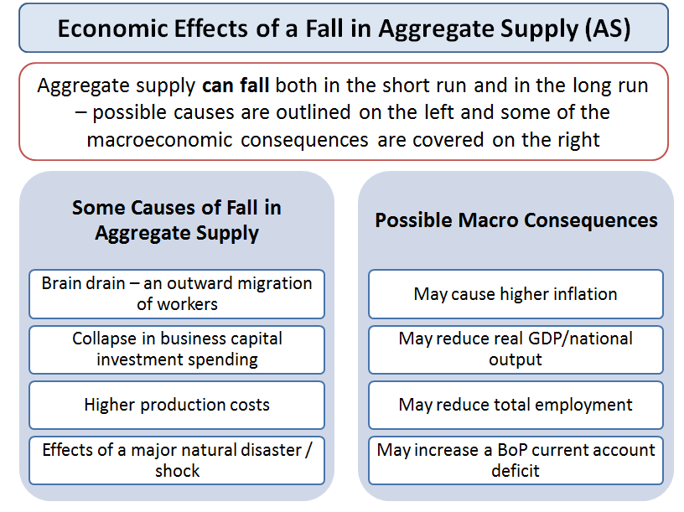Causes of a fall in aggregate supply

Long Run Aggregate Supply
In the long run, the ability of an economy to produce goods and services to meet demand is based on the state of production technology and the availability and quality of factor inputs
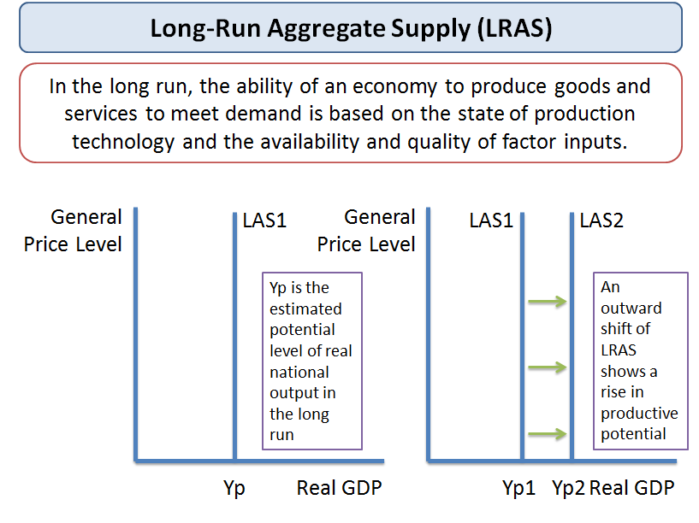Shifts in the long run aggregate supply curve
Key factors that have an effect on a country’s supply-side potential:
- Higher Productivity of Labour and Capital i.e. a rise in output per person employed or increased efficiency of technology
- Increased Labour Market Participation (Growing Labour Supply) - what policies can help increase employment?
- Demand and Supply-Side gains from Innovation and Enterprise - two key factors that determine competitiveness
- Capital Investment – including capital spending by domestic businesses, inward investment from overseas and Public Sector (Government)
Growth and size of economy
“Seemingly small differences in growth rates can have a large impact over a period of many years. For example, if an economy grew by 2 per cent every year, it would double in size within 35 years; if it grew at 2½ per cent a year, it would double in size after 28 years - seven years earlier”
Source: UK Treasury
A long run production function is written as follows:
Y*t = f (Lt, Kt, Mt)
- Y* is a measure of potential output
- t is the time period
- L represents the quantity and quality of labour input
- Kt represents the available capital stock
- Mt represents the availability of natural resources
LRAS is determined by the stock of a country’s resources and by the productivity of these factor inputs (labour, land and capital).
Changes in technology also affect potential real national output.
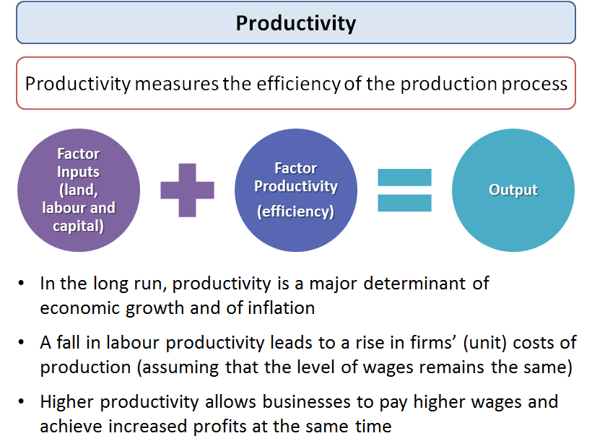Factor productivity affects a country's output potential
Causes of shifts in the long run aggregate supply curve
Any change that alters the natural rate of growth of output shifts LRAS
Improvements in productivity and efficiency or an increase in the stock of capital and labour resources cause the LRAS curve to shift out. This is shown in the diagram below
An increase in the size of the productive capital stock of a country will also shift out the LRAS e.g. arising from the effects of infrastructure investment or an injection of investment from overseas (FDI)
Policies to increase long run aggregate supply
- Expanding the labour supply - e.g. by improving work incentives and relaxing controls on inward labour migration. In the long term many countries must find ways of overcoming the effects of an ageing population and a rising ratio of dependents to active workers
- Increase the productivity of labour – e.g. by investment in training of the labour force and improvements in the quality of management of human resources. Productivity can be measured in several ways including output per person employed and output per hour worked
- Improve mobility of labour to reduce certain types of unemployment for example structural unemployment caused by occupational immobility of labour. If workers have more skills and flexibility, they will find it easier to get work. Conversely when unemployment remains high, the economy loses out on potential output and there is a waste of scarce resources
- Expanding the capital stock – i.e. increase investment and research and development
- Increase business efficiency by promoting greater competition within markets
- Stimulate invention and innovation – to promote lower costs and improvements in the dynamic efficiency of markets. Innovation creates new goods and services and encourages investment
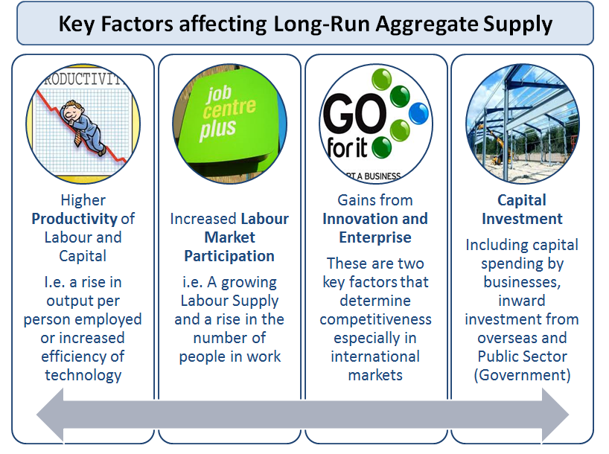Key factors influencing long run aggregate supply (LRAS)
Aggregate Supply Shocks
Aggregate supply shocks might occur when there is
A sudden rise in oil or gas prices or other essential inputs such as foodstuffs used in food-processing industries. Foodstuffs are intermediate products – i.e. items used up in manufacturing goods for consumers to buy
The invention and widespread diffusion of a new production technology
A major change in the movement of migrant workers from one economy to another
Shocks and long run aggregate supply
- The effects of temporary supply-side shocks are normally to cause a shift in the SRAS curve
- There are occasions when changes in production technologies or step-changes in the productivity of factors of production that were not expected causes a shift in the long run aggregate supply curve.
- Large-scale natural disasters and persistent political conflicts including civil wars can also have a significant effect on a country’s productive potential and therefore affect the LRAS. Conflict has generational effects on a nation’s productivity, investment and potential output.

Revision: Demand-side shocks
One of the really interesting things about being a macro economist is that lots of unexpected events can happen which cause changes in the level of demand, output and employment. The headwinds can alter direction with great speed leading to uncertainty about where the economy is heading. These unplanned events are called “shocks” and many of them happen in other countries or parts of the global economy but they have an effect across many different countries. We have certainly had more than our usual share of them in recent years! Students need to understand the possible causes of shocks but also to be able to trace and discuss their broader impact on specific industries and the economy as a whole.
One of the causes of fluctuations in the level of macroeconomic activity is the presence of demand-side shocks.
Some of the main causes of demand-side shocks are as follows:
o A capital investment boom e.g. a construction boom to increase the supply of new houses or to build new commercial and industrial buildings.
o A big rise or fall in the exchange rate – affecting net export demand and having follow-on effects on output, employment, incomes and profits of businesses linked to export industries. Sterling has depreciated by more than 25% over the last year - what possible effects will a sustained fall in sterling have on the UK economy and out trade partners?
o A contraction in consumer demand abroad in the country of one of our major trading partners which affects the demand for our exports of goods and services.
o A large slump in the housing market or a slump in share prices. Asset price deflation can have a huge impact on confidence and sentiment.
o An event such as the global credit crunch – involving a sharp fall in the amount of credit available for borrowing by households and businesses.
o An unexpected cut or an unexpected rise in interest rates or change in government taxation.
These shocks will bring about shifts in the aggregate demand curve and have direct and indirect effects on key indicators such as
(i) Inflation
(ii) Output
(iii) Business profits and investment
(iv) Government tax revenues, spending and borrowing
(v) Employment
A full set of AS macro revision notes is available here and our AS economics revision presentations can be found here

Recessions are good for the nation’s health
Is leisure good for you? A bit of a no brainer one might think. Indeed, until recently the consensus amongst applied economists was that even enforced leisure, by being made unemployed, seemed to be a good thing.
Recessions obviously make more time available for leisure as unemployment rises and opportunities for overtime shrink. The financial crisis led to more innovative ways of expanding leisure time amongst the labour force. Many people were given the option of switching to a part-time basis with reduced income rather than losing their job altogether.
The most extreme version of this is of course zero hours contracts. Given the choice, most people in these situations would choose to work, and work full time, rather than being forced to take more leisure time.
But there is a substantial literature suggesting that recessions actually increase longevity, and lead to a general improvement in the overall health of a nation.
The most famous example is the sharp increase in life expectancy which took place during the 1930s in the United States, at the time of the Great Depression when unemployment rates touched 25 per cent. This, however, is basically attributable to massive improvements in the public provision of better sewers and better water supplies not just in that decade, but throughout the opening decades of the 20thcentury.
The academic work investigating outcomes in more recent decades assigns specific short-term benefits to the health consequences of recessions. Levels of smoking are reduced, because people cannot afford to buy as many cigarettes. People take more physical exercise. They walk rather than use cars or public transport.
The splendidly named Tinna Asgeisdottir demonstrated very clear health benefits of the financial crisis in Iceland in a National Bureau of Economic Research (NBER) paper. Economists have even discovered positive benefits for the health of people in care homes. During recessions, the quality of staff competing for these jobs rises, because relatively skilled people are made unemployed, and so the overall standard of care increases.
These findings may seem somewhat implausible, but they emerge from careful statistical analysis of large scale data sets.
However, a new paper in the American Economic Association's journal Economic Policy does find strong evidence that recessions are particularly bad for workers approaching retirement age.
Courtney Coile and colleagues at the NBER merge data from sources such as the US Census and the Vital Statistics data base from the National Center of Health Statistics and examine the survival probabilities of those in the 55 to 65 age group. Even for this group, the short-term experience of a recession is for mortality to fall. But it soon rises quite sharply, resulting in lower survival rates at older ages. Of course, one reason is peculiar to America, namely the lack of access to health care when unemployed.
Perhaps in Europe even this group benefit from enforced leisure.

IMF 2014 Review of the UK Economy
Here is a link to a video report produced by the IMF as part of their annual assessment of the UK economy. Overall, the IMF is considerably more optimistic than it was in 2013 about prospects for near term recovery of output and continued reductions in unemployment.
Risks to macro stability are also considered, namely weak productivity growth and high housing prices
More suggested reading:
UK economy and the IMF: http://www.imf.org/external/country/gbr/
UK economy rebounding strongly (28 July 2014): http://www.imf.org/external/pubs/ft/survey/so/2014...
IMF predicts UK growth surge (Guardian): http://www.theguardian.com/business/2014/jul/24/im...
Pound is overvalued warns the IMF (Daily Telegraph): http://www.telegraph.co.uk/finance/economics/10996...

Cyclical and Structural Economic Issues Facing the UK
Our focus in an AS macro revision session was on the difference between cyclical issues and events and the wider / deeper structural problems and issues facing the UK economy at this fascinating time. Key macro policy decisions affect the path of an economy out of recession, but are these the same policies that will address the supply-side constraints and weaknesses that hold back growth, development and contribute to growing inequality?
Cyclical issues:
* Deep recession and a slow, weak, fragile recovery - UK GDP remains well below the peak at the end of the last cycle
* Falling real incomes and low consumer confidence
* Weak capital investment - the share of investment as a % of GDP has fallen steeply, low business animal spirits
* High cyclical unemployment as national output remains well below potential
* Cyclical fall in labour productivity (output per person employed) in part because of the weakness of demand
* Slower than expected expansion of UK exports - despite a competitive exchange rate - weakness in demand in our key export markets
* Cyclical fall in tax revenues and a rise in government transfer payments contributing to sizeable rise in size of fiscal deficit
* Rising household savings ratio, cyclical fall in property prices - both negative for consumer spending
Key issue here is why has recovery been so weak thus far (growth of less than 1% in 2011 and 2012 (forecast))?
Has monetary policy lost the power to stimulate demand, output and jobs?
Will Osborne’s Plan A of fiscal austerity make things worse - what will come under Plan B?
Structural issues
These focus mainly on the supply-side but keep in mind that an economy in semi-permanent recession with deficient aggregate demand for goods and services is likely to find that existing supply-side problems will deepen and become even harder to tackle
* An unbalanced economy - too dependent on financial services and housing, need to re-balance e.g. towards high value manufacturing, creative sectors
* Huge level of household debt - one of the highest among any advanced rich nation
* Structural weaknesses in the banking system - squeezing the supply and raising the cost of credit for businesses
* Long term low level of research and development as a share of national income
* Immobilities, disincentives, skills gaps in the labour market - resulting in high rates of structural unemployment
* Huge levels of youth unemployment
* Long term rise in economic inactivity, growing signs of people leaving the active labour market or having to settle for part time work
* Persistent productivity gap with many other countries
* Structural budget deficit is high - a key aim of the Coalition is to reduce this over the lifetime of this Parliament
* Structural changes in the balance of world economic power and influence - growing competitive threats from emerging countries (BRICs et al)
* UK economy falling back in international league tables for competitiveness
* Creaking infrastructure - telecoms, transportation, increasing pressure on public services such as education and health
* Structural rise in inequality / widening divide in income and wealth, deep regional disparities
These structural weaknesses mean that economic growth will be slower and unemployment higher in the years to come. The fall out from the global financial crisis is likely to have generational effects on employment and living standards especially for the younger generations. Do the current generation of politicians and policy-makers have the creativity, imagination and strength to develop policy ideas that will energise emerging industries and provide a platform for stronger growth in the years ahead? If not, the “new normal” will not be a good place to be

Positive and Negative Multiplier Effects
An initial change in aggregate demand can have a much greater final impact on equilibrium national income. This is known as the multiplier effect. It comes about because injections of new demand for goods and services into the circular flow of income can stimulate further rounds of spending – in other words “one person’s spending is another’s income”. Put another way, spending becomes someone else’s income. This can lead to a bigger eventual effect on output and employment.
Here are three recent news videos covering aspects of the multiplier effect at work:
Irish economy seeks foreign direct investment to sustain their economic recovery
1,300 lost jobs at Bombardier in Derby may threaten up to 13,000 other jobs - this new video on the story is particularly good about the wider knock-on economic effects: Bombardier trains: Loss of contract felt across UK
Mostyn port deal over windfarm creates 100 new jobs
What is the multiplier process?
• An initial change in aggregate demand can have a much greater final impact on equilibrium national income.
• This is known as the multiplier effect
• It comes about because injections of new demand for goods and services into the circular flow of income can stimulate further rounds of spending – in other words “one person’s spending is another’s income”
• Put another way, spending becomes someone else’s income
• This can lead to a bigger eventual effect on output and employment.
What is a simple definition of the multiplier?
It is the number of times a rise in national income exceeds the rise in injections of demand that caused it
Examples of the multiplier effect at work
Consider a £300 million increase in capital investment – for example created when an overseas company decides to build a new production plant in the UK. This may set off a chain reaction of increases in expenditures. Firms who produce the capital goods and construction businesses who win contracts to build the new factory will see an increase in their incomes and profits. If they and their employees in turn, collectively spend about 3/5 of that additional income, then £180m will be added to the incomes of others.
At this point, total income has grown by (£300m + (0.6 x £300m).
The sum will continue to increase as the producers of the additional goods and services realize an increase in their incomes, of which they in turn spend 60% on even more goods and services.
The increase in total income will then be (£300m + (0.6 x £300m) + (0.6 x £180m).
Each time, the extra spending and income is a fraction of the previous addition to the circular flow.
The Multiplier and Keynesian Economics
The concept of the multiplier process became important in the 1930s when John Maynard Keynes suggested it as a tool to help governments to maintain high levels of employment. This “demand-management approach”, designed to help overcome a shortage of capital investment, measured the amount of government spending needed to reach a level of national income that would prevent unemployment.
The higher is the propensity to consume domestically produced goods and services, the greater is the multiplier effect. The government can influence the size of the multiplier through changes in direct taxes. For example, a cut in the rate of income tax will increase the amount of extra income that can be spent on further goods and services.
Another factor affecting the size of the multiplier effect is the propensity to purchase imports. If, out of extra income, people spend their money on imports, this demand is not passed on in the form of fresh spending on domestically produced output. It leaks away from the circular flow of income and spending, reducing the size of the multiplier.
The multiplier process also requires that there is sufficient spare capacity for extra output to be produced.
If short-run aggregate supply is inelastic, the full multiplier effect is unlikely to occur, because increases in AD will lead to higher prices rather than a full increase in real national output. In contrast, when SRAS is perfectly elastic a rise in aggregate demand causes a large increase in national output.
In short – the multiplier effect will be larger when
1. The propensity to spend extra income on domestic goods and services is high
2. The marginal rate of tax on extra income is low
3. The propensity to spend extra income rather than save is high
4. Consumer confidence is high (this affects willingness to spend gains in income)
5. Businesses in the economy have the capacity to expand production to meet increases in demand
Time lags and the multiplier effect
It is important to remember that the multiplier effect will take time to come into full effect. A good example is the fiscal stimulus introduced into the US economy by the Obama government. They have set aside many billions of dollars of extra spending on infrastructure spending but these sorts of capital projects can take months if not years to be completed. Delays in sourcing raw materials, components and finding sufficient skilled labour can limit the initial impact of the spending projects.
Calculating the value of the multiplier
The formal calculation for the value of the multiplier is
Multiplier = 1 / (sum of the propensity to save + tax + import)
Therefore if there is an initial injection of demand of say £400m and
• The marginal propensity to save = 0.2
• The marginal rate of tax on income = 0.2
• The marginal propensity to import goods and services is 0.3
Then the value of national income multiplier = (1/0.7) = 1.43
An initial change of demand of £400m might lead to a final rise in GDP of 1.43 x £400m = £572m
If
• The marginal propensity to save = 0.1
• The marginal rate of tax on income = 0.2
• The marginal propensity to import goods and services is 0.2
The value of the multiplier = 1/0.5 = 2 – the same initial change in aggregate demand will lead to a bigger final change in the equilibrium level of national income.

The Output Gap
How much spare capacity does an economy have to meet a rise in demand? How close is an economy to operating at its productive potential? Has the recession damaged the economy’s productive potential? These sorts of questions all link to an important concept – the output gap. The output gap is the difference between theactual level of national output and the estimated potential level and is usually expressed as a percentage of the level of potential output.
Negative output gap – downward pressure on inflation
If actual GDP is less than potential GDP there is a negative output gap. Some factor resources such as labour and capital machinery are under-utilized and the main problem is likely to be higher than average unemployment.
A rising number of people out of work indicate an excess supply of labour, which causes pressure on real wage rates. We have seen millions of people in the labour market have to accept lower pay rises in recent years, many have seen wage freezes or actual wage cuts at a time when businesses have been under huge pressure to control their costs.
Positive output gap – upward pressure on inflation
• If actual GDP is greater than potential GDP then there is a positive output gap.
• Some resources including labour are likely to be working beyond their normal capacity e.g. making extra use of shift work and overtime.
• The main problem is likely to be an acceleration of demand-pull and cost-push inflation.
• A positive output gap is associated with countries where an economy is over-heating because of fast and rising demand - a good example of this might be countries such as India and China

Q&A: What is a Keynesian stimulus and will it work?
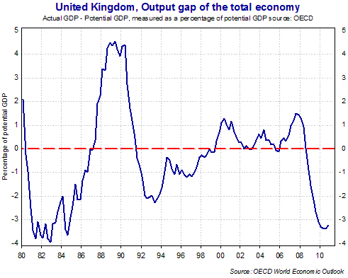
A Keynesian–style stimulus happens when policy-makers deliberately seek to stimulate one or more of the components of aggregate demand to boost output, jobs and incomes during an economic recession.
Keynesians tend to believe that an economy can get stuck at high levels of unemployment with national output persistently below its potential (i.e. operating with a negative output gap). When business and consumer confidence is low (animal spirits have worsened) there is a danger that high rates of saving can make a recession worse. This is known as the paradox of thrift. In this situation weaker demand for goods and services causes further job losses and can cause negative multiplier and accelerator effects particularly in industries that supply components and raw materials to manufacturers and service businesses.
So a Keynesian stimulus is designed to actively manage the level of and rate of growth of aggregate demand.
An example would be to inject extra government investment into infrastructure projects and finance this through a higher level of government borrowing. Keynesian believe that the positive effect on national income and jobs would help to reduce the risk of a higher budget deficit ‘crowding out’ activity in the private sector. Economist David Blanchflower has been lobbying for a huge public sector investment programme as a way of combating what he fears will be a return to mass unemployment with well in excess of three million people out of work.
Another example would be tax cuts targeted at lower-income consumers, targeted at this group because they tend to have a higher marginal propensity to spend any gains in income.
Some fiscal stimulus to demand is inevitable in a recession – this is due to the workings of the automatic stabilisers - the in-built social welfare net which increases government debt during recessions. When unemployment is rising, the government automatically provides more in welfare assistance. And in a recession the revenue from taxation also diminishes.
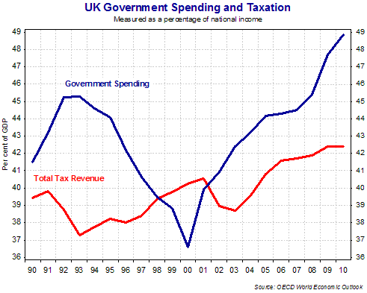
Some evaluation points
1. Fiscal policy may be more effective than monetary policy during a credit crunch because in today’s special circumstances, low interest rates have little impact if credit is not easily available. In the past monetary policy has been the dominant tool of short-term demand management but if zero interest rates seem to have little impact, the attention tends to switch to fiscal policy instead.
2. Are tax cuts to be preferred to extra government spending?
3. What are some of the potential effects of a huge government borrowing spree for the distribution of income and wealth?
4. No one knows for sure just how large are the fiscal multipliers from extra government spending or a tax cut – if they are large then a modest fiscal stimulus can have a significant effect on demand. But the likely depth of the recession means that a Keynesian stimulus package will have to be very large indeed.
5. The likely scale of government borrowing is enormous and there are real fears about what this will mean in the medium term for the costs of servicing government debt and the likely tax increases in years to come. Average inflation and interest rates are likely to be higher because of the increase in government borrowing and the supply of money – this will constrain a future recovery period. But it may stave off the damaging consequences of deflation in the near term. The employers’ organisation the CBI is warning about the dangers of a further rise in state spending and borrowing – “a further significant fiscal stimulus is unaffordable and would lead to businesses and households retrenching in fear of higher tax bills.”
6. What might happen to the UK economy when a Keynesian style fiscal stimulus is ended? Will there be sufficient confidence and momentum in the economy to keep a recovery going?

Animal Spirits
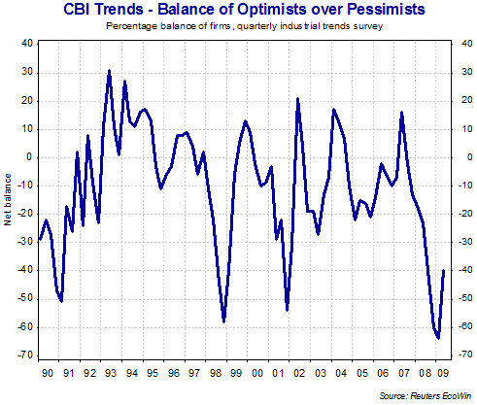
Animal spirits refers to the expectations of businesses, entrepreneurs and consumers. When business confidence is high, we expect to see a rise in planned capital investment at each rate of interest. If there is a downturn in business confidence, for example during a recession, then planned investment may fall and some capital investment projects may be scrapped even when interest rates are fairly low.

The animal spirits of consumers are also hugely important notably for countries where consumer demand for goods and services is the engine of short term growth. Consumer sentiment is affected by factors such as actual and expected unemployment, changes in house prices and share values, changes in direct and indirect taxation and people’s perceptions about the general state of the economy and where it might be heading.
The term “animal spirits” was popularized by John Maynard Keynes in his 1936 book “The General Theory of Employment, Interest and Money,” is related to consumer or business confidence. According to economist Robert Shiller, it refers also to the sense of trust that people have in each other and this can be damaged by events such as the credit crunch and the subsequent financial crisis. Shiller argues that “When animal spirits are on ebb, consumers do not want to spend and businesses do not want to make capital expenditures or hire people.”
Changes in animal spirits can lead to shifts in one or more of the components of aggregate demand and have a powerful effect on short run output and income. But when animal spirits are poor, the traditional techniques of managing aggregate demand by using fiscal and monetary policy may become less effective.

Trend Growth
This revision note looks at trend or long term growth in an economy. The trend rate of growth is the long run average rate for a country over a period of time. Measuring the trend requires a long-run series of data to identify the different stages of the economic cycle and then calculate average growth rates from peak to peak or trough to trough.

Another way of thinking about the trend growth rate is to view it as a safe speed limit for the economy. In other words, an estimate of how fast the economy can reasonably be expected to grow over a number of years without creating an increase in inflationary pressure.
Above trend growth – positive output gap: If the economy grows too quickly (much faster than the trend) – then aggregate demand will eventually exceed long-run aggregate supply and lead to a positive output gap emerging (excess demand in the economy). This can lead to demand-pull and cost-push inflation.
Below trend growth – negative output gap: If the economy experiences a sustained slowdown or recession (i.e. growth is well below the trend rate) then output will fall short of potential GDP leading to a negative output gap. The result is downward pressure on prices and rising unemployment because of a lack of aggregate demand.
For the UK, the trend rate of growth is estimated to be close to 2.5% per year although the OECD and some other economic forecasters have recently downgraded this to below 2% a year. Obviously it is much higher for many emerging market countries that are enjoying rapid growth and major economic change. China’s trend growth rate is probably closer to 8 or 9% per year whilst for India the long run average growth rate is well above 6% a year.
Potential output depends on the following factors
(1) The growth of the labour force—those people able available and willing to find employment: The Government has invested heavily in a number of schemes designed to raise employment including New Deal and reforms to the tax and benefit system. Changes in the age structure of the population also affect the total number of people seeking work. And we must also consider the effects that migration of workers into the UK from overseas, including the newly enlarged European Union, can have on our total labour supply. The age structure of the population also affects the size of the labour force.
(2) The growth of the nation’s stock of capital – driven by the level of fixed capital investment. This is often seen as the most important method of increasing growth - especially investment in critical infrastructure
(3) The trend growth of productivity of labour and capital. For most countries it is what happens to productivity that drives the long-term growth. The causes of improved efficiency come from making markets more competitive and achieving increased output per work within individual plants and factories.
(4) Technological improvements that flow from innovation are important because they reduce the costs of supplying goods and services which leads to an outward shift in a country’s production possibility frontier
To understand better the means by which an economy’s productive capacity and competitiveness can be improved - make sure you revise thoroughly supply-side policies.
A full set of AS macro revision notes is available here and our AS economics revision presentations can be found here

Recession

A recession is a hard-landing and means a fall in the level of real national output i.e. a period when the rate of growth is negative, leading to a contraction in employment, incomes and profits. There is in fact more than one definition and measurement of a recession.
The simple definition: A fall in real GDP for two consecutive quarters i.e. six months
The more detailed definition: A recession is a significant decline in economic activity spread across the economy, lasting more than a few months, normally visible in real GDP, real income, employment, industrial production, and wholesale-retail sales.
Real GDP growth rate, United Kingdom from Timetric
After 16 years of growth, Britain dropped into recession in the second half of 2008. By the summer of 2009 UK GDP was already 5 per cent lower than the fourth quarter of 2007 - a recovery started in 2009 but growth has remained weak since then
There are many symptoms of a recession – here is a selection of twelve key indicators:
1. A fall in purchases of components and raw materials from supply-chain businesses
2. A fall in real national output (GDP)
3. Rising unemployment
4. A rise in the number of business failures
5. A decline in consumer and business confidence
6. A contraction in total consumer spending & a rise in the percentage of income saved
7. Falling business capital spending
8. A sharp drop in the value of exports and imports of goods and services
9. Deep price discounts offered by businesses
10. Heavy de-stocking as businesses look to cut unsold stocks when demand is weak
11. Government tax revenues are falling
12. The budget (fiscal) deficit is rising quickly
Real GDP growth for Greece
Real GDP growth rate, Greece from Timetric
A slump or a depression is a prolonged and deep recession leading to a significant fall in output and average living standards.
Recessions are unusual. To some economists they are an inevitable feature of a market economy because of the cyclical nature of output, demand and employment.
Every recession is different! It is undeniable that the global credit crunch has been hugely significant in causing the downturn even though macroeconomic policy has tried hard to prevent it.
The 2009 recession in the UK was the result of a combination of domestic and external economic factors and forces:
1. The end of the property boom – falling house prices hit wealth and led to a large contraction in new house building
2. Reductions in real disposable incomes due to wages rising less quickly than prices
3. The lagged effects of rising interest rates in 2007-08 (a tightening of monetary policy)
4. A sharp fall in consumer confidence – made worse by rising unemployment – leading to an increase in saving – Keynes called this the ‘paradox of thrift.’
5. External events – such as recession in the UK’s major trading partners including the USA (which accounts for 15% of UK trade) and the Euro Area (which has 55% of UK trade)
6. UK exports declined and this hit manufacturing industry hard
7. Cut-backs in production have led to a negative multiplier effect causing a decline in demand for consumer / household services and lower sales and profits for supply-chain businesses
8. The credit crunch caused the supply of credit to dry up affecting millions of businesses and home-owners
9. Falling profits and weaker demand caused a fall in business sector capital investment – known as the negative accelerator effect.
10. Unemployment started to rise early in the downturn – a reflection of our flexible labour market and sticky wages
An important evaluation point is that, in a recession, some businesses are affected more than others. The extent of the effects will depend on the type of business, the market it operates in and the nature of the product sold. When average incomes are falling, we would expect to see a decline in demand for products with a high income elasticity of demand – typically these goods and services are regarded as luxury items by consumers, things that they might choose to do without when the economy is going through a bad time. The demand for products with a negative income elasticity of demand (i.e. inferior goods) might actually rise during a recession!

Spare Capacity
Spare capacity measures the extent to which an industry, or economy is operating below the maximum sustainable level of production - there are spare factor resources of land, labour and capital. There are many measures of capacity utilisation including surveys of business activity, the estimated output gap and the rate of unemployment in the labour market.
There are several reasons why a business will operate with spare capacity:
Lower demand:
- General reduction in market demand (e.g. during the credit crunch)
- Loss of market share (perhaps unsuccessful marketing, competitors introduce better product)
- Seasonal variation in demand - i.e. temporary, but expected spare capacity
Increase in capacity not yet matched by increased demand
- Possibly because new technology has been introduced in anticipation of higher demand in the future
- Improvements in productivity mean capacity increases for a given level of demand
- Be careful that the business has not over-invested in fixed assets
Provide some “slack”
- Allow some spare capacity to be able to respond to short-term or unexpected increases in demand
- Provide time for maintenance, repairs and training
Inefficiency
- A problem = less competitive - implies higher unit costs than the competition
Does spare capacity matter?
There are some potential downsides to operating with spare capacity:
- Higher fixed costs per unit produced implies lower profitability than could be achieved
- De-motivated employees: boredom, fear of job losses (factory workers who have been made redundant often say that they could “see it coming” because production had been quiet
- The opportunity cost of the spare capacity - the returns foregone from the cash invested
However, it is often said that a business should maintain a capacity buffer - somewhere around 10% of capacity to allow for unexpected demand, staff training and development. Spare capacity can be useful in that it allows businesses to respond to short-term or an unexpected increase in demand, when there is some productive slack, supply is price elastic. It also provides time for maintenance, repairs and employee training.

Linking Output Gap to other Macro Issues
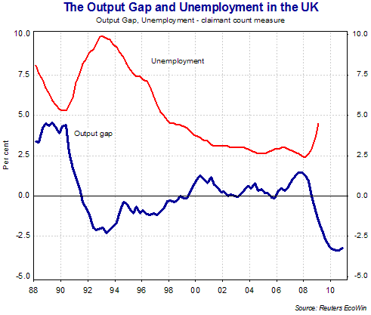
How much spare capacity does an economy have to meet a rise in demand? How close is an economy to operating at its productive potential? These sorts of questions link to an important concept – the output gap. The output gap is the difference between the actual level of national output and its potential level and is usually expressed as a percentage of the level of potential output. In this revision blog we link the output gap to aspects of macroeconomic performance.
Negative output gap – unemployment and deflation risks
If actual GDP is less than potential GDP there is a negative output gap. Some factor resources are under-utilised and the main macroeconomic problem is likely to be higher than average unemployment and also weak business profits and investment.
A second possible consequence from an economy operating with a large negative output gap is that there is deflationary pressure on prices and wages. Businesses left with unsold goods and services and a large margin of productive slack might choose to engage in heavy price discounts, or look to squeeze their costs including prices paid to suppliers and wages paid to their employees.
A rising number of people out of work indicate an excess supply of labour in the factor market which means there is downward pressure on real wage rates.
A negative output gap also causes a worsening of government finances – we have seen in the current recession how badly tax revenues have been affected by the slump in demand, profits and the subsequent rise in unemployment. The UK Treasury estimates that this ‘credit-crunch’ recession may have led to a permanent fall in real national output of perhaps 5% of GDP.
Positive output gap – upward pressure on inflation and a widening trade deficit
If actual GDP is greater than potential GDP then there is a positive output gap. Some resources including labour are likely to be working beyond their normal capacity e.g. making extra use of shift work and overtime. The main problem is likely to be an acceleration of demand pull and cost-push inflation. Shortages of labour put upward pressure on wage rates, and in the next time period, a rise in wage rates shifts SRAS upwards until actual and potential GDP are identical – assuming labour markets are flexible.
Excess demand in an economy can also lead to a worsening of a country’s trade balance as imports of goods and services flow in to satisfy the demands of consumers and manufacturers.

Beyond GDP: Well-being
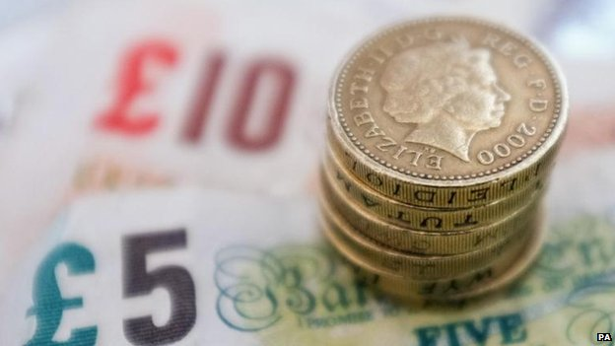
http://www.bbc.co.uk/news/business-30588469
The holidays are a good time to reflect on well-being. The ONS has done so, releasing alongside its latest GDP estimate an assessment of income that is intended to provide a more comprehensive picture of economic prosperity.
It's a theme that I'll be exploring in the new year as I prepare for an Analysis programme on Radio 4 on this topic.
Firstly, is it more informative than GDP alone?
It seems so. GDP told us that the economy is growing well at 0.7% in the third quarter of 2014. But revisions to previous quarters meant that, on an annual basis, the economy is expanding more slowly than previously estimated at 2.6% instead of 3%.
GDP per head told us rather more. GDP per capita grew by 0.6%, so more slowly than the economy as a whole.
Whereas GDP has recovered to pre-economic downturn levels and the services sector is now 7.2% above its pre-crisis peak (though not the other sectors such as manufacturing), GDP per head is still 1.8% below what it was before the crisis. Worse, net national disposable income (that's a mouthful), or the income of UK residents, has remained flat for nearly three years and remains 5.6% below pre-crisis levels.
Taken together, it's unsurprising that median incomes - that's the income of the middle person and not the average of all of the people - fell to £23,300 in 2012-13, which is the lowest in a decade.
In addition, inequality has increased. The distribution of wealth has gone more to owners of capital than households.
The net wealth of the UK economy grew by 4.4% last year to £7.6 trillion. However, household wealth rose by less than that, increasing by 2.6% - mainly because of increases in house prices.
Meanwhile, the net wealth of financial corporations has skyrocketed by 373% to £421bn in the past year.
The increase in the value of financial assets, eg shares and deposits, is not solely a British phenomenon as cheap money has propelled stock indexes in the US to multiple highs in the past year. But, it's worrying that the increased wealth exacerbates inequality and hasn't found its way into the real economy. The wealth of non-financial corporations decreased in 2013.
It's no wonder that even though the economy is improving and household incomes per head (adjusted for inflation) are now slightly above their pre-recession levels, the ONS finds that households feel that their financial situation has worsened slightly over the past year. It's worth remembering that how confident households are about the future affects their consumption and saving decisions, which are crucial to how an economy grows.
So, it seems that incomes rather than GDP alone reveal more about our economic well-being. And six years on from the global financial crisis, even though the economy has recovered, there is still some way to go before our well-being does.

Growing fast and growing slow - an anatomy of economic growth
Andy Haldane, Chief Economist at the Bank of England has recently given a superb speech on the dynamic of economic growth.
You can find the speech here and I urge all economics teachers and students to read it because the text provides a wonderful overview of much of the literature on economic growth that is directly relevant to work on growth and development in different countries.
There is a wonderful historical sweep across hundreds of years of economic data (yes I know that the accuracy of the figures can always be called into question!) allied to some telling quotes and perspectives on which headwind - secular stagnation or secular innovation may prove to be stronger in the years ahead.
The referencing of the speech is worth reading through - a superb piece of work from the staff at the Bank
Here are just a few selected lines from the speech:

GDP and well-being
It is increasingly well-recognised that GDP is a partial, and often imperfect, measure of societal well-being. As Einstein said, not all that can be counted counts.

Putting economic growth of China into perspective
China is now almost eight times the size of Italy. Indeed, China creates a new economy the size of Italy every 18 months; an economy the size of Portugal every quarter; an economy the size of Greece every month; and an economy the size of Cyprus every week

Growth and living standards
Save for wars, it suggests a straight-line growth path over the past 250 years or so, averaging 1.5% per year. That means each generation has been around a third better off than its predecessor. Growth has driven secular rises in living standards, generation by generation.
But whereas the growth lapses have been temporary, the leaps have been permanent. Over the past two and a half centuries, secular innovation has dwarfed secular stagnation.

A broader definition of capital
One way of accommodating these broader factors is to widen the definition of "capital": physical capital (such as plant and machinery); human capital (such as skills and expertise); social capital (such as cooperation and trust); intellectual capital (such as ideas and technologies); and infrastructural capital (such as transport networks and legal systems).

Rising inequality and the impact on economic growth
The IMF study estimates that a one percentage point rise in a country's Gini coefficient – a measure income distribution – lowers growth by around 0.1 percentage point.

UK economic well-being is improving, says ONS
By Brian Milligan Personal Finance Reporter Tuesday 31/03/2015
The financial well-being of UK households improved last year - but overall it is not much better than it was five years ago - according to the Office for National Statistics (ONS)
In a series of new measures, the ONS is seeking to quantify economic well-being, as well as economic growth.
Real Household Disposable Income (RHDI) per head increased by 1.9% in the year to December 2014.
However, the measure is only up by 0.2% from the second quarter of 2010.
This particular measure, RHDI, is the one favoured by the chancellor, George Osborne.
The ONS also reported a rise in households' optimism about their finances.
In December 2014, the ONS survey showed a balance of -5.2, meaning that the number of people who thought their financial situation was getting worse outweighed the number seeing an improvement.
However, that figure was an improvement on a year before, when the balance was -7.6.
The series of data was first published by the ONS in December 2014.

GDP
Household spending has also risen, according to the ONS.
Real household spending - after adjustments for inflation - rose by 0.3% in the year to December 2014.
And it has risen by 3% since the coalition government came to power in 2010.
All these measures were designed as alternatives to quantifying the UK economy by Gross Domestic Product (GDP) - which measures production, and the income it generates.
Such an approach was first suggested by the Nobel Prize-winning economist, Joseph Stiglitz.
In 2009, he concluded that as well as looking at the performance of the overall economy, it was important to look at the economics of individual households.
In measuring economic well-being, three particular problems are associated with GDP:
- It includes depreciation on goods such as cars. But most people would not consider that the falling value of their car contributes to a worse financial position
- Not all income measured by GDP goes to UK residents. Some is taken by foreign investors - while UK residents also take income from investments abroad
- GDP tends to increase as the population grows, so it needs to be measured on a "per head" basis.

UK economic growth slows to 0.3%
28 April 2015
George Osborne says we have reached a 'critical moment'
The rate of economic growth halved in the three months to the end of March, official figures show, marking the slowest quarterly growth for two years.
The UK economy grew by 0.3% in the quarter, the Office for National Statistics (ONS) said.
That compares with 0.6% in the last three months of 2014.
The figures, which come nine days before the general election, suggest a "temporary" slowdown in the economy, analysts said.
The ONS said the economy was 2.4% larger than the same period a year earlier.
Growth of 0.5% in the services industry was offset by a 1.6% fall in the pace of economic output in construction.
The UK services sector accounts for around three quarters of economic growth, with construction, manufacturing and production accounting for the remaining quarter.
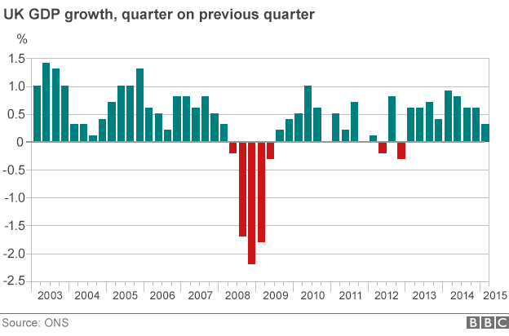

'Critical moment'
The Chancellor, George Osborne, said: "It's good news that the economy has continued to grow, but we have reached a critical moment. Today is a reminder that you can't take the recovery for granted and the future of our economy is on the ballot paper at this election."
But Labour's shadow chancellor, Ed Balls, said: "While the Tories have spent months patting themselves on the back these figures show they have not fixed the economy for working families."
Liberal Democrat Chief Secretary to the Treasury Danny Alexander, said the figures were still progress but a warning too.
He added it was vital his party were part of the next government to ensure the "fair and balanced approach needed to secure this recovery".
Lib Dem reaction to the slowing in UK growth
Scottish National Party (SNP) finance spokesman and Scottish Finance Minister John Swinney said the growth figures demonstrated the need for the "end of austerity and for greater investment in the economy".
"The lesson I take from that is that we have a chance in the election next Thursday to start to invest again in our economy by ending the austerity and spending cuts of the UK government," he said.
Vicky Redwood, chief UK economist at Capital Economics, said the figures would not help the coalition parties with just nine days to go until the general election.
But she added the slowdown in the economy "should just be temporary" and that quarterly economic growth should return to between 0.7% and 0.8% later in the year.
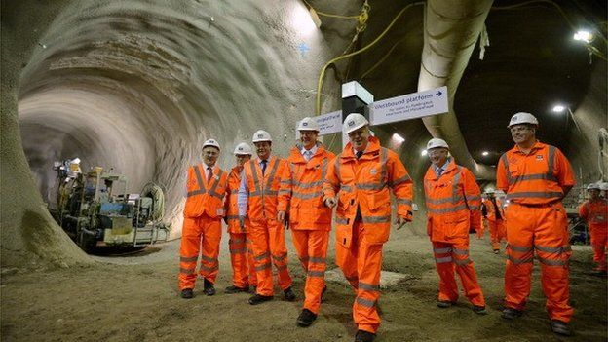Despite big infrastructure projects such as Crossrail, construction output fell 1.6% in the first quarter

Analysis: Robert Peston, BBC economics editor
For reasons no one can quite explain, construction in Britain has been lousy for six months.
The production industries have been especially hurt by the oil price collapse, which has led to something of a crisis in the North Sea. Excluding oil and gas, quarter-on-quarter growth would have been 0.1 of a percentage point higher at 0.4%.
But nor has manufacturing been sparkling: it showed growth of just 0.1%. And perhaps because of the strengthening pound, the growth rate of our manufacturers has progressively decelerated in a straight line from 1.4% a year ago
More unexpectedly, some service industries in which the UK is a world leader - finance, engineering and architecture - have had a poor few months.
One possible explanation of their slowing growth is that demand for our services and goods in important export markets - especially China and the US - may be a bit worse than official figures show. That could be a sign of trouble ahead.
So thank goodness for our domestic-facing services.
Or to put it another way, if we weren't a nation of shoppers and restaurant eaters, there would be very little growth at all. The output of distribution, hotels and restaurants increased by 1.2% in the quarter - only slightly slower than at the end of last year.
Read Robert's blog in full
The figures represent a first estimate of economic growth and are based on less than half of the total data required for the final output estimate.
But the ONS said that while estimates are subject to revision as more data become available, the revisions are typically small between the preliminary and third estimates.
ONS chief economist Joe Grice said: "The economy expanded a little more slowly in the first quarter of 2015 than we've seen in the past two years and that's largely due to the services sector, where growth has eased to 0.5%.
"In addition, there has been a further fall in construction output that itself takes around 0.1% off the GDP growth rate. But, as always, we warn against reading too much into one quarter's figures."

Paradox of Thrift
- 'Paradox of thrift; is a concept that if individuals decide to increase their private saving rates, it can lead to a fall in general consumption and lower output.
- Therefore, although it might make sense for an individual to save more, a rapid rise in national private savings can harm economic activity and be damaging to the overall economy.
- In a recession, we often see this 'paradox of thrift'. Faced with prospect of recession and unemployment, people take the reasonable step to increase their personal saving and cut back on spending. However, this fall in consumer spending leads to a decrease in aggregate demand and therefore lower economic growth.

Paradox of Thrift in 1930s
In the great depression of the 1930s, GDP fell, unemployment rose and the UK experienced a long period of deflation. In response to this disastrous economic situation, mainstream economists were at a loss as how to respond. Such a lengthy period of disequilibrium didn’t sit well with Classical theory which expected markets to operate smoothly and efficiently.
One policy the National government did approve was the cutting of unemployment benefits. The rationale was that in times of a depression the govt should set an example by reducing its debt. This example actually inspired members of the public to send in their savings in the hope that it would help the economy.
By reducing benefits they further reduced consumer spending and AD. This made areas of high unemployment even more impoverished. When people saved rather than spent their money it just made the recession worse.
J.M. Keynes argued that this 'paradox of thrift' was pushing the economy into a prolonged recession. He argued that in response to higher private saving, the government should borrow from the private sector and inject money into the economy.
This government borrowing wouldn't cause crowding out because the private sector were not investing, but just saving.
In the UK and US Keynes was largely ignored until after the war and as a consequence the UK economy experienced high levels of unemployment for the remainder of the decade.

Britain overtakes France to become world's 5th biggest economy

The latest Global Economic League Table published by the Centre for Economic and Business Research places the UK as the 5th largest economy in the world, overtaking France.
The UK appears to have overtaken France this year to become the world's 5th largest economy (but as the 2014 GDP figures are $2,828bn for the UK and $2,827bn for France, the gap is well within the margin of error)
According to the CEBR, Russia's well known economic woes show it dropping to tenth place. The collapse in the Turkish Lira brings it down from 17th to 19th place. Korea moves up a place as do Italy (surprisingly but only because the Russian economy is in even worse trouble than the Italian economy!) India, the Netherlands, Belgium (who swap places with Norway) and Austria. Argentina drops 3 places as its economy collapses.
Cebr Global's World Economic League Table is an annual calculation by Cebr Global, Cebr's global economic consultancy. The base data for 2013 is taken from the IMF World Economic Outlook and the GDP forecast draws on Cebr's Global Prospects model to forecast growth, inflation and exchange rates.
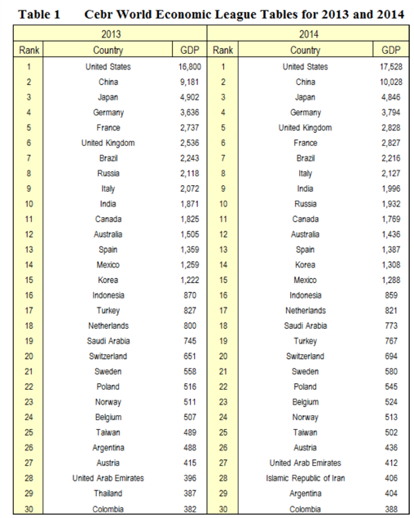
CEBR World Economic League table for 2013 and 2014

Economic Growth in the UK
In this recording of a recent Economics revision webinar, I provide an exam-focused summary of the key issues relating to the UK's economic growth prospects.
https://www.youtube.com/watch?v=8pNwfk-0pDQ
Download the slides used in this revision webinar here
Economic Growth in the UK

